Discoveries on the fifty datasets

# 52 Iris - Life

sepal length in cm (length):

Numerical >=0 format: All 150 values are numerical and greater or equal to 0 in the range (4.3:7.9).

sepal width in cm (width):

Numerical >=0 format: All 150 values are numerical and greater or equal to 0 in the range (2.0:4.4).

petal length in cm (length):

Numerical >=0 format: All 150 values are numerical and greater or equal to 0 in the range (1.0:6.9).

petal width in cm (width):

Numerical >=0 format: All 150 values are numerical and greater or equal to 0 in the range (0.1:2.5).

class:

All 150 values are correctly categorical.

Categorical format with 3 unique values:

Category Frequency

Iris-setosa 50

Iris-versicolor 50

Iris-virginica 50

Ydata did not find anything that we measure.

# 45 Heart Disease - Life

age:

Age format: All 303 values are numerical and valid in the range [0, 130].

Actual range of values: (29.0 : 77.0)

sex:

All 303 values are correctly categorical.

Categorical format with 2 unique values:

Category Frequency

1.0 206

0.0 97

cp (type):

All 303 values are correctly categorical.

Categorical format with 4 unique values:

Category Frequency

4.0 144

3.0 86

2.0 50

1.0 23

trestbps (integer):

Numerical format: All 303 values are numerical in the range (94.0:200.0).

chol (integer):

Numerical format: All 303 values are numerical in the range (126.0:564.0).

fbs (categorical):

All 303 values are correctly categorical.

Categorical format with 2 unique values:

Category Frequency

0.0 258

1.0 45

restecg (categorical):

All 303 values are correctly categorical.

Categorical format with 3 unique values:

Category Frequency

0.0 151

2.0 148

1.0 4

thalach (rate):

Numerical format: All 303 values are numerical in the range (71.0:202.0).

exang (yes):

All 303 values are correctly categorical.

Categorical format with 2 unique values:

Category Frequency

0.0 204

1.0 99

oldpeak (integer):

Numerical format: All 303 values are numerical in the range (0.0:6.2).

slope (categorical):

All 303 values are correctly categorical.

Categorical format with 3 unique values:

Category Frequency

1.0 142

2.0 140

3.0 21

ca (categorical):

Error(s) found:

DQI #1 (Missing Data - Completeness):

4 Blank/Empty/Null/Missing value(s) at index(es): 166, '?'), (192, '?'), (287, '?'), (302, '?')])

Categorical format with 5 unique values:

Category Frequency

0.0 176

1.0 65

2.0 38

3.0 20

? 4

thal (categorical):

Error(s) found:

DQI #1 (Missing Data - Completeness):

2 Blank/Empty/Null/Missing value(s) at index(es): [(87, '?'), (266, '?')])

Categorical format with 4 unique values:

Category Frequency

3.0 166

7.0 117

6.0 18

? 2

num (predicted):

All 303 values are correctly categorical.

Categorical format with 5 unique values:

Category Frequency

0 164

1 55

2 36

3 35

4 13

Ydata Profiling did not find the '?'s in the two columns above where DQI# 1 was found.

# 2 Adult - Social

age:

Age format: All 32561 values are numerical and valid in the range [0, 130].

Actual range of values: (17 : 90)

workclass (class):

Error(s) found:

DQI #1 (Missing Data - Completeness):

1836 Blank/Empty/Null/Missing value(s) at index(es): [(27, ' ?'), (61, ' ?'), (69, ' ?'), (77, ' ?'), (106, ' ?'), (128, ' ?'), (149, ' ?'), (154, ' ?'), (160, ' ?'), (187, ' ?'), ('...', '...'), (32426, ' ?'), (32477, ' ?'), (32490, ' ?'), (32494, ' ?'), (32525, ' ?'), (32530, ' ?'), (32531, ' ?'), (32539, ' ?'), (32541, ' ?'), (32542, ' ?')] (displaying only the first and last 10 items)

Categorical format with 9 unique values:

Category Frequency

Private 22696

Self-emp-not-inc 2541

Local-gov 2093

? 1836

State-gov 1298

Self-emp-inc 1116

Federal-gov 960

Without-pay 14

Never-worked 7

fnlwgt (weight):

Numerical >=0 format: All 32561 values are numerical and greater or equal to 0 in the range (12285:1484705).

education:

All 32561 values are correctly categorical.

Categorical format with 16 unique values:

Category Frequency

HS-grad 10501

Some-college 7291

Bachelors 5355

Masters 1723

Assoc-voc 1382

11th 1175

Assoc-acdm 1067

10th 933

7th-8th 646

Prof-school 576

9th 514

12th 433

Doctorate 413

5th-6th 333

1st-4th 168

Preschool 51

education-num (num)

Numerical format: All 32561 values are numerical in the range (1:16).

marital-status (status):

All 32561 values are correctly categorical.

Categorical format with 7 unique values:

Category Frequency

Married-civ-spouse 14976

Never-married 10683

Divorced 4443

Separated 1025

Widowed 993

Married-spouse-absent 418

Married-AF-spouse 23

occupation:

Error(s) found:

DQI #1 (Missing Data - Completeness):

1843 Blank/Empty/Null/Missing value(s) at index(es): [(27, ' ?'), (61, ' ?'), (69, ' ?'), (77, ' ?'), (106, ' ?'), (128, ' ?'), (149, ' ?'), (154, ' ?'), (160, ' ?'), (187, ' ?'), ('...', '...'), (32426, ' ?'), (32477, ' ?'), (32490, ' ?'), (32494, ' ?'), (32525, ' ?'), (32530, ' ?'), (32531, ' ?'), (32539, ' ?'), (32541, ' ?'), (32542, ' ?')] (displaying only the first and last 10 items)

Categorical format with 15 unique values:

Category Frequency

Prof-specialty 4140

Craft-repair 4099

Exec-managerial 4066

Adm-clerical 3770

Sales 3650

Other-service 3295

Machine-op-inspct 2002

? 1843

Transport-moving 1597

Handlers-cleaners 1370

Farming-fishing 994

Tech-support 928

Protective-serv 649

Priv-house-serv 149

Armed-Forces 9

relationship:

All 32561 values are correctly categorical.

Categorical format with 6 unique values:

Category Frequency

Husband 13193

Not-in-family 8305

Own-child 5068

Unmarried 3446

Wife 1568

Other-relative 981

race:

All 32561 values are correctly categorical.

Categorical format with 5 unique values:

Category Frequency

White 27816

Black 3124

Asian-Pac-Islander 1039

Amer-Indian-Eskimo 311

Other 271

sex:

All 32561 values are correctly categorical.

Categorical format with 2 unique values:

Category Frequency

Male 21790

Female 10771

capital-gain (gain):

Numerical format: All 32561 values are numerical in the range (0:99999).

capital-loss (loss):

Numerical format: All 32561 values are numerical in the range (0:4356).

hours-per-week (hours):

Numerical >=0 format: All 32561 values are numerical and greater or equal to 0 in the range (1:99).

native-country (country):

Country format: Error(s) found:

DQI #1 (Missing Data - Completeness):

583 Blank/Empty/Null/Missing value(s) at index(es): [(14, ' ?'), (38, ' ?'), (51, ' ?'), (61, ' ?'), (93, ' ?'), (245, ' ?'), (249, ' ?'), (297, ' ?'), (393, ' ?'), (453, ' ?'), ('...', '...'), (32213, ' ?'), (32232, ' ?'), (32254, ' ?'), (32307, ' ?'), (32413, ' ?'), (32449, ' ?'), (32469, ' ?'), (32492, ' ?'), (32510, ' ?'), (32525, ' ?')] (displaying only the first and last 10 items)

Frequency Distribution (showing top and bottom 10 of 42 categories):

Country Frequency

United-States 29170

Mexico 643

? 583

Philippines 198

Germany 137

Canada 121

Puerto-Rico 114

El-Salvador 106

India 100

Cuba 95

... ...

Cambodia 19

Trinadad&Tobago 19

Laos 18

Thailand 18

Yugoslavia 16

Outlying-US(Guam-USVI-etc) 14

Honduras 13

Hungary 13

Scotland 12

Holand-Netherlands 1

predicted-attribute (predicted):

Categorical format with 2 unique values:

Category Frequency

<=50K 24720

>50K 7841

Ydata Profiling did not find the errors related to '?' in the four columns presented before.

# 107 Wine - Physical

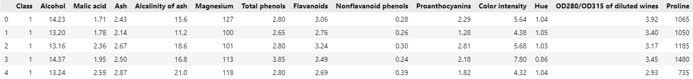

Class:

All 178 values are correctly categorical.

Categorical format with 3 unique values:

Category Frequency

2 71

1 59

3 48

Alcohol:

Numerical format: All 178 values are numerical in the range (11.03:14.83).

Malic acid (acid):

Numerical format: All 178 values are numerical in the range (0.74:5.8).

Ash:

Numerical >=0 format: All 178 values are numerical and greater or equal to 0 in the range (1.36:3.23).

Alcalinity of ash (ash):

Numerical >=0 format: All 178 values are numerical and greater or equal to 0 in the range (10.6:30.0).

Magnesium:

Numerical format: All 178 values are numerical in the range (70:162).

Total phenols (total):

Numerical format: All 178 values are numerical in the range (0.98:3.88).

Flavanoids:

Target word not found, and Format not determined

Nonflavanoid phenols:

Target word not found, and Format not determined

Proanthocyanins:

Target word not found, and Format not determined

Color intensity (intensity):

Numerical format: All 178 values are numerical in the range (1.28:13.0).

Hue:

Target word not found, and Format not determined

OD280/OD315 of diluted wines:

Target word not found, and Format not determined

Proline:

Target word not found, and Format not determined

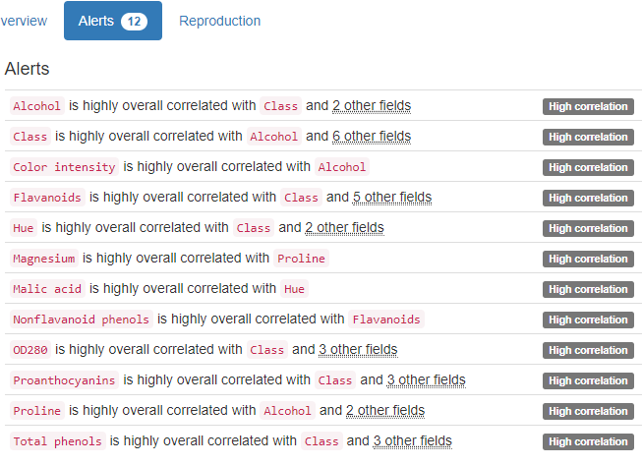

YData only found High correlation Alerts.

# 42 Glass Identification - Physical

|  |  |  |  |
| --- | --- | --- | --- |
| 1.       Id number | 1 | Id number | ID column |
| 2.       RI: refractive index | 2 | RI | numerical |
| 3.       Na: Sodium | 3 | Na | numerical |
| 4.       Mg: Magnesium | 4 | Mg | numerical |
| 5.       Al: Aluminum | 5 | Al | numerical |
| 6.       Si: Silicon | 6 | Si | numerical |
| 7.       K: Potassium | 7 | K | numerical |
| 8.       Ca: Calcium | 8 | Ca | numerical |
| 9.       Ba: Barium | 9 | Ba | numerical |
| 10.   Fe: Iron | 10 | Fe | numerical |
| 11.   Type of glass (class attribute) | 11 | Type of glass | categorical |

Id number (id):

ID column format: All 214 ID values are unique and valid, and thus suitable for use as a Primary Key.

Alphanumeric range of values: (1 : 99)

RI (index):

Numerical format: All 214 values are numerical in the range (1.51115:1.53393).

Na (sodium):

Numerical format: All 214 values are numerical in the range (10.73:17.38).

Mg (magnesium):

Numerical format: All 214 values are numerical in the range (0.0:4.49).

Al (aluminum):

Numerical format: All 214 values are numerical in the range (0.29:3.5).

Si (silicon):

Numerical format: All 214 values are numerical in the range (69.81:75.41).

K (potassium):

Numerical format: All 214 values are numerical in the range (0.0:6.21).

Ca (calcium):

Numerical format: All 214 values are numerical in the range (5.43:16.19).

Ba (barium):

Numerical format: All 214 values are numerical in the range (0.0:3.15).

Fe (iron):

Numerical format: All 214 values are numerical in the range (0.0:0.51).

Type of glass (type):

All 214 values are correctly categorical.

Categorical format with 6 unique values:

Category Frequency

2 76

1 70

7 29

3 17

5 13

6 9

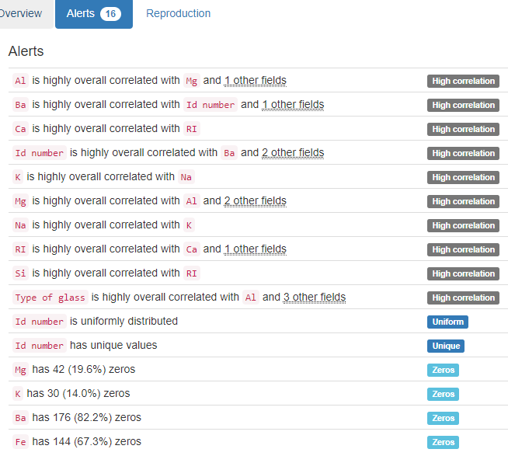

YData found that Id number is Unique as we did. No Data Quality Issue as we check.

# 58 Letter Recognition - Computer

lettr (letter): String format: All 20000 string values are valid.

String range (lexicographical): (A : Z)

x-box (x):

Numerical format: All 20000 values are numerical in the range (0:15).

y-box (y):

Numerical format: All 20000 values are numerical in the range (0:15).

width:

Numerical >=0 format: All 20000 values are numerical and greater or equal to 0 in the range (0:15).

high (height):

Numerical >=0 format: All 20000 values are numerical and greater or equal to 0 in the range (0:15).

onpix (integer):

Numerical format: All 20000 values are numerical in the range (0:15).

x-bar (x):

Numerical format: All 20000 values are numerical in the range (0:15).

y-bar (y):

Numerical format: All 20000 values are numerical in the range (0:15).

x2bar (integer):

Numerical format: All 20000 values are numerical in the range (0:15).

y2bar (integer):

Numerical format: All 20000 values are numerical in the range (0:15).

xybar (integer):

Numerical format: All 20000 values are numerical in the range (0:15).

x2ybr (integer):

Numerical format: All 20000 values are numerical in the range (0:15).

xy2br (integer):

Numerical format: All 20000 values are numerical in the range (0:15).

x-ege (x):

Numerical format: All 20000 values are numerical in the range (0:15).

xegvy (integer):

Numerical format: All 20000 values are numerical in the range (0:15).

y-ege (y):

Numerical format: All 20000 values are numerical in the range (0:15).

yegvx (integer):

Numerical format: All 20000 values are numerical in the range (0:15).

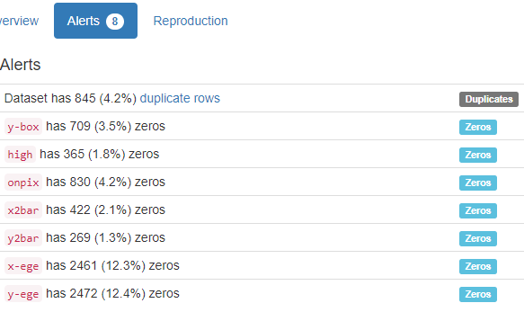

YData did not find any of the Data Quality Issues we search for.

# 142 Statlog (German Credit Data) - Financial

Status of existing checking account (status):

All 1000 values are correctly categorical.

Categorical format with 4 unique values:

Category Frequency

A14 394

A11 274

A12 269

A13 63

Duration in months (months):

Numerical >=0 format: All 1000 values are numerical and greater or equal to 0 in the range (4:72).

Credit history (qualitative):

All 1000 values are correctly categorical.

Categorical format with 5 unique values:

Category Frequency

A32 530

A34 293

A33 88

A31 49

A30 40

Purpose (qualitative):

All 1000 values are correctly categorical.

Categorical format with 10 unique values:

Category Frequency

A43 280

A40 234

A42 181

A41 103

A49 97

A46 50

A45 22

A44 12

A410 12

A48 9

Credit amount (amount):

Numerical format: All 1000 values are numerical in the range (250:18424).

Savings account (qualitative):

All 1000 values are correctly categorical.

Categorical format with 5 unique values:

Category Frequency

A61 603

A65 183

A62 103

A63 63

A64 48

Present employment since (qualitative):

All 1000 values are correctly categorical.

Categorical format with 5 unique values:

Category Frequency

A73 339

A75 253

A74 174

A72 172

A71 62

Installment rate in percentage of disposable income (percentage):

Percentage format: All numerical values are valid in the range [0, 100].

Actual range of values: (1 : 4)

Personal status and sex (status):

All 1000 values are correctly categorical.

Categorical format with 4 unique values:

Category Frequency

A93 548

A92 310

A94 92

A91 50

Other debtors (qualitative):

All 1000 values are correctly categorical.

Categorical format with 3 unique values:

Category Frequency

A101 907

A103 52

A102 41

Present residence since (since):

Numerical >=0 format: All 1000 values are numerical and greater or equal to 0 in the range (1:4).

Property (qualitative):

All 1000 values are correctly categorical.

Categorical format with 4 unique values:

Category Frequency

A123 332

A121 282

A122 232

A124 154

Age in years (age):

Age format: All 1000 values are numerical and valid in the range [0, 130].

Actual range of values: (19 : 75)

Other instalment plans (qualitative):

All 1000 values are correctly categorical.

Categorical format with 3 unique values:

Category Frequency

A143 814

A141 139

A142 47

Housing (qualitative):

All 1000 values are correctly categorical.

Categorical format with 3 unique values:

Category Frequency

A152 713

A151 179

A153 108

Number of existing credits at this bank (number):

Numerical format: All 1000 values are numerical in the range (1:4).

Job:

All 1000 values are correctly categorical.

Categorical format with 4 unique values:

Category Frequency

A173 630

A172 200

A174 148

A171 22

Number of people being liable to provide maintenance for (number):

Numerical format: All 1000 values are numerical in the range (1:2).

Telephone:

Phone format: Error(s) found:

DQI #15 (Domain Violation - Accuracy):

999 Incorrect telephone number format at index(es): [(0, 'A192'), (1, 'A191'), (2, 'A191'), (3, 'A191'), (4, 'A191'), (5, 'A192'),

…

(994, 'A192'), (995, 'A191'), (996, 'A192'), (997, 'A191'), (998, 'A192'), (999, 'A191')])

This column had to be altered manually in the AnalysedColumns sheet, from ‘phone’ to ‘categorical’ so that it could be analysed as such.

This is the new output:

Telephone:

Categorical format with 2 unique values:

Category Frequency

A191 596

A192 404

Foreign worker (worker):

All 1000 values are correctly categorical.

Categorical format with 2 unique values:

Category Frequency

A201 963

A202 37

predicted-attribute (predicted):

All 1000 values are correctly categorical.

Categorical format with 2 unique values:

Category Frequency

1 700

2 300

YData only found Imbalance alerts.

# 92 Spambase - Computer

word_freq_make (freq):

Numerical >=0 format: All 4601 values are numerical and greater or equal to 0 in the range (0.0:4.54).

word_freq_address (freq):

Numerical >=0 format: All 4601 values are numerical and greater or equal to 0 in the range (0.0:14.28).

word_freq_all (freq):

Numerical >=0 format: All 4601 values are numerical and greater or equal to 0 in the range (0.0:5.1).

word_freq_3d (freq):

Numerical >=0 format: All 4601 values are numerical and greater or equal to 0 in the range (0.0:42.81).

word_freq_our (freq):

Numerical >=0 format: All 4601 values are numerical and greater or equal to 0 in the range (0.0:10.0).

word_freq_over (freq):

Numerical >=0 format: All 4601 values are numerical and greater or equal to 0 in the range (0.0:5.88).

word_freq_remove (freq):

Numerical >=0 format: All 4601 values are numerical and greater or equal to 0 in the range (0.0:7.27).

word_freq_internet (freq):

Numerical >=0 format: All 4601 values are numerical and greater or equal to 0 in the range (0.0:11.11).

word_freq_order (freq):

Numerical >=0 format: All 4601 values are numerical and greater or equal to 0 in the range (0.0:5.26).

word_freq_mail (freq):

Numerical >=0 format: All 4601 values are numerical and greater or equal to 0 in the range (0.0:18.18).

word_freq_receive (freq):

Numerical >=0 format: All 4601 values are numerical and greater or equal to 0 in the range (0.0:2.61).

word_freq_will (freq):

Numerical >=0 format: All 4601 values are numerical and greater or equal to 0 in the range (0.0:9.67).

word_freq_people (freq):

Numerical >=0 format: All 4601 values are numerical and greater or equal to 0 in the range (0.0:5.55).

word_freq_report (freq):

Numerical >=0 format: All 4601 values are numerical and greater or equal to 0 in the range (0.0:10.0).

word_freq_addresses (freq):

Numerical >=0 format: All 4601 values are numerical and greater or equal to 0 in the range (0.0:4.41).

word_freq_free (freq):

Numerical >=0 format: All 4601 values are numerical and greater or equal to 0 in the range (0.0:20.0).

word_freq_business (freq):

Numerical >=0 format: All 4601 values are numerical and greater or equal to 0 in the range (0.0:7.14).

word_freq_email (freq):

Numerical >=0 format: All 4601 values are numerical and greater or equal to 0 in the range (0.0:9.09).

word_freq_you (freq):

Numerical >=0 format: All 4601 values are numerical and greater or equal to 0 in the range (0.0:18.75).

word_freq_credit (freq):

Numerical >=0 format: All 4601 values are numerical and greater or equal to 0 in the range (0.0:18.18).

word_freq_your (freq):

Numerical >=0 format: All 4601 values are numerical and greater or equal to 0 in the range (0.0:11.11).

word_freq_font (freq):

Numerical >=0 format: All 4601 values are numerical and greater or equal to 0 in the range (0.0:17.1).

word_freq_000 (freq):

Numerical >=0 format: All 4601 values are numerical and greater or equal to 0 in the range (0.0:5.45).

word_freq_money (freq):

Numerical >=0 format: All 4601 values are numerical and greater or equal to 0 in the range (0.0:12.5).

word_freq_hp (freq):

Numerical >=0 format: All 4601 values are numerical and greater or equal to 0 in the range (0.0:20.83).

word_freq_hpl (freq):

Numerical >=0 format: All 4601 values are numerical and greater or equal to 0 in the range (0.0:16.66).

word_freq_george (freq):

Numerical >=0 format: All 4601 values are numerical and greater or equal to 0 in the range (0.0:33.33).

word_freq_650 (freq):

Numerical >=0 format: All 4601 values are numerical and greater or equal to 0 in the range (0.0:9.09).

word_freq_lab (freq):

Numerical >=0 format: All 4601 values are numerical and greater or equal to 0 in the range (0.0:14.28).

word_freq_labs (freq):

Numerical >=0 format: All 4601 values are numerical and greater or equal to 0 in the range (0.0:5.88).

word_freq_telnet (freq):

Numerical >=0 format: All 4601 values are numerical and greater or equal to 0 in the range (0.0:12.5).

word_freq_857 (freq):

Numerical >=0 format: All 4601 values are numerical and greater or equal to 0 in the range (0.0:4.76).

word_freq_data (freq):

Numerical >=0 format: All 4601 values are numerical and greater or equal to 0 in the range (0.0:18.18).

word_freq_415 (freq):

Numerical >=0 format: All 4601 values are numerical and greater or equal to 0 in the range (0.0:4.76).

word_freq_85 (freq):

Numerical >=0 format: All 4601 values are numerical and greater or equal to 0 in the range (0.0:20.0).

word_freq_technology (freq):

Numerical >=0 format: All 4601 values are numerical and greater or equal to 0 in the range (0.0:7.69).

word_freq_1999 (freq):

Numerical >=0 format: All 4601 values are numerical and greater or equal to 0 in the range (0.0:6.89).

word_freq_parts (freq):

Numerical >=0 format: All 4601 values are numerical and greater or equal to 0 in the range (0.0:8.33).

word_freq_pm (freq):

Numerical >=0 format: All 4601 values are numerical and greater or equal to 0 in the range (0.0:11.11).

word_freq_direct (freq):

Numerical >=0 format: All 4601 values are numerical and greater or equal to 0 in the range (0.0:4.76).

word_freq_cs (freq):

Numerical >=0 format: All 4601 values are numerical and greater or equal to 0 in the range (0.0:7.14).

word_freq_meeting (freq):

Numerical >=0 format: All 4601 values are numerical and greater or equal to 0 in the range (0.0:14.28).

word_freq_original (freq):

Numerical >=0 format: All 4601 values are numerical and greater or equal to 0 in the range (0.0:3.57).

word_freq_project (freq):

Numerical >=0 format: All 4601 values are numerical and greater or equal to 0 in the range (0.0:20.0).

word_freq_re (freq):

Numerical >=0 format: All 4601 values are numerical and greater or equal to 0 in the range (0.0:21.42).

word_freq_edu (freq):

Numerical >=0 format: All 4601 values are numerical and greater or equal to 0 in the range (0.0:22.05).

word_freq_table (freq):

Numerical >=0 format: All 4601 values are numerical and greater or equal to 0 in the range (0.0:2.17).

word_freq_conference (freq):

Numerical >=0 format: All 4601 values are numerical and greater or equal to 0 in the range (0.0:10.0).

char_freq_; (freq):

Numerical >=0 format: All 4601 values are numerical and greater or equal to 0 in the range (0.0:4.385).

char_freq_ (freq):

Numerical >=0 format: All 4601 values are numerical and greater or equal to 0 in the range (0.0:9.752).

char_freq_[ (freq):

Numerical >=0 format: All 4601 values are numerical and greater or equal to 0 in the range (0.0:4.081).

char_freq_! (freq):

Numerical >=0 format: All 4601 values are numerical and greater or equal to 0 in the range (0.0:32.478).

char_freq_$ (freq):

Numerical >=0 format: All 4601 values are numerical and greater or equal to 0 in the range (0.0:6.003).

char_freq_* (freq):

Numerical >=0 format: All 4601 values are numerical and greater or equal to 0 in the range (0.0:19.829).

capital_run_length_average (length):

Numerical >=0 format: All 4601 values are numerical and greater or equal to 0 in the range (1.0:1102.5).

Capital_run_length_longest (length):

Numerical >=0 format: All 4601 values are numerical and greater or equal to 0 in the range (1:9989).

capital_run_length_total (length):

Numerical >=0 format: All 4601 values are numerical and greater or equal to 0 in the range (1:15841).

spam (nominal):

All 4601 values are correctly categorical.

Categorical format with 2 unique values:

Category Frequency

0 2788

1 1813

…



Even though there are 82 alerts from YData, there is no one that is interesting to us.

# 103 Congressional Voting Records – Social

Class Name (name):

Name format: All 435 Class Name values are valid.

Frequency Distribution:

Class Name Frequency

democrat 267

republican 168

handicapped-infants (yes):

Error(s) found:

DQI #1 (Missing Data - Completeness):

12 Blank/Empty/Null/Missing value(s) at index(es): [(2, '?'), (104, '?'), (129, '?'), (143, '?'), (178, '?'), (180, '?'), (183, '?'), (248, '?'), (390, '?'), (393, '?'), (402, '?'), (428, '?')])

Categorical format with 3 unique values:

Category Frequency

n 236

y 187

? 12

water-project-cost-sharing (yes):

Error(s) found:

DQI #1 (Missing Data - Completeness):

48 Blank/Empty/Null/Missing value(s) at index(es): [(17, '?'), (22, '?'), (36, '?'), (49, '?'), (68, '?'), (84, '?'), (104, '?'), (107, '?'), (108, '?'), (109, '?'), ('...', '...'), (248, '?'), (329, '?'), (331, '?'), (341, '?'), (376, '?'), (386, '?'), (390, '?'), (393, '?'), (428, '?'), (432, '?')] (displaying only the first and last 10 items)

Category Frequency

y 195

n 192

? 48

adoption-of-the-budget-resolution (yes):

Error(s) found:

DQI #1 (Missing Data - Completeness):

11 Blank/Empty/Null/Missing value(s) at index(es): [(96, '?'), (104, '?'), (107, '?'), (120, '?'), (151, '?'), (183, '?'), (248, '?'), (301, '?'), (393, '?'), (394, '?'), (428, '?')])

Categorical format with 3 unique values:

Category Frequency

y 253

n 171

? 11

physician-fee-freeze (yes):

Error(s) found:

DQI #1 (Missing Data - Completeness):

11 Blank/Empty/Null/Missing value(s) at index(es): [(2, '?'), (104, '?'), (107, '?'), (183, '?'), (248, '?'), (287, '?'), (341, '?'), (373, '?'), (393, '?'), (394, '?'), (395, '?')])

Categorical format with 3 unique values:

Category Frequency

n 247

y 177

? 11

el-salvador-aid (yes):

Error(s) found:

DQI #1 (Missing Data - Completeness):

15 Blank/Empty/Null/Missing value(s) at index(es): [3, '?'), (107, '?'), (115, '?'), (130, '?'), (159, '?'), (183, '?'), (248, '?'), (290, '?'), (322, '?'), (370, '?'), (371, '?'), (390, '?'), (394, '?'), (399, '?'), (429, '?')])

Categorical format with 3 unique values:

Category Frequency

y 212

n 208

? 15

religious-groups-in-schools (religion):

Error(s) found:

DQI #1 (Missing Data - Completeness):

11 Blank/Empty/Null/Missing value(s) at index(es): [20, '?'), (60, '?'), (107, '?'), (115, '?'), (130, '?'), (183, '?'), (248, '?'), (261, '?'), (342, '?'), (397, '?'), (424, '?')])

Categorical format with 3 unique values:

Category Frequency

y 272

n 152

? 11

anti-satellite-test-ban (yes):

Error(s) found:

DQI #1 (Missing Data - Completeness):

14 Blank/Empty/Null/Missing value(s) at index(es): [(54, '?'), (103, '?'), (107, '?'), (170, '?'), (183, '?'), (247, '?'), (248, '?'), (286, '?'), (290, '?'), (295, '?'), (377, '?'), (380, '?'), (390, '?'), (433, '?')])

Categorical format with 3 unique values:

Category Frequency

y 239

n 182

? 14

aid-to-nicaraguan-contras (yes):

Error(s) found:

DQI #1 (Missing Data - Completeness):

15 Blank/Empty/Null/Missing value(s) at index(es): [(51, '?'), (95, '?'), (107, '?'), (155, '?'), (183, '?'), (191, '?'), (194, '?'), (240, '?'), (248, '?'), (295, '?'), (315, '?'), (322, '?'), (377, '?'), (400, '?'), (433, '?')])

Categorical format with 3 unique values:

Category Frequency

y 242

n 178

? 15

mx-missile (yes):

Error(s) found:

DQI #1 (Missing Data - Completeness):

22 Blank/Empty/Null/Missing value(s) at index(es): [(13, '?'), (16, '?'), (45, '?'), (47, '?'), (81, '?'), (95, '?'), (102, '?'), (103, '?'), (107, '?'), (129, '?'), ('...', '...'), (238, '?'), (243, '?'), (248, '?'), (249, '?'), (286, '?'), (323, '?'), (325, '?'), (334, '?'), (415, '?'), (433, '?')] (displaying only the first and last 10 items)

Categorical format with 3 unique values:

Category Frequency

y 207

n 206

? 22

immigration (yes):

Error(s) found:

DQI #1 (Missing Data - Completeness):

7 Blank/Empty/Null/Missing value(s) at index(es): [(107, '?'), (170, '?'), (180, '?'), (183, '?'), (248, '?'), (389, '?'), (433, '?')])

Categorical format with 3 unique values:

Category Frequency

y 216

n 212

? 7

synfuels-corporation-cutback (corporation):

Error(s) found:

DQI #1 (Missing Data - Completeness):

21 Blank/Empty/Null/Missing value(s) at index(es): [(0, '?'), (10, '?'), (40, '?'), (99, '?'), (104, '?'), (107, '?'), (115, '?'), (129, '?'), (180, '?'), (183, '?'), ('...', '...'), (248, '?'), (261, '?'), (271, '?'), (275, '?'), (359, '?'), (370, '?'), (373, '?'), (377, '?'), (400, '?'), (413, '?')] (displaying only the first and last 10 items)

Categorical format with 3 unique values:

Category Frequency

n 264

y 150

? 21

education-spending (education):

Error(s) found:

DQI #1 (Missing Data - Completeness):

31 Blank/Empty/Null/Missing value(s) at index(es): [(4, '?'), (10, '?'), (11, '?'), (13, '?'), (18, '?'), (22, '?'), (64, '?'), (89, '?'), (95, '?'), (107, '?'), ('...', '...'), (248, '?'), (261, '?'), (282, '?'), (291, '?'), (354, '?'), (370, '?'), (377, '?'), (395, '?'), (400, '?'), (413, '?')] (displaying only the first and last 10 items)

Categorical format with 3 unique values:

Category Frequency

n 233

y 171

? 31

superfund-right-to-sue (yes):

Error(s) found:

DQI #1 (Missing Data - Completeness):

25 Blank/Empty/Null/Missing value(s) at index(es): [(6, '?'), (14, '?'), (16, '?'), (21, '?'), (36, '?'), (95, '?'), (107, '?'), (129, '?'), (157, '?'), (172, '?'), ('...', '...'), (295, '?'), (297, '?'), (315, '?'), (341, '?'), (372, '?'), (400, '?'), (403, '?'), (408, '?'), (413, '?'), (424, '?')] (displaying only the first and last 10 items)

Categorical format with 3 unique values:

Category Frequency

y 209

n 201

? 25

crime (yes):

Error(s) found:

DQI #1 (Missing Data - Completeness):

17 Blank/Empty/Null/Missing value(s) at index(es): [(14, '?'), (15, '?'), (21, '?'), (92, '?'), (95, '?'), (129, '?'), (157, '?'), (159, '?'), (183, '?'), (228, '?'), (248, '?'), (261, '?'), (295, '?'), (315, '?'), (341, '?'), (377, '?'), (429, '?')])

Categorical format with 3 unique values:

Category Frequency

y 248

n 170

? 17

duty-free-exports (yes):

Error(s) found:

DQI #1 (Missing Data - Completeness):

28 Blank/Empty/Null/Missing value(s) at index(es): [(7, '?'), (9, '?'), (11, '?'), (12, '?'), (52, '?'), (103, '?'), (107, '?'), (120, '?'), (129, '?'), (141, '?'), ('...', '...'), (257, '?'), (261, '?'), (273, '?'), (284, '?'), (287, '?'), (295, '?'), (336, '?'), (373, '?'), (377, '?'), (434, '?')] (displaying only the first and last 10 items)

Categorical format with 3 unique values:

Category Frequency

n 233

y 174

? 28

export-administration-act-south-africa (yes):

Error(s) found:

DQI #1 (Missing Data - Completeness):

104 Blank/Empty/Null/Missing value(s) at index(es): [(1, '?'), (9, '?'), (11, '?'), (12, '?'), (13, '?'), (14, '?'), (15, '?'), (24, '?'), (31, '?'), (40, '?'), ('...', '...'), (381, '?'), (382, '?'), (386, '?'), (387, '?'), (388, '?'), (389, '?'), (390, '?'), (393, '?'), (400, '?'), (425, '?')] (displaying only the first and last 10 items)

Categorical format with 3 unique values:

Category Frequency

y 269

? 104

n 62

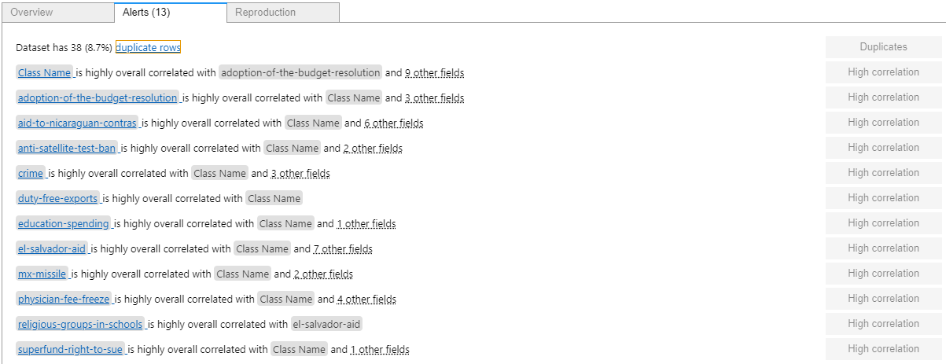

Ydata Profiling did not find any of the many columns with '?' on it.

# 27 Credit Approval - Financial

A1 (categorical):

Error(s) found:

DQI #1 (Missing Data - Completeness):

12 Blank/Empty/Null/Missing value(s) at index(es): [(248, '?'), (327, '?'), (346, '?'), (374, '?'), (453, '?'), (479, '?'), (489, '?'), (520, '?'), (598, '?'), (601, '?'), (641, '?'), (673, '?')])

Categorical with 3 unique values:

Category Frequency

b 468

a 210

? 12

A2 (continuous):

Numerical >=0 format: Error(s) found:

DQI #1 (Missing Data - Completeness):

12 Blank/Empty/Null/Missing value(s) at index(es): [(83, '?'), (86, '?'), (92, '?'), (97, '?'), (254, '?'), (286, '?'), (329, '?'), (445, '?'), (450, '?'), (500, '?'), (515, '?'), (608, '?')])

Range of values: (13.75:80.25).

A3 (continuous):

Numerical >=0 format: All 690 values are numerical and greater or equal to 0 in the range (0.0:28.0).

A4 (categorical):

Error(s) found:

DQI #1 (Missing Data - Completeness):

6 Blank/Empty/Null/Missing value(s) at index(es): [(206, '?'), (270, '?'), (330, '?'), (456, '?'), (592, '?'), (622, '?')])

Categorical with 4 unique values:

Category Frequency

u 519

y 163

? 6

l 2

A5 (categorical):

Error(s) found:

DQI #1 (Missing Data - Completeness):

6 Blank/Empty/Null/Missing value(s) at index(es): [(206, '?'), (270, '?'), (330, '?'), (456, '?'), (592, '?'), (622, '?')])

Categorical with 4 unique values:

Category Frequency

g 519

p 163

? 6

gg 2

A6 (categorical):

Error(s) found:

DQI #1 (Missing Data - Completeness):

9 Blank/Empty/Null/Missing value(s) at index(es): [(206, '?'), (270, '?'), (330, '?'), (456, '?'), (479, '?'), (539, '?'), (592, '?'), (601, '?'), (622, '?')])

Categorical with 15 unique values:

Category Frequency

c 137

q 78

w 64

i 59

aa 54

ff 53

k 51

cc 41

m 38

x 38

d 30

e 25

j 10

? 9

r 3

A7 (categorical):

Error(s) found:

DQI #1 (Missing Data - Completeness):

9 Blank/Empty/Null/Missing value(s) at index(es): [(206, '?'), (270, '?'), (330, '?'), (456, '?'), (479, '?'), (539, '?'), (592, '?'), (601, '?'), (622, '?')])

Categorical with 10 unique values:

Category Frequency

v 399

h 138

bb 59

ff 57

? 9

j 8

z 8

dd 6

n 4

o 2

A8 (continuous):

Numerical >=0 format: All 690 values are numerical and greater or equal to 0 in the range (0.0:28.5).

A9 (categorical):

All 690 values are correctly categorical.

Categorical format with 2 unique values:

Category Frequency

t 361

f 329

A10 (categorical):

All 690 values are correctly categorical.

Categorical format with 2 unique values:

Category Frequency

f 395

t 295

A11 (continuous):

Numerical >=0 format: All 690 values are numerical and greater or equal to 0 in the range (0:67).

A12 (categorical):

All 690 values are correctly categorical.

Categorical format with 2 unique values:

Category Frequency

f 374

t 316

A13 (categorical):

All 690 values are correctly categorical.

Categorical format with 3 unique values:

Category Frequency

g 625

s 57

p 8

A14 (continuous):

Numerical >=0 format: Error(s) found:

DQI #1 (Missing Data - Completeness):

13 Blank/Empty/Null/Missing value(s) at index(es): [(71, '?'), (202, '?'), (206, '?'), (243, '?'), (270, '?'), (278, '?'), (330, '?'), (406, '?'), (445, '?'), (456, '?'), (592, '?'), (622, '?'), (626, '?')])

Range of values: (0:2000).

A15 (continuous):

Numerical >=0 format: All 690 values are numerical and greater or equal to 0 in the range (0:100000).

A16 (categorical):

All 690 values are correctly categorical.

Categorical format with 2 unique values:

Category Frequency

- 383

+ 307

Ydata Profiling did not find any of the many columns with '?' on it.

# 186 - Wine Quality - Business

Dataset analysed: winequality-red.csv from <https://archive.ics.uci.edu/ml/machine-learning-databases/wine-quality/winequality-red.csv> (dataset_file_url column from Fiftydatasets.xlsx) has header

fixed acidity (acidity):

Numerical format: All 1599 values are numerical in the range (4.6:15.9).

volatile acidity (acidity):

Numerical format: All 1599 values are numerical in the range (0.12:1.58).

citric acid (acid):

Numerical format: All 1599 values are numerical in the range (0.0:1.0).

residual sugar (sugar):

Numerical format: All 1599 values are numerical in the range (0.9:15.5).

chlorides (chloride):

Numerical format: All 1599 values are numerical in the range (0.012:0.611).

free sulfur dioxide (sulfur):

Numerical format: All 1599 values are numerical in the range (1.0:72.0).

total sulfur dioxide (total):

Numerical format: All 1599 values are numerical in the range (6.0:289.0).

density:

Numerical >=0 format: All 1599 values are numerical and greater or equal to 0 in the range (0.99007:1.00369).

pH:

pH format: All 1599 values are numerical and valid in the range [0, 14].

Actual range of values: (2.74 : 4.01)

sulphates (sulphate):

Numerical format: All 1599 values are numerical in the range (0.33:2.0).

alcohol:

Numerical format: All 1599 values are numerical in the range (8.4:14.9).

quality (score):

Numerical >=0 format: All 1599 values are numerical and greater or equal to 0 in the range (3:8).

Last run on: 2024-01-26 12:45:06

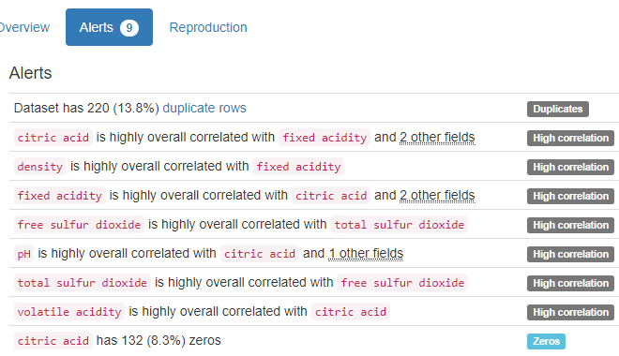

YData did not find anything that we search for.

# 222 - Bank Marketing - Business

Dataset analysed: 3 - bank-additional/bank-additional-full.csv from bank-additional.zip obtained at <https://archive.ics.uci.edu/ml/machine-learning-databases/00222/bank-additional.zip> (dataset_file_url column from Fiftydatasets.xlsx) Has header

age:

Age format: All 41188 values are numerical and valid in the range [0, 130].

Actual range of values: (17 : 98)

job:

Categorical format: Error(s) found:

DQI #4 (Ambiguous Data - Accuracy, Consistency):

330 Unacceptable value(s) at index(es): [(29, 'unknown'), (35, 'unknown'), (73, 'unknown'), (91, 'unknown'), (144, 'unknown'), (299, 'unknown'), (303, 'unknown'), (343, 'unknown'), (388, 'unknown'), (428, 'unknown'), ('...', '...'), (40058, 'unknown'), (40208, 'unknown'), (40240, 'unknown'), (40244, 'unknown'), (40289, 'unknown'), (40370, 'unknown'), (40428, 'unknown'), (40656, 'unknown'), (41005, 'unknown'), (41108, 'unknown')] (displaying only the first and last 10 items)

Categorical format with 12 unique values:

Category Frequency

admin. 10422

blue-collar 9254

technician 6743

services 3969

management 2924

retired 1720

entrepreneur 1456

self-employed 1421

housemaid 1060

unemployed 1014

student 875

unknown 330

marital:

Categorical format: Error(s) found:

DQI #4 (Ambiguous Data - Accuracy, Consistency):

80 Unacceptable value(s) at index(es): [(40, 'unknown'), (390, 'unknown'), (413, 'unknown'), (1493, 'unknown'), (1608, 'unknown'), (3167, 'unknown'), (3478, 'unknown'), (4196, 'unknown'), (4344, 'unknown'), (4454, 'unknown'), ('...', '...'), (36380, 'unknown'), (36434, 'unknown'), (37258, 'unknown'), (37387, 'unknown'), (37425, 'unknown'), (38550, 'unknown'), (38579, 'unknown'), (39322, 'unknown'), (39323, 'unknown'), (40857, 'unknown')] (displaying only the first and last 10 items)

Categorical format with 4 unique values:

Category Frequency

married 24928

single 11568

divorced 4612

unknown 80

education:

Categorical format: Error(s) found:

DQI #4 (Ambiguous Data - Accuracy, Consistency):

1731 Unacceptable value(s) at index(es): [(7, 'unknown'), (10, 'unknown'), (26, 'unknown'), (30, 'unknown'), (31, 'unknown'), (32, 'unknown'), (67, 'unknown'), (73, 'unknown'), (78, 'unknown'), (91, 'unknown'), ('...', '...'), (41108, 'unknown'), (41109, 'unknown'), (41110, 'unknown'), (41113, 'unknown'), (41114, 'unknown'), (41118, 'unknown'), (41120, 'unknown'), (41122, 'unknown'), (41135, 'unknown'), (41175, 'unknown')] (displaying only the first and last 10 items)

Categorical format with 8 unique values:

Category Frequency

university.degree 12168

high.school 9515

basic.9y 6045

professional.course 5243

basic.4y 4176

basic.6y 2292

unknown 1731

illiterate 18

default (categorical):

Categorical format: Error(s) found:

DQI #4 (Ambiguous Data - Accuracy, Consistency):

8597 Unacceptable value(s) at index(es): [(1, 'unknown'), (5, 'unknown'), (7, 'unknown'), (10, 'unknown'), (15, 'unknown'), (17, 'unknown'), (19, 'unknown'), (21, 'unknown'), (27, 'unknown'), (28, 'unknown'), ('...', '...'), (40673, 'unknown'), (40702, 'unknown'), (40714, 'unknown'), (40718, 'unknown'), (40727, 'unknown'), (40886, 'unknown'), (40940, 'unknown'), (40941, 'unknown'), (40969, 'unknown'), (40986, 'unknown')] (displaying only the first and last 10 items)

Categorical format with 3 unique values:

Category Frequency

no 32588

unknown 8597

yes 3

housing (categorical):   
 Categorical format: Error(s) found:

DQI #4 (Ambiguous Data - Accuracy, Consistency):

990 Unacceptable value(s) at index(es): [(29, 'unknown'), (81, 'unknown'), (261, 'unknown'), (385, 'unknown'), (401, 'unknown'), (470, 'unknown'), (485, 'unknown'), (494, 'unknown'), (495, 'unknown'), (501, 'unknown'), ('...', '...'), (40792, 'unknown'), (40832, 'unknown'), (40875, 'unknown'), (40895, 'unknown'), (40941, 'unknown'), (40990, 'unknown'), (41014, 'unknown'), (41015, 'unknown'), (41029, 'unknown'), (41115, 'unknown')] (displaying only the first and last 10 items)

Categorical format with 3 unique values:

Category Frequency

yes 21576

no 18622

unknown 990

loan (categorical):

Categorical format: Error(s) found:

DQI #4 (Ambiguous Data - Accuracy, Consistency):

990 Unacceptable value(s) at index(es): [(29, 'unknown'), (81, 'unknown'), (261, 'unknown'), (385, 'unknown'), (401, 'unknown'), (470, 'unknown'), (485, 'unknown'), (494, 'unknown'), (495, 'unknown'), (501, 'unknown'), ('...', '...'), (40792, 'unknown'), (40832, 'unknown'), (40875, 'unknown'), (40895, 'unknown'), (40941, 'unknown'), (40990, 'unknown'), (41014, 'unknown'), (41015, 'unknown'), (41029, 'unknown'), (41115, 'unknown')] (displaying only the first and last 10 items)

Categorical format with 3 unique values:

Category Frequency

no 33950

yes 6248

unknown 990

contact (categorical):

All 41188 values are correctly categorical.

Categorical format with 2 unique values:

Category Frequency

cellular 26144

telephone 15044

month:

Month format: All 41188 month values are valid.

Frequency Distribution:

Month Frequency

May 13769

July 7174

August 6178

June 5318

November 4101

April 2632

October 718

September 570

March 546

December 182

day_of_week (day of week):   
Weekday format: All 41188 weekday values are valid.

Weekday format:

Frequency Distribution:

Weekday Frequency

Thursday 8623

Monday 8514

Wednesday 8134

Tuesday 8090

Friday 7827

duration:

Numerical >=0 format: All 41188 values are correct (numeric and >=0) in the range (0:4918).

campaign:

Categorical format: All 41188 values are correctly categorical.

Categorical format with 42 unique value(s):

Category Frequency

1 17642

2 10570

3 5341

4 2651

5 1599

6 979

7 629

8 400

9 283

10 225

... ...

32 4

33 4

34 3

40 2

42 2

43 2

37 1

39 1

41 1

56 1

pdays (number):

Numerical format: All 41188 values are numerical in the range (0:999).

previous (number):

Numerical format: All 41188 values are numerical in the range (0:7).

poutcome (categorical):

All 41188 values are correctly categorical.

Categorical format with 3 unique values:

Category Frequency

nonexistent 35563

failure 4252

success 1373

emp.var.rate (rate):

Numerical format: All 41188 values are numerical in the range (-3.4:1.4).

cons.price.idx (price):

Numerical format: All 41188 values are numerical in the range (92.201:94.767).

cons.conf.idx (indicator):

Numerical format: All 41188 values are numerical in the range (-50.8:-26.9).

euribor3m (indicator):

Numerical format: All 41188 values are numerical in the range (0.634:5.045)

nr.employed (indicator):

Numerical format: All 41188 values are numerical in the range (4963.6:5228.1).

y - has the client subscribed a term deposit? (binary):

Binary format: All 41188 binary values are valid.

Frequency Distribution:

Value Frequency

no 36548

yes 4640

Last run on: 2024-01-25 00:02:33

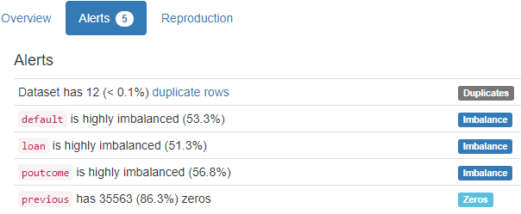

YData did not find anything that we care

# 352*** Desc+Cust ID - Online Retail - Business

Dataset analysed: Online Retail.xlsx from <https://archive.ics.uci.edu/ml/machine-learning-databases/00352/Online%20Retail.xlsx> (dataset_file_url column from Fiftydatasets.xlsx) has_header

InvoiceNo StockCode Description Quantity I am running a few minutes late; my previous meeting is running over.

0 536365 85123A WHITE HANGING HEART T-LIGHT HOLDER 6

1 536365 71053 WHITE METAL LANTERN 6

2 536365 84406B CREAM CUPID HEARTS COAT HANGER 8

3 536365 84029G KNITTED UNION FLAG HOT WATER BOTTLE 6

4 536365 84029E RED WOOLLY HOTTIE WHITE HEART. 6

InvoiceDate UnitPrice CustomerID Country

0 2010-12-01 08:26:00 2.55 17850.0 United Kingdom

1 2010-12-01 08:26:00 3.39 17850.0 United Kingdom

2 2010-12-01 08:26:00 2.75 17850.0 United Kingdom

3 2010-12-01 08:26:00 3.39 17850.0 United Kingdom

4 2010-12-01 08:26:00 3.39 17850.0 United Kingdom

Alerts in Ydata-Profiling

It could not analyse the three last columns above, which are analysed below, with the Data Quality Issues found:

InvoiceNo (number):

Numerical format: Error(s) found:

DQI #17 (Wrong Data Type - Consistency):

9291 Non-numeric value(s) at index(es): [(141, 'C536379'), (154, 'C536383'), (235, 'C536391'), (236, 'C536391'), (237, 'C536391'), (238, 'C536391'), (239, 'C536391'), (240, 'C536391'), (241, 'C536391'), (939, 'C536506'), ('...', '...'), (540141, 'C581468'), (540142, 'C581468'), (540176, 'C581470'), (540422, 'C581484'), (540448, 'C581490'), (540449, 'C581490'), (541541, 'C581499'), (541715, 'C581568'), (541716, 'C581569'), (541717, 'C581569')] (displaying only the first and last 10 items)

Range of values: (536365.0:581587.0).

StockCode (code):

Categorical format: Error(s) found:

DQI #10 (Structural Conflicts - Consistency, Uniqueness):

Data seems not categorical or has too many categories (> 100).

Categorical format with 4070 unique values:

Category Frequency

85123A 2313

22423 2203

85099B 2159

47566 1727

20725 1639

84879 1502

22720 1477

22197 1476

21212 1385

20727 1350

... ...

DCGS0055 1

DCGS0057 1

DCGS0066P 1

DCGS0067 1

DCGS0068 1

DCGS0071 1

DCGS0072 1

DCGS0073 1

DCGS0074 1

m 1

Description (nominal):

Categorical format: Error(s) found:

1501 Blank/Empty/Null/Missing value(s) at index(es):

1454 NULL values: [(622, 'NULL'), (1970, 'NULL'), (1971, 'NULL'), (1972, 'NULL'), (1987, 'NULL'), (1988, 'NULL'), (2024, 'NULL'), (2025, 'NULL'), (2026, 'NULL'), (2406, 'NULL'), ('...', '...'), (524473, 'NULL'), (524475, 'NULL'), (529667, 'NULL'), (533711, 'NULL'), (533712, 'NULL'), (535322, 'NULL'), (535326, 'NULL'), (535332, 'NULL'), (536981, 'NULL'), (538554, 'NULL')]

47 Non-NULL values: [(7313, '?'), (21518, '?'), (38261, '?'), (43662, '?'), (50806, '?'), (51673, '?'), (68920, '?'), (78235, '?'), (94765, '?'), (97643, '?'), ('...', '...'), (352827, '?'), (360738, '?'), (381307, '?'), (384187, '?'), (384222, '?'), (392675, '?'), (395168, '?'), (397026, '?'), (397225, '?'), (421093, '?')]

DQI #10 (Structural Conflicts - Consistency, Uniqueness):

Data seems not categorical or has too many categories (> 100).

Categorical format with 4224 unique values:

Category Frequency

WHITE HANGING HEART T-LIGHT HOLDER 2369

REGENCY CAKESTAND 3 TIER 2200

JUMBO BAG RED RETROSPOT 2159

PARTY BUNTING 1727

LUNCH BAG RED RETROSPOT 1638

ASSORTED COLOUR BIRD ORNAMENT 1501

SET OF 3 CAKE TINS PANTRY DESIGN 1473

NULL 1454

PACK OF 72 RETROSPOT CAKE CASES 1385

LUNCH BAG BLACK SKULL. 1350

... ...

wrong code? 1

wrongly coded 23343 1

wrongly coded-23343 1

wrongly marked 1

wrongly marked 23343 1

wrongly marked carton 22804 1

wrongly marked. 23343 in box 1

wrongly sold (22719) barcode 1

wrongly sold as sets 1

wrongly sold sets 1

Quantity:

Numerical format: All 541909 values are numerical in the range (-80995:80995).

InvoiceDate (date and time):

Datetime format: All 541909 datetime values are valid in the YYYYMMDD format in the range 2010/12/01 08:26 to 2011/12/09 12:50.

UnitPrice (price):

Numerical format: All 541909 values are numerical in the range (-11062.06:38970.0).

CustomerID (id):

ID column format: Error(s) found:

DQI #1 (Missing Data - Completeness):

135080 Blank/Empty/Null/Missing value(s) at index(es): [(622, ''), (1443, ''), (1444, ''), (1445, ''), (1446, ''), (1447, ''), (1448, ''), (1449, ''), (1450, ''), (1451, ''), ('...', '...'), (541531, ''), (541532, ''), (541533, ''), (541534, ''), (541535, ''), (541536, ''), (541537, ''), (541538, ''), (541539, ''), (541540, '')] (displaying only the first and last 10 items)

135080 Blank/Empty/Null/Missing value(s) at index(es): All NULL values:

[(622, 'NULL'), (1443, 'NULL'), (1444, 'NULL'), (1445, 'NULL'), (1446, 'NULL'), (1447, 'NULL'), (1448, 'NULL'), (1449, 'NULL'), (1450, 'NULL'), (1451, 'NULL'), ('...', '...'), (541531, 'NULL'), (541532, 'NULL'), (541533, 'NULL'), (541534, 'NULL'), (541535, 'NULL'), (541536, 'NULL'), (541537, 'NULL'), (541538, 'NULL'), (541539, 'NULL'), (541540, 'NULL')]

DQI #9 (Duplicates - Uniqueness):

**541830** Duplicate value(s) at index(es): [[0, 17850], [1, 17850], [2, 17850], [3, 17850], [4, 17850], [5, 17850], [6, 17850], [7, 17850], [8, 17850], [9, 13047], ('...', '...'), [541899, 12680], [541900, 12680], [541901, 12680], [541902, 12680], [541903, 12680], [541904, 12680], [541905, 12680], [541906, 12680], [541907, 12680], [541908, 12680]] (displaying only the first and last 10 items)

DQI #19 (Uniqueness Violation - Uniqueness):

**537536** Uniqueness violation(s) at index(es): [(1, 17850), (2, 17850), (3, 17850), (4, 17850), (5, 17850), (6, 17850), (7, 17850), (8, 17850), (10, 13047), (11, 13047), ('...', '...'), (541899, 12680), (541900, 12680), (541901, 12680), (541902, 12680), (541903, 12680), (541904, 12680), (541905, 12680), (541906, 12680), (541907, 12680), (541908, 12680)] (displaying only the first and last 10 items)

DQI #9 (Duplicates - Uniqueness):

**406750** Duplicate value(s) at index(es): [[0.0, 17850.0], [1.0, 17850.0], [2.0, 17850.0], [3.0, 17850.0], [4.0, 17850.0], [5.0, 17850.0], [6.0, 17850.0], [7.0, 17850.0], [8.0, 17850.0], [9.0, 13047.0], ('...', '...'), [541899.0, 12680.0], [541900.0, 12680.0], [541901.0, 12680.0], [541902.0, 12680.0], [541903.0, 12680.0], [541904.0, 12680.0], [541905.0, 12680.0], [541906.0, 12680.0], [541907.0, 12680.0], [541908.0, 12680.0]] (displaying only the first and last 10 items)

DQI #19 (Uniqueness Violation - Uniqueness):

**402457** Uniqueness violation(s) at index(es): [(1, 17850.0), (2, 17850.0), (3, 17850.0), (4, 17850.0), (5, 17850.0), (6, 17850.0), (7, 17850.0), (8, 17850.0), (10, 13047.0), (11, 13047.0), ('...', '...'), (541899, 12680.0), (541900, 12680.0), (541901, 12680.0), (541902, 12680.0), (541903, 12680.0), (541904, 12680.0), (541905, 12680.0), (541906, 12680.0), (541907, 12680.0), (541908, 12680.0)] (displaying only the first and last 10 items)

Alphanumeric range of values: (12346.0 : 18287.0)



This code also managed to find the 135080 Missing values, but it also found Duplicates and Uniqueness Violation errors in almost all values of this variable, while Ydata-Profiling found Duplicate rows in only 17,7% of the data:



Country:

Country format: All 541909 country values are valid.

Frequency Distribution (showing top and bottom 10 of 38 categories):

Country Frequency

United Kingdom 495478

Germany 9495

France 8557

EIRE 8196

Spain 2533

Netherlands 2371

Belgium 2069

Switzerland 2002

Portugal 1519

Australia 1259

... ...

Malta 127

United Arab Emirates 68

European Community 61

RSA 58

Lebanon 45

Lithuania 35

Brazil 32

Czech Republic 30

Bahrain 19

Saudi Arabia 10

# 602 - Dry Bean Dataset - Computer

Dataset analysed: DryBeanDataset/Dry_Bean_Dataset.xlsx from <https://archive.ics.uci.edu/ml/machine-learning-databases/00602/DryBeanDataset.zip> (dataset_file_url column from Fiftydatasets.xlsx) has_header

Area:

Numerical >=0 format: All 13611 values are numerical and greater or equal to 0 in the range (20420:254616).

Perimeter:

Numerical >=0 format: All 13611 values are numerical and greater or equal to 0 in the range (524.736:1985.37).

Major axis length (length):

Numerical >=0 format: All 13611 values are numerical and greater or equal to 0 in the range (183.6011650038393:738.8601534818813).

Minor axis length (length):

Numerical >=0 format: All 13611 values are numerical and greater or equal to 0 in the range (122.51265345074418:460.1984968278401).

Aspect ratio (ratio):

Numerical format: All 13611 values are numerical in the range (1.0248675960667681:2.430306446836626).

Eccentricity:

Numerical format: All 13611 values are numerical in the range (0.21895126335356507:0.9114229684680053).

Convex area (area):

Numerical >=0 format: All 13611 values are numerical and greater or equal to 0 in the range (20684:263261).

Equivalent diameter (diameter):

Numerical >=0 format: All 13611 values are numerical and greater or equal to 0 in the range (161.24376423134018:569.3743583287609).

Extent (area):

Numerical >=0 format: All 13611 values are numerical and greater or equal to 0 in the range (0.55531471681117:0.8661946405648266).

Solidity (ratio):

Numerical format: All 13611 values are numerical in the range (0.9192461570857022:0.9946774999456888).

Roundness (calculated):

Numerical format: All 13611 values are numerical in the range (0.4896182562412148:0.9906853996160323).

Compactness:

Numerical >=0 format: All 13611 values are numerical and greater or equal to 0 in the range (0.6405767589768725:0.9873029693778109).

tdewpoint1 (factor):

Numerical format: All 13611 values are numerical in the range (0.0027780126683855494:0.010451169324378654).

ShapeFactor2 (factor):

Numerical format: All 13611 values are numerical in the range (0.0005641690180332927:0.0036649719644516834).

ShapeFactor3 (factor):

Numerical format: All 13611 values are numerical in the range (0.41033858414131424:0.9747671533422431).

ShapeFactor4 (factor):

Numerical format: All 13611 values are numerical in the range (0.9476874027098624:0.9997325300471389).

Class:

All 13611 values are correctly categorical.

Categorical format with 7 unique values:

Category Frequency

DERMASON 3546

SIRA 2636

SEKER 2027

HOROZ 1928

CALI 1630

BARBUNYA 1322

BOMBAY 522

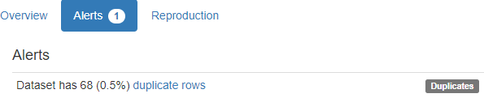

YData did not find anything that we care.

# 545 - Rice (Cammeo and Osmancik) - Computer

dataset_file_url was empty at Fiftydatasets.xlsx

Dataset analysed: @DATA part extracted from Rice_Cammeo_Osmancik.arff that was obtained at rice+cammeo+and+osmancik.zip from <https://archive.ics.uci.edu/dataset/545/rice+cammeo+and+osmancik> in the new data folders from UCI

Area:

Numerical >=0 format: All 3810 values are correct (numeric and >=0).

Perimeter:

Numerical >=0 format: All 3810 values are correct (numeric and >=0).

Major Axis Length (length):

Numerical >=0 format: All 3810 values are correct (numeric and >=0).

Minor Axis Length (length):

Numerical >=0 format: All 3810 values are correct (numeric and >=0).

Eccentricity:

Numerical format: All 3810 values are numerical.

Convex Area (area):

Numerical >=0 format: All 3810 values are correct (numeric and >=0).

Extent (area):

Numerical format: All 3810 values are numerical.

Class:

All 3810 values are correctly categorical.

Categorical format with 2 unique values:

Category Frequency

Osmancik 2180

Cammeo 1630

There were no Alerts provided from YDATA

# 360 - Air quality - Computer

Dataset analysed: 2 - AirQualityUCI.xlsx from <https://archive.ics.uci.edu/ml/machine-learning-databases/00360/AirQualityUCI.zip> (dataset_file_url column from Fiftydatasets.xlsx) has_header

Date:

Date format: All 9357 date values are valid in the YYYYMMDD format in the range 2004/03/10 to 2005/04/04.

Time:

Time format: All 9357 time values are valid in the range 00:00:00 to 23:00:00



True hourly averaged concentration CO in mg (concentration):

Numerical >=0 format: Error(s) found:

DQI #15 (Domain Violation - Accuracy):

1683 Negative value(s) at index(es): [(10, -200.0), (34, -200.0), (39, -200.0), (58, -200.0), (82, -200.0), (106, -200.0), (130, -200.0), (154, -200.0), (178, -200.0), (202, -200.0), ('...', '...'), (8821, -200.0), (8822, -200.0), (8842, -200.0), (8914, -200.0), (8986, -200.0), (9058, -200.0), (9130, -200.0), (9202, -200.0), (9274, -200.0), (9346, -200.0)] (displaying only the first and last 10 items)

Range of values: (-200.0:11.9).

PT08.S1 (averaged):

Numerical format: All 9357 values are numerical in the range (-200.0:2039.75)

True hourly averaged overall Non Metanic HydroCarbons concentration in microg (concentration):

Numerical >=0 format: Error(s) found:

DQI #15 (Domain Violation - Accuracy):

8443 Negative value(s) at index(es): [(39, -200), (184, -200), (185, -200), (186, -200), (187, -200), (188, -200), (189, -200), (190, -200), (191, -200), (192, -200), ('...', '...'), (9347, -200), (9348, -200), (9349, -200), (9350, -200), (9351, -200), (9352, -200), (9353, -200), (9354, -200), (9355, -200), (9356, -200)] (displaying only the first and last 10 items)

Range of values: (-200:1189).

True hourly averaged Benzene concentration in microg (concentration):

Numerical >=0 format: Error(s) found:

DQI #15 (Domain Violation - Accuracy):

366 Negative value(s) at index(es): [(524, -200.0), (525, -200.0), (526, -200.0), (701, -200.0), (702, -200.0), (703, -200.0), (704, -200.0), (705, -200.0), (706, -200.0), (707, -200.0), ('...', '...'), (8106, -200.0), (8107, -200.0), (8108, -200.0), (8109, -200.0), (8110, -200.0), (8111, -200.0), (8112, -200.0), (8113, -200.0), (8114, -200.0), (8777, -200.0)] (displaying only the first and last 10 items)

Range of values: (-200.0:63.74147644829163).

PT08.S2 (averaged):

Numerical format: All 9357 values are numerical in the range (-200.0:2214.0)

True hourly averaged NOx concentration in ppb (concentration):

Numerical >=0 format: Error(s) found:

DQI #15 (Domain Violation - Accuracy):

1639 Negative value(s) at index(es): [(9, -200.0), (33, -200.0), (39, -200.0), (57, -200.0), (81, -200.0), (105, -200.0), (129, -200.0), (153, -200.0), (177, -200.0), (201, -200.0), ('...', '...'), (8553, -200.0), (8577, -200.0), (8601, -200.0), (8625, -200.0), (8649, -200.0), (8673, -200.0), (8697, -200.0), (8721, -200.0), (8745, -200.0), (8755, -200.0)] (displaying only the first and last 10 items)

Range of values: (-200.0:1479.0).

PT08.S3 (averaged):

Numerical format: All 9357 values are numerical in the range (-200.0:2682.75)

True hourly averaged NO2 concentration in microg (concentration):

Numerical >=0 format: Error(s) found:

DQI #15 (Domain Violation - Accuracy):

1642 Negative value(s) at index(es): [(9, -200.0), (33, -200.0), (39, -200.0), (57, -200.0), (81, -200.0), (105, -200.0), (129, -200.0), (153, -200.0), (177, -200.0), (201, -200.0), ('...', '...'), (8553, -200.0), (8577, -200.0), (8601, -200.0), (8625, -200.0), (8649, -200.0), (8673, -200.0), (8697, -200.0), (8721, -200.0), (8745, -200.0), (8755, -200.0)] (displaying only the first and last 10 items)

Range of values: (-200.0:339.7).

PT08.S4 (averaged):

Numerical format: All 9357 values are numerical in the range (-200.0:2775.0)

PT08.S5 (averaged):

Numerical format: All 9357 values are numerical in the range (-200.0:2522.75)

Temperature in °C (temperature):

Numerical format: All 9357 values are numerical in the range (-200.0:44.60000038147)

Relative Humidity (humidity):

Numerical >=0 format: Error(s) found:

DQI #15 (Domain Violation - Accuracy):

**366** Negative value(s) at index(es): [(**524, -200.0), (525, -200.0), (526, -200.0**), (701, -200.0), (702, -200.0), (703, -200.0), (704, -200.0), (705, -200.0), (706, -200.0), (707, -200.0), ('...', '...'), (8106, -200.0), (8107, -200.0), (8108, -200.0), (8109, -200.0), (8110, -200.0), (8111, -200.0), (8112, -200.0), (8113, -200.0), (8114, -200.0), (8777, -200.0)] (displaying only the first and last 10 items)

Range of values: (-200.0:88.72500038147)

AH Absolute Humidity (humidity):

Numerical >=0 format: Error(s) found:

DQI #15 (Domain Violation - Accuracy):

**366** Negative value(s) at index(es): [(**524, -200.0), (525, -200.0), (526, -200.0**), (701, -200.0), (702, -200.0), (703, -200.0), (704, -200.0), (705, -200.0), (706, -200.0), (707, -200.0), ('...', '...'), (8106, -200.0), (8107, -200.0), (8108, -200.0), (8109, -200.0), (8110, -200.0), (8111, -200.0), (8112, -200.0), (8113, -200.0), (8114, -200.0), (8777, -200.0)] (displaying only the first and last 10 items)

Range of values: (-200.0:2.2310357155831864)

Last run on: 2024-01-23 19:24:17

Ydata Profiling did find negative values in the two last columns, but it did not give any emphasis on it.

**Below are lines 524 to 526. Observe that many other values have the content -200, besides the two last Humidity values:**

|  |  |  |  |  |  |  |  |  |  |  |  |  |  |  |
| --- | --- | --- | --- | --- | --- | --- | --- | --- | --- | --- | --- | --- | --- | --- |
| Date | Time | CO(GT) | **PT08.S1(CO)** | NMHC(GT) | **C6H6(GT)** | PT08.S2(NMHC) | NOx(GT) | PT08.S3(NOx) | NO2(GT) | **PT08.S4(NO2)** | **PT08.S5(O3)** | **T** | **RH** | **AH** |
| 1/04/2004 | 14:00:00 | 1.7 | **-200** | 222 | **-200.0** | -200 | 99 | -200 | 72 | **-200** | **-200** | **-200** | **-200** | **-200** |
| 1/04/2004 | 15:00:00 | 1.9 | **-200** | 197 | **-200.0** | -200 | 108 | -200 | 81 | **-200** | **-200** | **-200** | **-200** | **-200** |
| 1/04/2004 | 16:00:00 | 2.3 | **-200** | 319 | **-200.0** | -200 | 131 | -200 | 93 | **-200** | **-200** | **-200** | **-200** | **-200** |

# 242 - Energy efficiency - Computer

Dataset analysed: ENB2012_data.xlsx from <https://archive.ics.uci.edu/ml/machine-learning-databases/00242/ENB2012_data.xlsx> (dataset_file_url column from Fiftydatasets.xlsx) has_header

X1 (compactness):

Numerical >=0 format: All 768 values are numerical and greater or equal to 0 in the range (0.62:0.98)

X2 (area):

Numerical >=0 format: All 768 values are numerical and greater or equal to 0 in the range (514.5:808.5)

X3 (area):

Numerical >=0 format: All 768 values are numerical and greater or equal to 0 in the range (245.0:416.5)

X4 (area):

Numerical >=0 format: All 768 values are numerical and greater or equal to 0 in the range (110.25:220.5)

X5 (height):

Numerical >=0 format: All 768 values are numerical and greater or equal to 0 in the range (3.5:7.0)

X6 (orientation):

Numerical format: All 768 values are numerical in the range (2:5)

X7 (area):

Numerical >=0 format: All 768 values are numerical and greater or equal to 0 in the range (0.0:0.4)

X8 (area):

Numerical >=0 format: All 768 values are numerical and greater or equal to 0 in the range (0:5)

y1 (load):

Numerical format: All 768 values are numerical in the range (6.01:43.1)

y2 (load):

Numerical format: All 768 values are numerical in the range (10.9:48.03)

Last run on: 2024-01-23 19:19:31

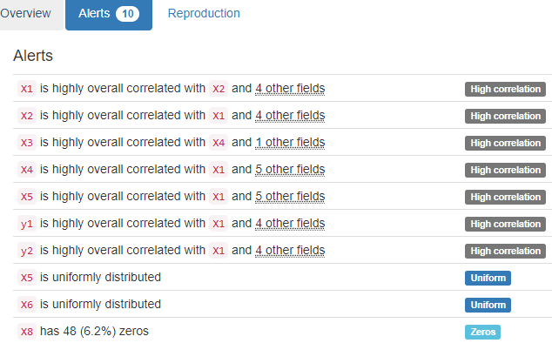

YData did not find anything that we care.

# 267 - banknote authentication – Computer

Dataset analysed: data_banknote_authentication.txt from <https://archive.ics.uci.edu/ml/machine-learning-databases/00267/data_banknote_authentication.txt> (dataset_file_url column from Fiftydatasets.xlsx)

variance of Wavelet Transformed image (variance):

Numerical format: All 1372 values are numerical in the range (-7.0421:6.8248).

skewness of Wavelet Transformed image (skewness):

Numerical format: All 1372 values are numerical in the range (-13.7731:12.9516).

curtosis of Wavelet Transformed image (curtosis):

Numerical format: All 1372 values are numerical in the range (-5.2861:17.9274).

entropy of image (entropy):

Numerical format: All 1372 values are numerical in the range (-8.5482:2.4495).

class (integer):

Numerical format: All 1372 values are numerical in the range (0:1).

Last run on: 2024-01-28 15:37:37

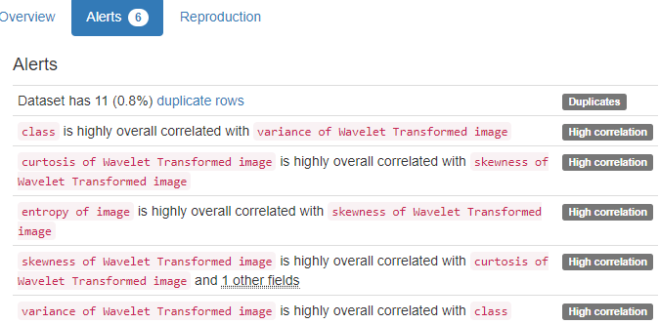

YData did not find anything that we care.

# 29 - Computer Hardware – Computer

Dataset analysed: machine.data from <https://archive.ics.uci.edu/ml/machine-learning-databases/cpu-performance/machine.data> (dataset_file_url column from Fiftydatasets.xlsx) It does not have header

vendor name (name):

Name format: All 209 vendor name values are valid.

Frequency Distribution:

vendor name Frequency

ibm 32

nas 19

honeywell 13

nor 13

sperry 13

siemens 12

amdahl 9

cdc 9

burroughs 8

dg 7

... ...

nixdorf 3

perkin-elmer 3

apollo 2

basf 2

bti 2

wang 2

adviser 1

four-phase 1

microdata 1

sratus 1

Range of Values: (adviser to wang)

Model Name:

Model Name format: All 209 Model Name values are valid.

Frequency Distribution:

Model Name Frequency

100 1

1100/61-h1 1

1100/81 1

1100/82 1

1100/83 1

1100/84 1

1100/93 1

1100/94 1

1636-1 1

1636-10 1

... ...

v8635 1

v8650 1

v8655 1

v8665 1

v8670 1

vax:11/730 1

vax:11/750 1

vax:11/780 1

vs-100 1

vs-90 1

Range of Values: (100 to vs-90)

MYCT (integer):

Numerical format: All 209 values are numerical in the range (17:1500).

MMIN (minimum):

Numerical format: All 209 values are numerical in the range (64:32000).

MMAX (maximum):

Numerical format: All 209 values are numerical in the range (64:64000).

CACH (integer):

Numerical format: All 209 values are numerical in the range (0:256).

CHMIN (minimum):

Numerical format: All 209 values are numerical in the range (0:52).

CHMAX (maximum):

Numerical format: All 209 values are numerical in the range (0:176).

PRP (integer):

Numerical format: All 209 values are numerical in the range (6:1150).

ERP (integer):

Numerical format: All 209 values are numerical in the range (15:1238).

Last run on: 2024-01-28 19:22:45

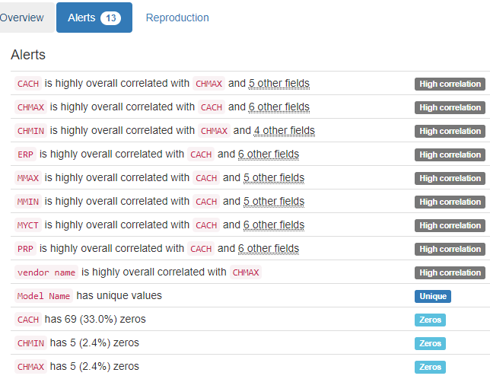

YData found that Model Name has unique values. We have not checked that.

# 294 - Combined Cycle Power Plant - Computer

Dataset analysed: CCPP/Folds5x2_pp.xlsx from <https://archive.ics.uci.edu/ml/machine-learning-databases/00294/CCPP.zip> (dataset_file_url column from Fiftydatasets.xlsx)

This was the original description of the Attributes Information:

"Features consist of hourly average ambient variables

1. Temperature (T) in the range 1.81°C and 37.11°C,

2. Ambient Pressure (AP) in the range 992.89-1033.30 milibar,

3. Relative Humidity (RH) in the range 25.56% to 100.16%

4. Exhaust Vacuum (V) in teh range 25.36-81.56 cm Hg

5. Net hourly electrical energy output (EP) 420.26-495.76 MW

The averages are taken from various sensors located around the plant that record the ambient variables every second. The variables are given without normalization."

And these were the first 5 items:

AT V AP RH PE

0 14.96 41.76 1024.07 73.17 463.26

1 25.18 62.96 1020.04 59.08 444.37

2 5.11 39.40 1012.16 92.14 488.56

3 20.86 57.32 1010.24 76.64 446.48

4 10.82 37.50 1009.23 96.62 473.90

The order of the dataset are not the ones in the description. Only the first and last are correct. The others are changed. The second column in the data is V, which is the fourth column in the description. The third column in the data is AP, which is the second column in the description, and the fourth column in the dataset is RH, which is the third in the description.

After correcting the order of the columns, the result was:

Temperature:

Numerical format: All 9568 values are numerical in the range (1.81:37.11).

Exhaust Vacuum (vacuum):

Numerical format: All 9568 values are numerical in the range (25.36:81.56).

Ambient Pressure (pressure):

Numerical format: All 9568 values are numerical in the range (992.89:1033.3).

Relative Humidity (humidity):

Numerical >=0 format: All 9568 values are numerical and greater or equal to 0 in the range (25.56:100.16).

Net hourly electrical energy output (energy):

Numerical >=0 format: All 9568 values are numerical and greater or equal to 0 in the range (420.26:495.76).

Last run on: 2024-01-29 12:23:35

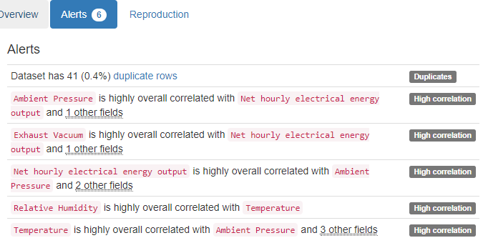

YData did not find anything that we care.

# 229 - Skin Segmentation – Computer

Dataset analysed: Skin_NonSkin.txt from <https://archive.ics.uci.edu/ml/machine-learning-databases/00229/Skin_NonSkin.txt> (dataset_file_url column from Fiftydatasets.xlsx)

x1 (b):

Numerical format: All 245057 values are numerical in the range (0:255).

x2 (g):

Numerical format: All 245057 values are numerical in the range (0:255).

x3 (r):

Numerical format: All 245057 values are numerical in the range (0:255).

y (class):

All 245057 values are correctly categorical.

Categorical format with 2 unique values:

Category Frequency

2 194198

1 50859

Last run on: 2024-01-29 13:50:39

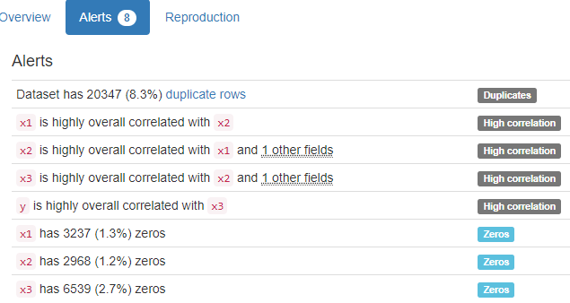

YData did not find anything that we care.

# 246 - 3D Road Network (North Jutland, Denmark) – Computer

Dataset analysed: 3D_spatial_network.txt from <https://archive.ics.uci.edu/ml/machine-learning-databases/00246/3D_spatial_network.txt> (dataset_file_url column from Fiftydatasets.xlsx)

OSM_ID (id):

ID column format: Error(s) found:

DQI #9 (Duplicates - Uniqueness):

421305 Duplicate value(s) at index(es): [[0, 144552912], [1, 144552912], [2, 144552912], [3, 144552912], [4, 144552912], [5, 144552912], [6, 144552912], [7, 144552912], [8, 144552912], [9, 144552912], ('...', '...'), [434864, 93323205], [434865, 93323205], [434866, 93323205], [434867, 93323205], [434868, 93323205], [434869, 93323205], [434870, 93323205], [434871, 93323205], [434872, 93323209], [434873, 93323209]] (displaying only the first and last 10 items)

DQI #19 (Uniqueness Violation - Uniqueness):

377545 Uniqueness violation(s) at index(es): [(1, 144552912), (2, 144552912), (3, 144552912), (4, 144552912), (5, 144552912), (6, 144552912), (7, 144552912), (8, 144552912), (9, 144552912), (10, 144552912), ('...', '...'), (434863, 93323205), (434864, 93323205), (434865, 93323205), (434866, 93323205), (434867, 93323205), (434868, 93323205), (434869, 93323205), (434870, 93323205), (434871, 93323205), (434873, 93323209)] (displaying only the first and last 10 items)

Numeric range of values: (4482444 : 157742416)

YDATA found nothing!

LONGITUDE:

Longitude format: All 434874 values are numerical and valid in the range [-180, 180].

Actual range of values: (8.1461259 : 11.1993265)

LATITUDE:

Latitude format: All 434874 values are numerical and valid in the range [-90, 90].

Actual range of values: (56.5824856 : 57.750511)

ALTITUDE:

Numerical format: All 434874 values are numerical in the range (-8.60818370517905:134.441946906076).

Last run on: 2024-01-29 14:03:03

# 374 - Appliances energy prediction – Computer

Dataset analysed: energydata_complete.csv from <https://archive.ics.uci.edu/ml/machine-learning-databases/00374/energydata_complete.csv> (dataset_file_url column from Fiftydatasets.xlsx) has header

date time year-month-day hour (date time):

Datetime format: All 19735 datetime values are valid in the YYYYMMDD format in the range 2016/01/11 17:00 to 2016/05/27 18:00.

Appliances, energy use in Wh (energy):

Numerical >=0 format: All 19735 values are numerical and greater or equal to 0 in the range (10:1080).

lights, energy use of light fixtures in the house in Wh (energy):

Numerical >=0 format: All 19735 values are numerical and greater or equal to 0 in the range (0:70).

T1, Temperature in kitchen area, in Celsius (temperature):

Numerical format: All 19735 values are numerical in the range (16.79:26.26).

RH_1, Humidity in kitchen area, in % (humidity):

Numerical >=0 format: All 19735 values are numerical and greater or equal to 0 in the range (27.0233333333333:63.36).

T2, Temperature in living room area, in Celsius (temperature):

Numerical format: All 19735 values are numerical in the range (16.1:29.8566666666667).

RH_2, Humidity in living room area, in % (humidity):

Numerical >=0 format: All 19735 values are numerical and greater or equal to 0 in the range (20.463333333333296:56.0266666666667).

T3, Temperature in laundry room area (temperature):

Numerical format: All 19735 values are numerical in the range (17.2:29.236).

RH_3, Humidity in laundry room area, in % (humidity):

Numerical >=0 format: All 19735 values are numerical and greater or equal to 0 in the range (28.7666666666667:50.1633333333333).

T4, Temperature in office room, in Celsius (temperature):

Numerical format: All 19735 values are numerical in the range (15.1:26.2).

RH_4, Humidity in office room, in % (humidity):

Numerical >=0 format: All 19735 values are numerical and greater or equal to 0 in the range (27.66:51.09).

T5, Temperature in bathroom, in Celsius (temperature):

Numerical format: All 19735 values are numerical in the range (15.33:25.795).

RH_5, Humidity in bathroom, in % (humidity):

Numerical >=0 format: All 19735 values are numerical and greater or equal to 0 in the range (29.815:96.3216666666667).

T6, Temperature outside the building (temperature):

Numerical format: All 19735 values are numerical in the range (-6.065:28.29).

RH_6, Humidity outside the building (humidity):

Numerical >=0 format: All 19735 values are numerical and greater or equal to 0 in the range (1.0:99.9).

T7, Temperature in ironing room , in Celsius (temperature):

Numerical format: All 19735 values are numerical in the range (15.39:26.0).

RH_7, Humidity in ironing room, in % (humidity):

Numerical >=0 format: All 19735 values are numerical and greater or equal to 0 in the range (23.2:51.4).

T8, Temperature in teenager room 2, in Celsius (temperature):

Numerical format: All 19735 values are numerical in the range (16.3066666666667:27.23).

RH_8, Humidity in teenager room 2, in % (humidity):

Numerical >=0 format: All 19735 values are numerical and greater or equal to 0 in the range (29.6:58.78).

T9, Temperature in parents room, in Celsius (temperature):

Numerical format: All 19735 values are numerical in the range (14.89:24.5).

RH_9, Humidity in parents room, in % (humidity):

Numerical >=0 format: All 19735 values are numerical and greater or equal to 0 in the range (29.1666666666667:53.3266666666667).

To, Temperature outside (temperature):

Numerical format: All 19735 values are numerical in the range (-5.0:26.1).

Pressure:

Numerical format: All 19735 values are numerical in the range (729.2999999999998:772.2999999999998).

RH_out, Humidity outside (humidity):

Numerical >=0 format: All 19735 values are numerical and greater or equal to 0 in the range (24.0:100.0).

Wind speed (speed):

Numerical format: All 19735 values are numerical in the range (0.0:14.0).

Visibility:

Numerical format: All 19735 values are numerical in the range (1.0:66.0).

Tdewpoint (dewpoint):

Numerical format: All 19735 values are numerical in the range (-6.6:15.5).

rv1, Random variable 1, nondimensional (random):

Numerical format: All 19735 values are numerical in the range (0.0053216819651424:49.9965296825394).

rv2, Random variable 2, nondimensional (random):

Numerical format: All 19735 values are numerical in the range (0.0053216819651424:49.9965296825394).

Last run on: 2024-01-29 14:41:33

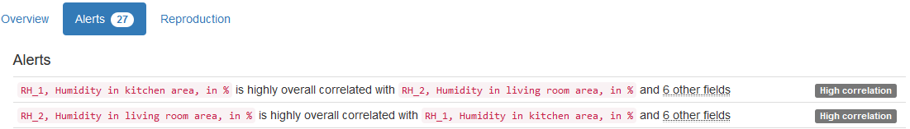

…

YData found 3 columns that are Unique. We have not checked that.

# 248 - Buzz in social media - Computer

Dataset analysed: 1 ./regression/TomsHardware/TomsHardware.data from <https://archive.ics.uci.edu/ml/machine-learning-databases/00248/regression.tar.gz> (dataset_file_url column from Fiftydatasets.xlsx) does not have header

NCD_0 (number):

Numerical format: All 28179 values are numerical in the range (0:182).

NCD_1 (number):

Numerical format: All 28179 values are numerical in the range (0:118).

NCD_2 (number):

Numerical format: All 28179 values are numerical in the range (0:118).

NCD_3 (number):

Numerical format: All 28179 values are numerical in the range (0:118).

NCD_4 (number):

Numerical format: All 28179 values are numerical in the range (0:118).

NCD_5 (number):

Numerical format: All 28179 values are numerical in the range (0:118).

NCD_6 (number):

Numerical format: All 28179 values are numerical in the range (0:154).

NCD_7 (number):

Numerical format: All 28179 values are numerical in the range (0:88).

BL_0 (burstiness):

Numerical format: All 28179 values are numerical in the range (0.0:1.0).

BL_1 (burstiness):

Numerical format: All 28179 values are numerical in the range (0.0:1.0).

BL_2 (burstiness):

Numerical format: All 28179 values are numerical in the range (0.0:1.0).

BL_3 (burstiness):

Numerical format: All 28179 values are numerical in the range (0.0:1.0).

BL_4 (burstiness):

Numerical format: All 28179 values are numerical in the range (0.0:1.0).

BL_5 (burstiness):

Numerical format: All 28179 values are numerical in the range (0.0:1.0).

BL_6 (burstiness):

Numerical format: All 28179 values are numerical in the range (0.0:1.0).

BL_7 (burstiness):

Numerical format: All 28179 values are numerical in the range (0.0:1.0).

NAD_0 (length):

Numerical >=0 format: All 28179 values are numerical and greater or equal to 0 in the range (0:217).

NAD_1 (length):

Numerical >=0 format: All 28179 values are numerical and greater or equal to 0 in the range (0:210).

NAD_2 (length):

Numerical >=0 format: All 28179 values are numerical and greater or equal to 0 in the range (0:210).

NAD_3 (length):

Numerical >=0 format: All 28179 values are numerical and greater or equal to 0 in the range (0:210).

NAD_4 (length):

Numerical >=0 format: All 28179 values are numerical and greater or equal to 0 in the range (0:210).

NAD_5 (length):

Numerical >=0 format: All 28179 values are numerical and greater or equal to 0 in the range (0:194).

NAD_6 (length):

Numerical >=0 format: All 28179 values are numerical and greater or equal to 0 in the range (0:170).

NAD_7 (length):

Numerical >=0 format: All 28179 values are numerical and greater or equal to 0 in the range (0:185).

AI_0 (increase):

Numerical format: All 28179 values are numerical in the range (0:158).

AI_1 (increase):

Numerical format: All 28179 values are numerical in the range (0:146).

AI_2 (increase):

Numerical format: All 28179 values are numerical in the range (0:149).

AI_3 (increase):

Numerical format: All 28179 values are numerical in the range (0:161).

AI_4 (increase):

Numerical format: All 28179 values are numerical in the range (0:169).

AI_5 (increase):

Numerical format: All 28179 values are numerical in the range (0:149).

AI_6 (increase):

Numerical format: All 28179 values are numerical in the range (0:156).

AI_7 (increase):

Numerical format: All 28179 values are numerical in the range (0:160).

NAC_0 (number):

Numerical format: All 28179 values are numerical in the range (0:1734).

NAC_1 (number):

Numerical format: All 28179 values are numerical in the range (0:1966).

NAC_2 (number):

Numerical format: All 28179 values are numerical in the range (0:1734).

NAC_3 (number):

Numerical format: All 28179 values are numerical in the range (0:1734).

NAC_4 (number):

Numerical format: All 28179 values are numerical in the range (0:1734).

NAC_5 (number):

Numerical format: All 28179 values are numerical in the range (0:1657).

NAC_6 (number):

Numerical format: All 28179 values are numerical in the range (0:1403).

NAC_7 (number):

Numerical format: All 28179 values are numerical in the range (0:1707).

ND_0 (number):

Numerical format: All 28179 values are numerical in the range (0:235271).

ND_1 (number):

Numerical format: All 28179 values are numerical in the range (0:197284).

ND_2 (number):

Numerical format: All 28179 values are numerical in the range (0:225099).

ND_3 (number):

Numerical format: All 28179 values are numerical in the range (0:207633).

ND_4 (number):

Numerical format: All 28179 values are numerical in the range (0:272256).

ND_5 (number):

Numerical format: All 28179 values are numerical in the range (0:272256).

ND_6 (number):

Numerical format: All 28179 values are numerical in the range (0:330561).

ND_7 (number):

Numerical format: All 28179 values are numerical in the range (0:272256).

CS_0 (contribution):

Numerical >=0 format: All 28179 values are numerical and greater or equal to 0 in the range (0.0:1.0).

CS_1 (contribution):

Numerical >=0 format: All 28179 values are numerical and greater or equal to 0 in the range (0.0:1.0).

CS_2 (contribution):

Numerical >=0 format: All 28179 values are numerical and greater or equal to 0 in the range (0.0:1.0).

CS_3 (contribution):

Numerical >=0 format: All 28179 values are numerical and greater or equal to 0 in the range (0.0:1.0).

CS_4 (contribution):

Numerical >=0 format: All 28179 values are numerical and greater or equal to 0 in the range (0.0:1.0).

CS_5 (contribution):

Numerical >=0 format: All 28179 values are numerical and greater or equal to 0 in the range (0.0:1.0).

CS_6 (contribution):

Numerical >=0 format: All 28179 values are numerical and greater or equal to 0 in the range (0.0:1.0).

CS_7 (contribution):

Numerical >=0 format: All 28179 values are numerical and greater or equal to 0 in the range (0.0:1.0).

AT_0 (interaction):

Numerical format: All 28179 values are numerical in the range (0.0:105.0).

AT_1 (interaction):

Numerical format: All 28179 values are numerical in the range (0.0:98.0).

AT_2 (interaction):

Numerical format: All 28179 values are numerical in the range (0.0:104.0).

AT_3 (interaction):

Numerical format: All 28179 values are numerical in the range (0.0:106.0).

AT_4 (interaction):

Numerical format: All 28179 values are numerical in the range (0.0:107.0).

AT_5 (interaction):

Numerical format: All 28179 values are numerical in the range (0.0:107.0).

AT_6 (interaction):

Numerical format: All 28179 values are numerical in the range (0.0:104.0).

AT_7 (interaction):

Numerical format: All 28179 values are numerical in the range (0.0:106.0).

NA_0 (number):

Numerical format: All 28179 values are numerical in the range (0:313).

NA_1 (number):

Numerical format: All 28179 values are numerical in the range (0:313).

NA_2 (number):

Numerical format: All 28179 values are numerical in the range (0:313).

NA_3 (number):

Numerical format: All 28179 values are numerical in the range (0:313).

NA_4 (number):

Numerical format: All 28179 values are numerical in the range (0:313).

NA_5 (number):

Numerical format: All 28179 values are numerical in the range (0:322).

NA_6 (number):

Numerical format: All 28179 values are numerical in the range (0:264).

NA_7 (number):

Numerical format: All 28179 values are numerical in the range (0:309).

ADL_0 (length):

Numerical >=0 format: All 28179 values are numerical and greater or equal to 0 in the range (0.0:150.0).

ADL_1 (length):

Numerical >=0 format: All 28179 values are numerical and greater or equal to 0 in the range (0.0:150.0).

ADL_2 (length):

Numerical >=0 format: All 28179 values are numerical and greater or equal to 0 in the range (0.0:150.0).

ADL_3 (length):

Numerical >=0 format: All 28179 values are numerical and greater or equal to 0 in the range (0.0:150.0).

ADL_4 (length):

Numerical >=0 format: All 28179 values are numerical and greater or equal to 0 in the range (0.0:150.0).

ADL_5 (length):

Numerical >=0 format: All 28179 values are numerical and greater or equal to 0 in the range (0.0:150.0).

ADL_6 (length):

Numerical >=0 format: All 28179 values are numerical and greater or equal to 0 in the range (0.0:150.0).

ADL_7 (length):

Numerical >=0 format: All 28179 values are numerical and greater or equal to 0 in the range (0.0:150.0).

-- Attention Level (measured with number of authors) (AS(NA))

(columns [80,87])

+----------+-----+-------+-------+-------+

| feature | min | max | mean | std |

+----------+-----+-------+-------+-------+

| AS(NA)_0 | 0 | 0.120 | 0.002 | 0.008 |

+----------+-----+-------+-------+-------+

| AS(NA)_1 | 0 | 0.129 | 0.002 | 0.008 |

+----------+-----+-------+-------+-------+

| AS(NA)_2 | 0 | 0.129 | 0.002 | 0.008 |

+----------+-----+-------+-------+-------+

| AS(NA)_3 | 0 | 0.159 | 0.002 | 0.008 |

+----------+-----+-------+-------+-------+

| AS(NA)_4 | 0 | 0.166 | 0.002 | 0.008 |

+----------+-----+-------+-------+-------+

| AS(NA)_5 | 0 | 0.166 | 0.002 | 0.008 |

+----------+-----+-------+-------+-------+

| AS(NA)_6 | 0 | 0.155 | 0.002 | 0.007 |

+----------+-----+-------+-------+-------+

| AS(NA)_7 | 0 | 0.147 | 0.002 | 0.007 |

+----------+-----+-------+-------+-------+

AS_NA)_0 (number):

Numerical format: All 28179 values are numerical in the range (0.0:0.120455).

AS_NA)_1 (number):

Numerical format: All 28179 values are numerical in the range (0.0:0.12885).

AS_NA)_2 (number):

Numerical format: All 28179 values are numerical in the range (0.0:0.12885).

AS_NA)_3 (number):

Numerical format: All 28179 values are numerical in the range (0.0:0.159019).

AS_NA)_4 (number):

Numerical format: All 28179 values are numerical in the range (0.0:0.16569).

AS_NA)_5 (number):

Numerical format: All 28179 values are numerical in the range (0.0:0.16569).

AS_NA)_6 (number):

Numerical format: All 28179 values are numerical in the range (0.0:0.155071).

AS_NA)_7 (number):

Numerical format: All 28179 values are numerical in the range (0.0:0.147081).

-- Attention Level (measured with number of contributions) (AS(NAC))

(columns [88,95])

+-----------+-----+-------+-------+-------+

| feature | min | max | mean | std |

+-----------+-----+-------+-------+-------+

| AS(NAC)_0 | 0 | 0.107 | 0.002 | 0.006 |

+-----------+-----+-------+-------+-------+

| AS(NAC)_1 | 0 | 0.130 | 0.002 | 0.006 |

+-----------+-----+-------+-------+-------+

| AS(NAC)_2 | 0 | 0.136 | 0.002 | 0.006 |

+-----------+-----+-------+-------+-------+

| AS(NAC)_3 | 0 | 0.153 | 0.002 | 0.006 |

+-----------+-----+-------+-------+-------+

| AS(NAC)_4 | 0 | 0.153 | 0.002 | 0.006 |

+-----------+-----+-------+-------+-------+

| AS(NAC)_5 | 0 | 0.147 | 0.002 | 0.006 |

+-----------+-----+-------+-------+-------+

| AS(NAC)_6 | 0 | 0.179 | 0.002 | 0.006 |

+-----------+-----+-------+-------+-------+

| AS(NAC)_7 | 0 | 0.188 | 0.002 | 0.006 |

+-----------+-----+-------+-------+-------+

AS_NAC)_0 (number):

Numerical format: All 28179 values are numerical in the range (0.0:0.107367).

AS_NAC)_1 (number):

Numerical format: All 28179 values are numerical in the range (0.0:0.130337).

AS_NAC)_2 (number):

Numerical format: All 28179 values are numerical in the range (0.0:0.135633).

AS_NAC)_3 (number):

Numerical format: All 28179 values are numerical in the range (0.0:0.153209).

AS_NAC)_4 (number):

Numerical format: All 28179 values are numerical in the range (0.0:0.153209).

AS_NAC)_5 (number):

Numerical format: All 28179 values are numerical in the range (0.0:0.147003).

AS_NAC)_6 (number):

Numerical format: All 28179 values are numerical in the range (0.0:0.179334).

AS_NAC)_7 (number):

Numerical format: All 28179 values are numerical in the range (0.0:0.187696).

Feature to predict (feature):

Categorical format: Error(s) found:

DQI #10 (Structural Conflicts - Consistency, Uniqueness):

Data seems not categorical or has too many categories (> 100).

Categorical format with 8895 unique values:

Category Frequency

2.0 217

1.5 182

0.5 175

2.5 169

1.0 157

4.0 143

3.0 142

3.5 134

6.0 128

4.5 126

... ...

206317.5 1

211342.0 1

211967.0 1

214715.0 1

215597.5 1

219497.5 1

223389.5 1

237281.0 1

242383.0 1

265916.5 1

Last run on: 2024-01-30 14:49:19

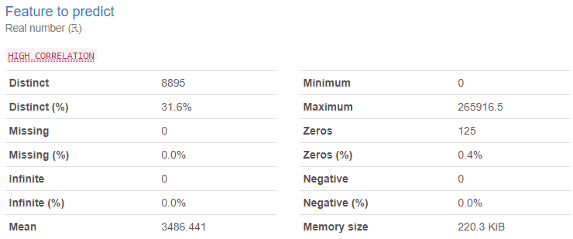

YData confirmed in its analysis that the Feature to predict column had really 8895 distinct values, which seems to be a major problem in such a column. Our code found that to be a problem for a Categorical column should not have over 100 distinct values. Besides that YData found many High Correlation and Zeros.

# 343 - Occupancy Detection – Computer

Dataset analysed: datatest.txt from <https://archive.ics.uci.edu/ml/machine-learning-databases/00357/occupancy_data.zip> (dataset_file_url column from Fiftydatasets.xlsx)

date time year-month-day hour (date time):

Datetime format: All 2665 datetime values are valid in the YYYYMMDD format in the range 2015/02/02 14:19 to 2015/02/04 10:43.

Temperature, in Celsius (temperature):

Numerical format: All 2665 values are numerical in the range (20.2:24.4083333333333).

Relative Humidity, % (humidity):

Numerical >=0 format: All 2665 values are numerical and greater or equal to 0 in the range (22.1:31.4725).

Light, in Lux (light):

Numerical >=0 format: All 2665 values are numerical and greater or equal to 0 in the range (0.0:1697.25).

CO2, in ppm (co2):

Numerical >=0 format: All 2665 values are numerical and greater or equal to 0 in the range (427.5:1402.25).

Humidity Ratio, Derived quantity from temperature and relative humidity, in kgwater-vapor/kg-air (temperature):

Numerical format: All 2665 values are numerical in the range (0.0033033144722347:0.0053777588397133).

Occupancy, 0 or 1, 0 for not occupied, 1 for occupied status (status):

All 2665 values are correctly categorical.

Categorical format with 2 unique values:

Category Frequency

0 1693

1 972

Last run on: 2024-01-30 18:56:59

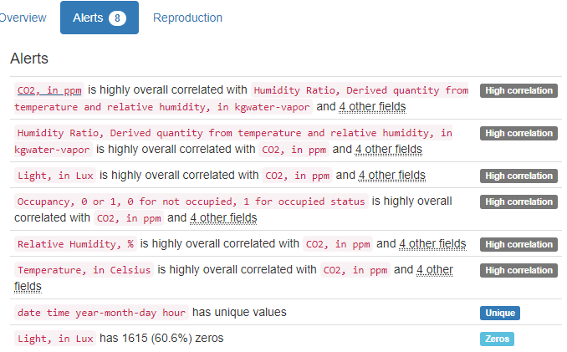

YData found that the first column is Unique. We have not checked that.

# 128 - KDD Cup 1999 Data - Computer

Dataset analysed: corrected (without file ending), renamed to corrected.txt, from <http://kdd.ics.uci.edu/databases/kddcup99/corrected.gz> obtained at <https://kdd.ics.uci.edu/databases/kddcup99/kddcup99.html>, instead of the original dataset_file_url column from Fiftydatasets.xlsx which was at <https://archive.ics.uci.edu/ml/machine-learning-databases/kddcup99-mld/corrected.gz> but it is not valid anymore. It does not have header.

duration:

Numerical >=0 format: All 311029 values are numerical and greater or equal to 0 in the range (0:57715).

protocol_type (type):

All 311029 values are correctly categorical.

Categorical format with 3 unique values:

Category Frequency

icmp 164969

tcp 119357

udp 26703

service:

All 311029 values are correctly categorical.

Categorical format with 65 unique values:

Category Frequency

ecr_i 164352

private 78510

http 41237

smtp 8268

pop_3 3972

domain_u 3160

ftp_data 2223

other 2185

telnet 2077

ftp 837

... ...

csnet_ns 50

klogin 50

supdup 50

hostnames 48

IRC 24

pm_dump 16

X11 15

tim_i 7

icmp 2

tftp_u 1

flag:

All 311029 values are correctly categorical.

Categorical format with 11 unique values:

Category Frequency

SF 248379

REJ 41945

S0 18012

RSTO 1393

RSTR 872

S3 289

SH 84

S1 27

S2 22

OTH 4

RSTOS0 2

src_bytes (bytes):

Numerical >=0 format: All 311029 values are numerical and greater or equal to 0 in the range (0:62825648).

dst_bytes (bytes):

Numerical >=0 format: All 311029 values are numerical and greater or equal to 0 in the range (0:5203179).

land (symbolic):

All 311029 values are correctly categorical.

Categorical format with 2 unique values:

Category Frequency

0 311020

1 9

wrong_fragment (continuous):

Numerical >=0 format: All 311029 values are numerical and greater or equal to 0 in the range (0:3).

urgent (continuous):

Numerical >=0 format: All 311029 values are numerical and greater or equal to 0 in the range (0:3).

hot (continuous):

Numerical >=0 format: All 311029 values are numerical and greater or equal to 0 in the range (0:101).

num_failed_logins (num):

Numerical format: All 311029 values are numerical in the range (0:4).

logged_in (symbolic):

All 311029 values are correctly categorical.

Categorical format with 2 unique values:

Category Frequency

0 257384

1 53645

num_compromised (num):

Numerical format: All 311029 values are numerical in the range (0:796).

root_shell (continuous):

Numerical >=0 format: All 311029 values are numerical and greater or equal to 0 in the range (0:1).

su_attempted (attempted):

Numerical >=0 format: All 311029 values are numerical and greater or equal to 0 in the range (0:2).

num_root (num):

Numerical format: All 311029 values are numerical in the range (0:878).

num_file_creations (num):

Numerical format: All 311029 values are numerical in the range (0:100).

num_shells (num):

Numerical format: All 311029 values are numerical in the range (0:5).

num_access_files (num):

Numerical format: All 311029 values are numerical in the range (0:4).

num_outbound_cmds (num):

Numerical format: All 311029 values are numerical in the range (0:0).

is_host_login (symbolic):

All 311029 values are correctly categorical.

Categorical format with 2 unique values:

Category Frequency

0 311017

1 12

is_guest_login (symbolic):

All 311029 values are correctly categorical.

Categorical format with 2 unique values:

Category Frequency

0 310275

1 754

count:

Numerical >=0 format: All 311029 values are numerical and greater or equal to 0 in the range (0:511).

srv_count (count):

Numerical >=0 format: All 311029 values are numerical and greater or equal to 0 in the range (0:511).

serror_rate (rate):

Numerical format: All 311029 values are numerical in the range (0.0:1.0).

srv_serror_rate (rate):

Numerical format: All 311029 values are numerical in the range (0.0:1.0).

rerror_rate (rate):

Numerical format: All 311029 values are numerical in the range (0.0:1.0).

srv_rerror_rate (rate):

Numerical format: All 311029 values are numerical in the range (0.0:1.0).

same_srv_rate (rate):

Numerical format: All 311029 values are numerical in the range (0.0:1.0).

diff_srv_rate (rate):

Numerical format: All 311029 values are numerical in the range (0.0:1.0).

srv_diff_host_rate (rate):

Numerical format: All 311029 values are numerical in the range (0.0:1.0).

dst_host_count (count):

Numerical >=0 format: All 311029 values are numerical and greater or equal to 0 in the range (0:255).

dst_host_srv_count (count):

Numerical >=0 format: All 311029 values are numerical and greater or equal to 0 in the range (0:255).

dst_host_same_srv_rate (rate):

Numerical format: All 311029 values are numerical in the range (0.0:1.0).

dst_host_diff_srv_rate (rate):

Numerical format: All 311029 values are numerical in the range (0.0:1.0).

dst_host_same_src_port_rate (rate):

Numerical format: All 311029 values are numerical in the range (0.0:1.0).

dst_host_srv_diff_host_rate (rate):

Numerical format: All 311029 values are numerical in the range (0.0:1.0).

dst_host_serror_rate (rate):

Numerical format: All 311029 values are numerical in the range (0.0:1.0).

dst_host_srv_serror_rate (rate):

Numerical format: All 311029 values are numerical in the range (0.0:1.0).

dst_host_rerror_rate (rate):

Numerical format: All 311029 values are numerical in the range (0.0:1.0).

dst_host_srv_rerror_rate (rate):

Numerical format: All 311029 values are numerical in the range (0.0:1.0).

class:

All 311029 values are correctly categorical.

Categorical format with 38 unique values:

Category Frequency

smurf. 164091

normal. 60593

neptune. 58001

snmpgetattack. 7741

mailbomb. 5000

guess_passwd. 4367

snmpguess. 2406

satan. 1633

warezmaster. 1602

back. 1098

... ...

xlock. 9

xsnoop. 4

ftp_write. 3

loadmodule. 2

perl. 2

phf. 2

sqlattack. 2

udpstorm. 2

worm. 2

imap. 1

Last run on: 2024-02-21 21:03:45

Dataset

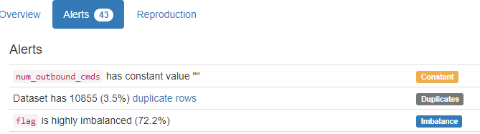

It shows column num_outbound_cmds with constant value "". We have not checked that. For us it is a numerical with values in the range (0:0).

…



# 303 - Perfume Data - Computer

Dataset analysed: 1 perfume_data.xlsx from <https://archive.ics.uci.edu/static/public/303/perfume+data.zip> instead of the original dataset_file_url column from Fiftydatasets.xlsx which was at <https://archive.ics.uci.edu/ml/machine-learning-databases/00303/perfume_data.xlsx> but it is not valid anymore.

Perfume_name (name):

Name format: Error(s) found:

DQI #5 (Extraneous Data - Consistency, Uniqueness):

1 Extraneous data value(s) at index(es): [(16, 'constrected2')]

Frequency Distribution:

Perfume_name Frequency

RoseMusk 1

TeaTreeOil 1

ajayeb 1

ajmal 1

amreaj 1

aood 1

asgar_ali 1

bukhoor 1

burberrry 1

carolina_herrera 1

constrected 1

constrected2 1

dehenalaod 1

junaid 1

kausar 1

oudh_ma'alattar 1

raspberry 1

rose 1

solidmusk 1

strawberry 1

Range of Values: (RoseMusk to strawberry)

Take_1 (take):

Numerical format: All 20 values are numerical in the range (46014:85056).

Take_2 (take):

Numerical format: All 20 values are numerical in the range (46014:85056).

Take_3 (take):

Numerical format: All 20 values are numerical in the range (46014:85056).

Take_4 (take):

Numerical format: All 20 values are numerical in the range (46014:85056).

Take_5 (take):

Numerical format: All 20 values are numerical in the range (46014:85056).

Take_6 (take):

Numerical format: All 20 values are numerical in the range (46015:85056).

Take_7 (take):

Numerical format: All 20 values are numerical in the range (46015:85056).

Take_8 (take):

Numerical format: All 20 values are numerical in the range (46015:85056).

Take_9 (take):

Numerical format: All 20 values are numerical in the range (46015:85056).

Take_10 (take):

Numerical format: All 20 values are numerical in the range (46015:85056).

Take_11 (take):

Numerical format: All 20 values are numerical in the range (46015:85056).

Take_12 (take):

Numerical format: All 20 values are numerical in the range (46015:85056).

Take_13 (take):

Numerical format: All 20 values are numerical in the range (46015:85056).

Take_14 (take):

Numerical format: All 20 values are numerical in the range (46015:85056).

Take_15 (take):

Numerical format: All 20 values are numerical in the range (46015:85056).

Take_16 (take):

Numerical format: All 20 values are numerical in the range (46015:85056).

Take_17 (take):

Numerical format: All 20 values are numerical in the range (46015:85056).

Take_18 (take):

Numerical format: All 20 values are numerical in the range (46015:85056).

Take_19 (take):

Numerical format: All 20 values are numerical in the range (46015:85056).

Take_20 (take):

Numerical format: All 20 values are numerical in the range (46015:85056).

Take_21 (take):

Numerical format: All 20 values are numerical in the range (46015:85056).

Take_22 (take):

Numerical format: All 20 values are numerical in the range (46015:85056).

Take_23 (take):

Numerical format: All 20 values are numerical in the range (46015:85056).

Take_24 (take):

Numerical format: All 20 values are numerical in the range (46015:85056).

Take_25 (take):

Numerical format: All 20 values are numerical in the range (46015:85056).

Take_26 (take):

Numerical format: All 20 values are numerical in the range (46015:85056).

Take_27 (take):

Numerical format: All 20 values are numerical in the range (46015:85056).

Take_28 (take):

Numerical format: All 20 values are numerical in the range (46015:85056).

Last run on: 2024-02-22 13:35:16

YData found that all columns have Unique values, but did not find the problem in Perfume_name

|  |  |
| --- | --- |
|  |  |

# 225$$$ - Restaurant & consumer data – Computer

Dataset analysed: 5 - geoplaces2.csv from <https://archive.ics.uci.edu/ml/machine-learning-databases/00232/RCdata.zip> (dataset_file_url column from Fiftydatasets.xlsx) has header but it’s format is not UTF-8.

placeID (id):

ID column format: All 130 ID values are unique and valid, and thus suitable for use as a Primary Key.

Alphanumeric range of values: (132560 : 135109)

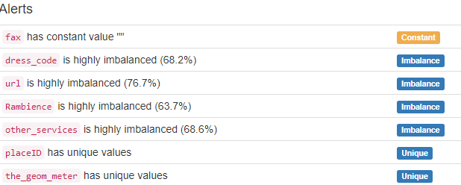

YData did not find the many ‘?’s, but found two Unique values that we also found, as ID and in the categorical column below that has all 130 values as unique, but we have not alerted it. And it found that fax column has only one value, considered Constant, but considered for them a different value than the ‘?’ we found.

latitude:

Latitude format: All 130 values are numerical and valid in the range [-90, 90].

Actual range of values: (18.859803 : 23.7602683)

longitude:

Longitude format: All 130 values are numerical and valid in the range [-180, 180].

Actual range of values: (-101.0286 : -99.1265059)

the_geom_meter (nominal):

Categorical format: Error(s) found:

DQI #10 (Structural Conflicts - Consistency, Uniqueness):

Data seems not categorical or has too many categories (> 100).

Categorical format with 130 unique values:

Category Frequency

0101000020957F000000DD3546816E5AC119D4BD17FD544A41 1

0101000020957F000003B195E25F8457C1C535BD04614B4941 1

0101000020957F000004457BB7AA8657C15F10835CD9444941 1

0101000020957F000005810F19B84858C136805B2745A74B41 1

0101000020957F00000B6735CA004858C108FD525CB2A44B41 1

0101000020957F00000F14BF6B2C8657C1963CCB8E5C464941 1

0101000020957F00000F624C60B54958C11757339BCCA24B41 1

0101000020957F000011DFB4E3EE4858C13F78758452AB4B41 1

0101000020957F000011E92CCE714B58C19BF8C0CA75924B41 1

0101000020957F000013696871A24558C11EE432FB04A14B41 1

... ...

0101000020957F0000F9F19DDC3B4858C191B265A83BA44B41 1

0101000020957F0000FA1A0E5A9B4858C17C884C4173AE4B41 1

0101000020957F0000FBE7171F056F5AC1E8A6C0A5AF554A41 1

0101000020957F0000FC60BDA8E88157C1B2C357D6DA4E4941 1

0101000020957F0000FC799354656C5AC1233FCC70E7584A41 1

0101000020957F0000FC8866CF17785AC14CD7055B02514A41 1

0101000020957F0000FD78FFF7AD4458C1896A33F029A04B41 1

0101000020957F0000FDF8D26EE08157C1FEDB6A1FDB4E4941 1

0101000020957F0000FE987FAF936D5AC1E1D486215E524A41 1

0101000020957F0000FEC3FB453E4B58C19B4A463617994B41 1

name:

Name format: Error(s) found:

DQI #5 (Extraneous Data - Consistency, Uniqueness):

3 Extraneous data value(s) at index(es): [(10, 'Restaurante 75'), (66, 'Cenaduria El RincÃ³n de Tlaquepaque'), (103, 'Carnitas Mata Calle 16 de Septiembre')]

DQI #15 (Domain Violation - Accuracy):

51 Capitalization/Format issue(s) at index(es): [(1, 'puesto de tacos'), (3, 'little pizza Emilio Portes Gil'), (4, 'carnitas_mata'), (5, 'Restaurant los Compadres'), (6, 'Taqueria EL amigo '), (7, 'shi ro ie'), (9, 'la Estrella de Dimas'), (12, 'El angel Restaurante'), (15, 'Tortas y hamburguesas el gordo'), (17, 'rockabilly '), ('...', '...'), (102, 'pizza clasica'), (104, 'Restaurante de Mariscos la Langosta'), (106, 'puesto de gorditas'), (109, 'carnitas mata calle Emilio Portes Gil'), (110, 'crudalia'), (111, 'tacos de barbacoa enfrente del Tec'), (115, 'Cafeteria cenidet'), (122, 'tacos abi'), (123, 'la perica hamburguesa'), (129, 'sirloin stockade')] (displaying only the first and last 10 items)

Frequency Distribution:

name Frequency

Gorditas Dona Tota 2

Abondance Restaurante Bar 1

Arrachela Grill 1

Cabana Huasteca 1

Cafe Chaires 1

Cafeteria cenidet 1

Cafeteria y Restaurant El Pacifico 1

Carls Jr 1

Carnitas Mata Calle 16 de Septiembre 1

Carreton de Flautas y Migadas 1

... ...

puesto de tacos 1

rockabilly 1

shi ro ie 1

sirloin stockade 1

tacos abi 1

tacos de barbacoa enfrente del Tec 1

tacos de la estacion 1

tacos los volcanes 1

tortas hawai 1

vips 1

Range of Values: (Abondance Restaurante Bar to vips)

address:

Street format: Error(s) found:

DQI #1 (Missing Data - Completeness):

27 Blank/Empty/Null/Missing value(s) at index(es): [(7, '?'), (19, '?'), (23, '?'), (27, '?'), (31, '?'), (43, '?'), (45, '?'), (62, '?'), (70, '?'), (72, '?'), ('...', '...'), (95, '?'), (96, '?'), (107, '?'), (110, '?'), (111, '?'), (118, '?'), (122, '?'), (123, '?'), (127, '?'), (129, '?')] (displaying only the first and last 10 items)

27 Non-NULL values: [(7, '?'), (19, '?'), (23, '?'), (27, '?'), (31, '?'), (43, '?'), (45, '?'), (62, '?'), (70, '?'), (72, '?'), ('...', '...'), (95, '?'), (96, '?'), (107, '?'), (110, '?'), (111, '?'), (118, '?'), (122, '?'), (123, '?'), (127, '?'), (129, '?')]

DQI #5 (Extraneous Data - Consistency, Uniqueness):

1 Extraneous street data value(s) at index(es): [(78, 'Rio Papaloapan 265 Lomas de San Luis (3)')]

DQI #15 (Domain Violation - Accuracy):

26 Capitalization/Format issue(s) at index(es): [(1, 'esquina santos degollado y leon guzman'), (3, 'calle emilio portes gil'), (4, 'lic. Emilio portes gil'), (5, 'Camino a Simon Diaz 155 Centro'), (8, 'tampico'), (16, 'carr. mexico'), (17, 'agustin de iturbide'), (26, 'avenida salvador montiel '), (29, 'r.b. anaya esq. florencia'), (34, '1a. de Lozada 1'), ('...', '...'), (80, 'sevilla y olmedo 715 a'), (81, 'circuito oriente esq. carretera 57'), (85, 'Av. Saan Luis enttre moctezuma y salinas'), (89, 'Zaragoza entre Francisco Zarco y Lopez Velarde'), (93, 'avenida hivno nacional'), (98, 'Paseo de las Fuentes'), (101, 'Av. de los Pintores'), (106, 'frente al tecnologico'), (114, 'Himno nacional esq. Blvd. Juarez'), (124, 'Rayon sn col. Centro')] (displaying only the first and last 10 items)

city:

City format: Error(s) found:

DQI #1 (Missing Data - Completeness):

18 Blank/Empty/Null/Missing value(s) at index(es): [(7, '?'), (27, '?'), (31, '?'), (43, '?'), (45, '?'), (62, '?'), (70, '?'), (72, '?'), (83, '?'), (87, '?'), (95, '?'), (96, '?'), (107, '?'), (110, '?'), (111, '?'), (118, '?'), (127, '?'), (129, '?')]

18 Non-NULL values: [(7, '?'), (27, '?'), (31, '?'), (43, '?'), (45, '?'), (62, '?'), (70, '?'), (72, '?'), (83, '?'), (87, '?'), (95, '?'), (96, '?'), (107, '?'), (110, '?'), (111, '?'), (118, '?'), (127, '?'), (129, '?')]

DQI #15 (Domain Violation - Accuracy):

23 Capitalization/Format issue(s) at index(es): [(1, 's.l.p.'), (3, 'victoria '), (4, 'victoria'), (8, 'victoria'), (17, 'san luis potosi'), (19, 'victoria'), (26, 'cuernavaca'), (29, 'slp'), (39, 'san luis potosi'), (41, 'victoria'), ('...', '...'), (76, 'victoria'), (80, 'san luis potosi'), (81, 'san luis potosi '), (90, 's.l.p'), (93, 'san luis potosi'), (103, 'victoria '), (106, 'victoria'), (109, 'victoria'), (122, 'victoria'), (123, 'victoria')] (displaying only the first and last 10 items)

Frequency Distribution (showing top and bottom 10 of 17 categories):

City Frequency

San Luis Potosi 64

? 18

Cuernavaca 15

victoria 10

san luis potosi 5

Jiutepec 4

Ciudad Victoria 2

Soledad 2

victoria 2

Cd Victoria 1

Cd. Victoria 1

cuernavaca 1

s.l.p 1

s.l.p. 1

san luis potos 1

san luis potosi 1

slp 1

state:

State format: Error(s) found:

18 Blank/Empty/Null/Missing value(s) at index(es): [(7, '?'), (27, '?'), (31, '?'), (43, '?'), (45, '?'), (56, '?'), (70, '?'), (72, '?'), (83, '?'), (87, '?'), (95, '?'), (96, '?'), (107, '?'), (110, '?'), (111, '?'), (118, '?'), (127, '?'), (129, '?')]

18 Non-NULL values: [(7, '?'), (27, '?'), (31, '?'), (43, '?'), (45, '?'), (56, '?'), (70, '?'), (72, '?'), (83, '?'), (87, '?'), (95, '?'), (96, '?'), (107, '?'), (110, '?'), (111, '?'), (118, '?'), (127, '?'), (129, '?')]

DQI #15 (Domain Violation - Accuracy):

20 Capitalization/Format issue(s) at index(es): [(1, 's.l.p.'), (3, 'tamaulipas'), (17, 'san luis potosi'), (19, 'tamaulipas'), (26, 'morelos'), (29, 'slp'), (39, 'san luis potosi'), (46, 'mexico'), (66, 'san luis potosi'), (73, 'tamaulipas'), (76, 'tamaulipas'), (80, 'san luis potosi'), (81, 'slp'), (90, 'mexico'), (93, 'san luis potos'), (103, 'tamaulipas'), (106, 'tamaulipas'), (109, 'tamaulipas'), (122, 'tamaulipas'), (123, 'tamaulipas')]

Frequency Distribution (showing top and bottom 10 of 13 categories):

State Frequency

SLP 50

Morelos 19

? 18

San Luis Potosi 14

tamaulipas 9

Tamaulipas 7

san luis potosi 4

S.L.P. 2

mexico 2

slp 2

morelos 1

s.l.p. 1

san luis potos 1

country:

Country format: Error(s) found:

DQI #1 (Missing Data - Completeness):

28 Blank/Empty/Null/Missing value(s) at index(es): [(3, '?'), (7, '?'), (27, '?'), (31, '?'), (39, '?'), (43, '?'), (45, '?'), (46, '?'), (56, '?'), (70, '?'), ('...', '...'), (98, '?'), (103, '?'), (107, '?'), (109, '?'), (110, '?'), (111, '?'), (118, '?'), (123, '?'), (127, '?'), (129, '?')] (displaying only the first and last 10 items)

28 Non-NULL values: [(3, '?'), (7, '?'), (27, '?'), (31, '?'), (39, '?'), (43, '?'), (45, '?'), (46, '?'), (56, '?'), (70, '?'), ('...', '...'), (98, '?'), (103, '?'), (107, '?'), (109, '?'), (110, '?'), (111, '?'), (118, '?'), (123, '?'), (127, '?'), (129, '?')]

DQI #15 (Domain Violation - Accuracy):

13 Capitalization/Format issue(s) at index(es): [(1, 'mexico'), (17, 'mexico'), (19, 'mexico'), (26, 'mexico'), (29, 'mexico'), (66, 'mexico'), (76, 'mexico'), (80, 'mexico'), (81, 'mexico'), (85, 'mexico'), (93, 'mexico'), (106, 'mexico'), (122, 'mexico')]

Frequency Distribution:

Country Frequency

Mexico 89

? 28

mexico 13

fax:

Phone format: Error(s) found:

DQI #1 (Missing Data - Completeness):

130 Blank/Empty/Null/Missing value(s) at index(es): [(0, '?'), (1, '?'), (2, '?'), (3, '?'), (4, '?'), (5, '?'), (6, '?'), (7, '?'), (8, '?'), (9, '?'), ('...', '...'), (120, '?'), (121, '?'), (122, '?'), (123, '?'), (124, '?'), (125, '?'), (126, '?'), (127, '?'), (128, '?'), (129, '?')] (displaying only the first and last 10 items)

130 Non-NULL values: [(0, '?'), (1, '?'), (2, '?'), (3, '?'), (4, '?'), (5, '?'), (6, '?'), (7, '?'), (8, '?'), (9, '?'), ('...', '...'), (120, '?'), (121, '?'), (122, '?'), (123, '?'), (124, '?'), (125, '?'), (126, '?'), (127, '?'), (128, '?'), (129, '?')]



zip:

Postal Code format: Error(s) found:

DQI #1 (Missing Data - Completeness):

74 Blank/Empty/Null/Missing value(s) at index(es): [(0, '?'), (3, '?'), (4, '?'), (7, '?'), (8, '?'), (15, '?'), (16, '?'), (17, '?'), (18, '?'), (19, '?'), ('...', '...'), (115, '?'), (117, '?'), (118, '?'), (120, '?'), (122, '?'), (123, '?'), (125, '?'), (127, '?'), (128, '?'), (129, '?')] (displaying only the first and last 10 items)

74 Non-NULL values: [(0, '?'), (3, '?'), (4, '?'), (7, '?'), (8, '?'), (15, '?'), (16, '?'), (17, '?'), (18, '?'), (19, '?'), ('...', '...'), (115, '?'), (117, '?'), (118, '?'), (120, '?'), (122, '?'), (123, '?'), (125, '?'), (127, '?'), (128, '?'), (129, '?')]

alcohol (nominal):

All 130 values are correctly categorical.

Categorical format with 3 unique values:

Category Frequency

No_Alcohol_Served 87

Wine-Beer 34

Full_Bar 9

smoking_area (nominal):

Categorical format: Error(s) found:

DQI #1 (Missing Data - Completeness):

70 Blank/Empty/Null/Missing value(s) at index(es): [(0, 'none'), (1, 'none'), (3, 'none'), (5, 'none'), (6, 'none'), (9, 'none'), (10, 'none'), (11, 'none'), (13, 'none'), (16, 'none'), ('...', '...'), (113, 'none'), (114, 'none'), (116, 'none'), (117, 'none'), (120, 'none'), (122, 'none'), (123, 'none'), (126, 'none'), (128, 'none'), (129, 'none')]

70 Non-NULL values: [(0, 'None'), (1, 'None'), (3, 'None'), (5, 'None'), (6, 'None'), (9, 'None'), (10, 'None'), (11, 'None'), (13, 'None'), (16, 'None'), ('...', '...'), (113, 'None'), (114, 'None'), (116, 'None'), (117, 'None'), (120, 'None'), (122, 'None'), (123, 'None'), (126, 'None'), (128, 'None'), (129, 'None')]

Categorical format with 5 unique values:

Category Frequency

none 70

not permitted 25

section 24

permitted 9

only at bar 2

dress_code (code):

All 130 values are correctly categorical.

Categorical format with 3 unique values:

Category Frequency

informal 118

casual 10

formal 2

accessibility (nominal):

All 130 values are correctly categorical.

Categorical format with 3 unique values:

Category Frequency

no_accessibility 76

completely 45

partially 9

price (nominal):

All 130 values are correctly categorical.

Categorical format with 3 unique values:

Category Frequency

medium 60

low 45

high 25

url:

URL format: Error(s) found:

DQI #1 (Missing Data - Completeness):

116 Blank/Empty/Null/Missing value(s) at index(es): [(1, '?'), (2, '?'), (3, '?'), (4, '?'), (5, '?'), (6, '?'), (7, '?'), (8, '?'), (9, '?'), (10, '?'), ('...', '...'), (119, '?'), (120, '?'), (121, '?'), (122, '?'), (123, '?'), (125, '?'), (127, '?'), (128, '?'), (129, '?')] (displaying only the first and last 10 items)

116 Non-NULL values: [(1, '?'), (2, '?'), (3, '?'), (4, '?'), (5, '?'), (6, '?'), (7, '?'), (8, '?'), (9, '?'), (10, '?'), ('...', '...'), (118, '?'), (119, '?'), (120, '?'), (121, '?'), (122, '?'), (123, '?'), (125, '?'), (127, '?'), (128, '?'), (129, '?')]

DQI #15 (Domain Violation - Accuracy):

1 Invalid URL format issue(s) at index(es): [(124, 'no')]

Frequency Distribution:

URL Frequency

? 116

lacantinaslp.com 2

carlosandcharlies.com 1

chilis.com.mx 1

eloceanodorado.com 1

kikucuernavaca.com.mx 1

lagranvia.com.mx 1

lasmananitas.com.mx 1

lostoneles.com.mx 1

lunacafe.com.mx 1

no 1

reyecito.com 1

sushi-itto.com.mx 1

[www.cenidet.edu.mx](https://file+.vscode-resource.vscode-cdn.net/c%3A/Users/290099c/OneDrive/Documentos/Android%20Meus%20Documentos/PhD/SECOND%20paper/CODING%20SECOND%20PAPER/www.cenidet.edu.mx) 1

Rambience (nominal):

All 130 values are correctly categorical.

Categorical format with 2 unique values:

Category Frequency

familiar 121

quiet 9

franchise (ranch):

All 130 values are correctly categorical.

Categorical format with 2 unique values:

Category Frequency

f 108

t 22

area (nominal):

All 130 values are correctly categorical.

Categorical format with 2 unique values:

Category Frequency

closed 115

open 15

other_services (nominal):

Categorical format: Error(s) found:

DQI #1 (Missing Data - Completeness):

119 Blank/Empty/Null/Missing value(s) at index(es): [(0, 'none'), (1, 'none'), (2, 'none'), (3, 'none'), (4, 'none'), (5, 'none'), (6, 'none'), (8, 'none'), (9, 'none'), (10, 'none'), ('...', '...'), (119, 'none'), (120, 'none'), (121, 'none'), (122, 'none'), (123, 'none'), (124, 'none'), (125, 'none'), (126, 'none'), (128, 'none'), (129, 'none')]

119 Non-NULL values: [(0, 'None'), (1, 'None'), (2, 'None'), (3, 'None'), (4, 'None'), (5, 'None'), (6, 'None'), (8, 'None'), (9, 'None'), (10, 'None'), ('...', '...'), (119, 'None'), (120, 'None'), (121, 'None'), (122, 'None'), (123, 'None'), (124, 'None'), (125, 'None'), (126, 'None'), (128, 'None'), (129, 'None')]

Categorical format with 3 unique values:

Category Frequency

None 119

variety 7

Internet 4

Last run on: 2024-02-22 15:41:41

# 17 - Breast Cancer Wisconsin (Diagnostic) – Life

Dataset analysed: wdbc.data from <https://archive.ics.uci.edu/static/public/17/breast+cancer+wisconsin+diagnostic.zip> instead of the https://archive.ics.uci.edu/ml/machine-learning-databases/breast-cancer-wisconsin/breast-cancer-wisconsin.data that was in the dataset_file_url column from Fiftydatasets.xlsx. Curiously this same dataset is being used for a similar dataset, 15 - Breast Cancer Wisconsin (Original) – Life, that is presented later on this document. It does not have header.

ID number (id):

ID column format: All 569 ID values are unique and valid, and thus suitable for use as a Primary Key.

Alphanumeric range of values: (842302 : 92751)

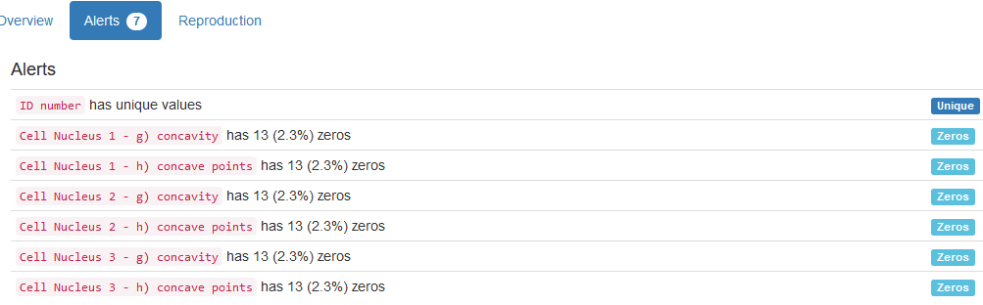

YData shows the column 'ID number' as Unique. We consider it not only unique but suitable for use as a Primary Key.

Diagnosis:

All 569 values are correctly categorical.

Categorical format with 2 unique values:

Category Frequency

B 357

M 212

Cell Nucleus 1 - a) radius (radius):

Numerical >=0 format: All 569 values are numerical and greater or equal to 0 in the range (6.981:28.11).

Cell Nucleus 1 - b) texture (texture):

Numerical format: All 569 values are numerical in the range (9.71:39.28).

Cell Nucleus 1 - c) perimeter (perimeter):

Numerical >=0 format: All 569 values are numerical and greater or equal to 0 in the range (43.79:188.5).

Cell Nucleus 1 - d) area (area):

Numerical >=0 format: All 569 values are numerical and greater or equal to 0 in the range (143.5:2501.0).

Cell Nucleus 1 - e) smoothness (smoothness):

Numerical >=0 format: All 569 values are numerical and greater or equal to 0 in the range (0.05263:0.1634).

Cell Nucleus 1 - f) compactness (compactness):

Numerical >=0 format: All 569 values are numerical and greater or equal to 0 in the range (0.01938:0.3454).

Cell Nucleus 1 - g) concavity (concavity):

Numerical format: All 569 values are numerical in the range (0.0:0.4268).

Cell Nucleus 1 - h) concave points (points):

Numerical >=0 format: All 569 values are numerical and greater or equal to 0 in the range (0.0:0.2012).

Cell Nucleus 1 - i) symmetry (symmetry):

Numerical format: All 569 values are numerical in the range (0.106:0.304).

Cell Nucleus 1 - j) fractal dimension (dimension):

Numerical format: All 569 values are numerical in the range (0.04996:0.09744).

Cell Nucleus 2 - a) radius (radius):

Numerical >=0 format: All 569 values are numerical and greater or equal to 0 in the range (0.1115:2.873).

Cell Nucleus 2 - b) texture (texture):

Numerical format: All 569 values are numerical in the range (0.3602:4.885).

Cell Nucleus 2 - c) perimeter (perimeter):

Numerical >=0 format: All 569 values are numerical and greater or equal to 0 in the range (0.757:21.98).

Cell Nucleus 2 - d) area (area):

Numerical >=0 format: All 569 values are numerical and greater or equal to 0 in the range (6.802:542.2).

Cell Nucleus 2 - e) smoothness (smoothness):

Numerical >=0 format: All 569 values are numerical and greater or equal to 0 in the range (0.001713:0.03113).

Cell Nucleus 2 - f) compactness (compactness):

Numerical >=0 format: All 569 values are numerical and greater or equal to 0 in the range (0.002252:0.1354).

Cell Nucleus 2 - g) concavity (concavity):

Numerical format: All 569 values are numerical in the range (0.0:0.396).

Cell Nucleus 2 - h) concave points (points):

Numerical >=0 format: All 569 values are numerical and greater or equal to 0 in the range (0.0:0.05279).

Cell Nucleus 2 - i) symmetry (symmetry):

Numerical format: All 569 values are numerical in the range (0.007882:0.07895).

Cell Nucleus 2 - j) fractal dimension (dimension):

Numerical format: All 569 values are numerical in the range (0.0008948:0.02984).

Cell Nucleus 3 - a) radius (radius):

Numerical >=0 format: All 569 values are numerical and greater or equal to 0 in the range (7.93:36.04).

Cell Nucleus 3 - b) texture (texture):

Numerical format: All 569 values are numerical in the range (12.02:49.54).

Cell Nucleus 3 - c) perimeter (perimeter):

Numerical >=0 format: All 569 values are numerical and greater or equal to 0 in the range (50.41:251.2).

Cell Nucleus 3 - d) area (area):

Numerical >=0 format: All 569 values are numerical and greater or equal to 0 in the range (185.2:4254.0).

Cell Nucleus 3 - e) smoothness (smoothness):

Numerical >=0 format: All 569 values are numerical and greater or equal to 0 in the range (0.07117:0.2226).

Cell Nucleus 3 - f) compactness (compactness):

Numerical >=0 format: All 569 values are numerical and greater or equal to 0 in the range (0.02729:1.058).

Cell Nucleus 3 - g) concavity (concavity):

Numerical format: All 569 values are numerical in the range (0.0:1.252).

Cell Nucleus 3 - h) concave points (points):

Numerical >=0 format: All 569 values are numerical and greater or equal to 0 in the range (0.0:0.291).

Cell Nucleus 3 - i) symmetry (symmetry):

Numerical format: All 569 values are numerical in the range (0.1565:0.6638).

Cell Nucleus 3 - j) fractal dimension (dimension):

Numerical format: All 569 values are numerical in the range (0.05504:0.2075).

Last run on: 2024-02-23 18:27:01

# 850 - Raisin Dataset – Life

Dataset analysed: Raisin_Dataset\Raisin_Dataset.xlsx from <https://archive.ics.uci.edu/ml/machine-learning-databases/00617/Raisin_Dataset.zip> (dataset_file_url column from Fiftydatasets.xlsx) has header

Area:

Numerical >=0 format: All 900 values are numerical and greater or equal to 0 in the range (25387:235047).

Perimeter:

Numerical >=0 format: All 900 values are numerical and greater or equal to 0 in the range (225.629541:997.2919406).

MajorAxisLength (length):

Numerical >=0 format: All 900 values are numerical and greater or equal to 0 in the range (143.7108718:492.2752785).

MinorAxisLength (minimum):

Numerical format: All 900 values are numerical in the range (0.348729642:0.96212444).

Eccentricity:

Numerical format: All 900 values are numerical in the range (26139:278217).

ConvexArea (area):

Numerical >=0 format: All 900 values are numerical and greater or equal to 0 in the range (0.379856115:0.835454545).

Extent (ratio):

Numerical format: All 900 values are numerical in the range (619.074:2697.753).

Class:

All 900 values are correctly categorical.

Categorical format with 2 unique values:

Category Frequency

Besni 450

Kecimen 450

Last run on: 2024-02-23 16:02:26

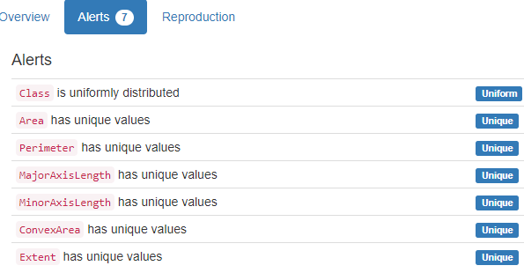

YData shows 6 columns as Unique. We have not checked that.

# 1 - Abalone – Life

Dataset analysed: abalone.data from <https://archive.ics.uci.edu/ml/machine-learning-databases/abalone/abalone.data> (dataset_file_url column from Fiftydatasets.xlsx) It does not have header

Sex:

All 4177 values are correctly categorical.

Categorical format with 3 unique values:

Category Frequency

M 1528

I 1342

F 1307

Length:

Numerical >=0 format: All 4177 values are numerical and greater or equal to 0 in the range (0.075:0.815).

Diameter:

Numerical >=0 format: All 4177 values are numerical and greater or equal to 0 in the range (0.055:0.65).

Height:

Numerical format: All 4177 values are numerical in the range (0.0:1.13).

Whole weight (weight):

Numerical >=0 format: All 4177 values are numerical and greater or equal to 0 in the range (0.002:2.8255).

Shucked weight (weight):

Numerical >=0 format: All 4177 values are numerical and greater or equal to 0 in the range (0.001:1.488).

Viscera weight (weight):

Numerical >=0 format: All 4177 values are numerical and greater or equal to 0 in the range (0.0005:0.76).

Shell weight (weight):

Numerical >=0 format: All 4177 values are numerical and greater or equal to 0 in the range (0.0015:1.005).

Rings (integer):

Numerical format: All 4177 values are numerical in the range (1:29).

Last run on: 2024-02-23 16:26:24

YData did not find any Alerts in this Dataset

# 15 - Breast Cancer Wisconsin (Original) – Life

Dataset analysed: breast-cancer-wisconsin.data from <https://archive.ics.uci.edu/ml/machine-learning-databases/breast-cancer-wisconsin/breast-cancer-wisconsin.data> (dataset_file_url column from Fiftydatasets.xlsx) It does not have header.

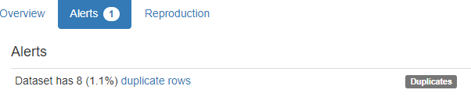

YData only found Duplicate entire rows. We found a duplicate ID column, and other problem in the first ID column. We also found ‘?’ in ‘Bare Nuclei’

Sample code number (id):

ID column format: Error(s) found:

DQI #9 (Duplicates - Uniqueness):

100 Duplicate value(s) at index(es): [[4, 1017023], [8, 1033078], [9, 1033078], [29, 1070935], [30, 1070935], [42, 1100524], [47, 1105524], [61, 1115293], [62, 1116116], [64, 1116192], ('...', '...'), [661, 1339781], [672, 1354840], [673, 1354840], [683, 466906], [684, 466906], [689, 654546], [690, 654546], [691, 695091], [697, 897471], [698, 897471]] (displaying only the first and last 10 items)

DQI #19 (Uniqueness Violation - Uniqueness):

54 Uniqueness violation(s) at index(es): [(9, 1033078), (30, 1070935), (82, 1143978), (109, 1171710), (116, 1173347), (121, 1174057), (195, 1212422), (208, 1218860), (252, 1017023), (253, 1100524), ('...', '...'), (618, 1061990), (632, 1238777), (639, 1277792), (644, 1299596), (661, 1339781), (673, 1354840), (684, 466906), (690, 654546), (691, 695091), (698, 897471)] (displaying only the first and last 10 items)

Alphanumeric range of values: (1000025 : 95719)

Clump Thickness (thickness):

Numerical format: All 699 values are numerical in the range (1:10).

Uniformity of Cell Size (size):

Numerical >=0 format: All 699 values are numerical and greater or equal to 0 in the range (1:10).

Uniformity of Cell Shape (uniformity):

Numerical format: All 699 values are numerical in the range (1:10).

Marginal Adhesion (adhesion):

Numerical format: All 699 values are numerical in the range (1:10).

Single Epithelial Cell Size (size):

Numerical >=0 format: All 699 values are numerical and greater or equal to 0 in the range (1:10).

Bare Nuclei (nuclei):

Numerical format: Error(s) found:

DQI #1 (Missing Data - Completeness):

16 Blank/Empty/Null/Missing value(s) at index(es): [(23, '?'), (40, '?'), (139, '?'), (145, '?'), (158, '?'), (164, '?'), (235, '?'), (249, '?'), (275, '?'), (292, '?'), (294, '?'), (297, '?'), (315, '?'), (321, '?'), (411, '?'), (617, '?')]

Range of values: (1:10).

Bland Chromatin (chromatin):

Numerical format: All 699 values are numerical in the range (1:10).

Normal Nucleoli (nucleoli):

Numerical format: All 699 values are numerical in the range (1:10).

Mitoses:

Numerical format: All 699 values are numerical in the range (1:10).

Class:

All 699 values are correctly categorical.

Categorical format with 2 unique values:

Category Frequency

2 458

4 241

Last run on: 2024-02-23 18:29:53

# 73 - Mushroom - Life

Dataset analysed: agaricus-lepiota.data from <https://archive.ics.uci.edu/ml/machine-learning-databases/mushroom/agaricus-lepiota.data> (dataset_file_url column from Fiftydatasets.xlsx) It does not have header.

All fields are categorical and have been altered manually in the AllColumnsfromFortyDatasets file.

poisonous (categorical):

All 8124 values are correctly categorical.

Categorical format with 2 unique values:

Category Frequency

e 4208

p 3916

cap-shape (categorical):

All 8124 values are correctly categorical.

Categorical format with 6 unique values:

Category Frequency

x 3656

f 3152

k 828

b 452

s 32

c 4

cap-surface (categorical):

All 8124 values are correctly categorical.

Categorical format with 4 unique values:

Category Frequency

y 3244

s 2556

f 2320

g 4

cap-color (color):

All 8124 values are correctly categorical.

Categorical format with 10 unique values:

Category Frequency

n 2284

g 1840

e 1500

y 1072

w 1040

b 168

p 144

c 44

r 16

u 16

bruises? (categorical):

All 8124 values are correctly categorical.

Categorical format with 2 unique values:

Category Frequency

f 4748

t 3376

odor (categorical):

All 8124 values are correctly categorical.

Categorical format with 9 unique values:

Category Frequency

n 3528

f 2160

s 576

y 576

a 400

l 400

p 256

c 192

m 36

gill-attachment (categorical):

All 8124 values are correctly categorical.

Categorical format with 2 unique values:

Category Frequency

f 7914

a 210

gill-spacing (categorical):

All 8124 values are correctly categorical.

Categorical format with 2 unique values:

Category Frequency

c 6812

w 1312

gill-size (categorical):

All 8124 values are correctly categorical.

Categorical format with 2 unique values:

Category Frequency

b 5612

n 2512

gill-color (color):

All 8124 values are correctly categorical.

Categorical format with 12 unique values:

Category Frequency

b 1728

p 1492

w 1202

n 1048

g 752

h 732

u 492

k 408

e 96

y 86

o 64

r 24

stalk-shape (categorical):

All 8124 values are correctly categorical.

Categorical format with 2 unique values:

Category Frequency

t 4608

e 3516

stalk-root (categorical):

Categorical format: Error(s) found:

DQI #1 (Missing Data - Completeness):

2480 Blank/Empty/Null/Missing value(s) at index(es): [(3984, '?'), (4023, '?'), (4076, '?'), (4100, '?'), (4104, '?'), (4196, '?'), (4200, '?'), (4283, '?'), (4291, '?'), (4326, '?'), ('...', '...'), (8113, '?'), (8115, '?'), (8116, '?'), (8117, '?'), (8118, '?'), (8119, '?'), (8120, '?'), (8121, '?'), (8122, '?'), (8123, '?')] (displaying only the first and last 10 items)

Categorical format with 5 unique values:

Category Frequency

b 3776

? 2480

e 1120

c 556

r 192

stalk-surface-above-ring (categorical):

All 8124 values are correctly categorical.

Categorical format with 4 unique values:

Category Frequency

s 5176

k 2372

f 552

y 24

stalk-surface-below-ring (categorical):

All 8124 values are correctly categorical.

Categorical format with 4 unique values:

Category Frequency

s 4936

k 2304

f 600

y 284

stalk-color-above-ring (color):

All 8124 values are correctly categorical.

Categorical format with 9 unique values:

Category Frequency

w 4464

p 1872

g 576

n 448

b 432

o 192

e 96

c 36

y 8

stalk-color-below-ring (color):

All 8124 values are correctly categorical.

Categorical format with 9 unique values:

Category Frequency

w 4384

p 1872

g 576

n 512

b 432

o 192

e 96

c 36

y 24

veil-type (type):

All 8124 values are correctly categorical.

Categorical format with 1 unique values:

Category Frequency

p 8124

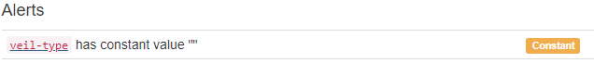

YData just found that this column has only one value. We showed it but have not considered an Alert. Besides that it did not find that ‘stalk-root’ had ‘?’ values

Other Alerts they show are High Correlation and Imbalance

veil-color (color):

All 8124 values are correctly categorical.

Categorical format with 4 unique values:

Category Frequency

w 7924

n 96

o 96

y 8

ring-number (categorical):

All 8124 values are correctly categorical.

Categorical format with 3 unique values:

Category Frequency

o 7488

t 600

n 36

ring-type (type):

All 8124 values are correctly categorical.

Categorical format with 5 unique values:

Category Frequency

p 3968

e 2776

l 1296

f 48

n 36

spore-print-color (color):

All 8124 values are correctly categorical.

Categorical format with 9 unique values:

Category Frequency

w 2388

n 1968

k 1872

h 1632

r 72

b 48

o 48

u 48

y 48

population (categorical):

All 8124 values are correctly categorical.

Categorical format with 6 unique values:

Category Frequency

v 4040

y 1712

s 1248

n 400

a 384

c 340

habitat (categorical):

All 8124 values are correctly categorical.

Categorical format with 7 unique values:

Category Frequency

d 3148

g 2148

p 1144

l 832

u 368

m 292

w 192

Last run on: 2024-02-23 20:33:28

# 14 - Breast Cancer – Life

Dataset analysed: breast-cancer.data from <https://archive.ics.uci.edu/ml/machine-learning-databases/breast-cancer/breast-cancer.data> (dataset_file_url column from Fiftydatasets.xlsx) It does not have header.

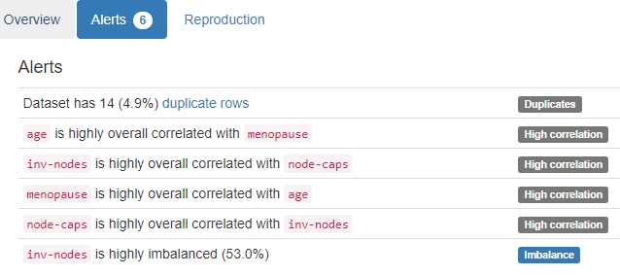

YData just found whole Duplicate lines, High correlation and Imbalance. Not the 2 cases of ‘?’ values.

Class:

All 286 values are correctly categorical.

Categorical format with 2 unique values:

Category Frequency

no-recurrence-events 201

recurrence-events 85

age (10-):

All 286 values are correctly categorical.

Categorical format with 6 unique values:

Category Frequency

50-59 96

40-49 90

60-69 57

30-39 36

70-79 6

20-29 1

menopause:

All 286 values are correctly categorical.

Categorical format with 3 unique values:

Category Frequency

premeno 150

ge40 129

lt40 7

tumor-size (0-):

All 286 values are correctly categorical.

Categorical format with 11 unique values:

Category Frequency

30-34 60

25-29 54

20-24 50

15-19 30

10-14 28

40-44 22

35-39 19

0-4 8

50-54 8

5-9 4

45-49 3

inv-nodes (node):

All 286 values are correctly categorical.

Categorical format with 7 unique values:

Category Frequency

0-2 213

3-5 36

6-8 17

9-11 10

15-17 6

12-14 3

24-26 1

node-caps (node):

Categorical format: Error(s) found:

DQI #1 (Missing Data - Completeness):

8 Blank/Empty/Null/Missing value(s) at index(es): [(145, '?'), (163, '?'), (164, '?'), (183, '?'), (184, '?'), (233, '?'), (263, '?'), (264, '?')]

Categorical format with 3 unique values:

Category Frequency

no 222

yes 56

? 8

deg-malig (degree):

All 286 values are correctly categorical.

Categorical format with 3 unique values:

Category Frequency

2 130

3 85

1 71

breast:

All 286 values are correctly categorical.

Categorical format with 2 unique values:

Category Frequency

left 152

right 134

breast-quad (breast):

Categorical format: Error(s) found:

DQI #1 (Missing Data - Completeness):

1 Blank/Empty/Null/Missing value(s) at index(es): 206, '?')]

Categorical format with 6 unique values:

Category Frequency

left_low 110

left_up 97

right_up 33

right_low 24

central 21

? 1

irradiat (yes):

All 286 values are correctly categorical.

Categorical format with 2 unique values:

Category Frequency

no 218

yes 68

Last run on: 2024-02-25 11:33:55

# 236 - seeds – Life

Dataset analysed: seeds_dataset.txt from [archive.ics.uci.edu/ml/machine-learning-databases/00236/seeds_dataset.txt](https://archive.ics.uci.edu/ml/machine-learning-databases/00236/seeds_dataset.txt) (dataset_file_url column from Fiftydatasets.xlsx) It does not have header.

15.26 14.84 0.871 5.763 3.312 2.221 5.22 1

14.88 14.57 0.8811 5.554 3.333 1.018 4.956 1

14.29 14.09 0.905 5.291 3.337 2.699 4.825 1

13.84 13.94 0.8955 5.324 3.379 2.259 4.805 1

16.14 14.99 0.9034 5.658 3.562 1.355 5.175 1

14.38 14.21 0.8951 5.386 3.312 2.462 4.956 1

14.69 14.49 0.8799 5.563 3.259 3.586 5.219 1

14.11 14.1 0.8911 5.42 3.302 2.7 5 1

16.63 15.46 0.8747 6.053 3.465 2.04 5.877 1

16.44 15.25 0.888 5.884 3.505 1.969 5.533 1

15.26 14.85 0.8696 5.714 3.242 4.543 5.314 1

The code was altered so that two tabs now are just one.

area A (area):

Numerical >=0 format: All 210 values are numerical and greater or equal to 0 in the range (10.59:21.18).

perimeter P (perimeter):

Numerical >=0 format: All 210 values are numerical and greater or equal to 0 in the range (12.41:17.25).

compactness C = 4*pi*A (compactness):

Numerical >=0 format: All 210 values are numerical and greater or equal to 0 in the range (0.8081:0.9183).

length of kernel (length):

Numerical >=0 format: All 210 values are numerical and greater or equal to 0 in the range (4.899:6.675).

width of kernel (width):

Numerical >=0 format: All 210 values are numerical and greater or equal to 0 in the range (2.63:4.033).

asymmetry coefficient (coefficient):

Numerical format: All 210 values are numerical in the range (0.7651:8.456).

length of kernel groove (length):

Numerical >=0 format: All 210 values are numerical and greater or equal to 0 in the range (4.519:6.55).

class:

All 210 values are correctly categorical.

Categorical format with 3 unique values:

Category Frequency

1 70

2 70

3 70

Last run on: 2024-02-25 12:14:03

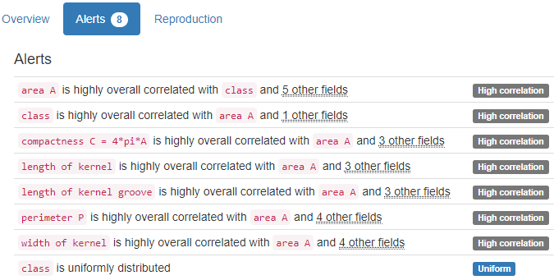

YData did not find anything that we care.

# 111 - Zoo - Life

Dataset analysed: zoo.data from [archive.ics.uci.edu/ml/machine-learning-databases/zoo/zoo.data](https://archive.ics.uci.edu/ml/machine-learning-databases/zoo/zoo.data) (dataset_file_url column from Fiftydatasets.xlsx) It does not have header.

animal name (name):

Name format: All 101 animal name values are valid.

Frequency Distribution:

animal name Frequency

frog 2

aardvark 1

antelope 1

bass 1

bear 1

boar 1

buffalo 1

calf 1

carp 1

catfish 1

... ...

tuatara 1

tuna 1

vampire 1

vole 1

vulture 1

wallaby 1

wasp 1

wolf 1

worm 1

wren 1

Range of Values: (aardvark to wren)

hair (boolean):

Binary format: All 101 binary values are valid.

Frequency Distribution:

Value Frequency

0 58

1 43

feathers (boolean):

Binary format: All 101 binary values are valid.

Frequency Distribution:

Value Frequency

0 81

1 20

eggs (boolean):

Binary format: All 101 binary values are valid.

Frequency Distribution:

Value Frequency

1 59

0 42

milk (boolean):

Binary format: All 101 binary values are valid.

Frequency Distribution:

Value Frequency

0 60

1 41

airborne (boolean):

Binary format: All 101 binary values are valid.

Frequency Distribution:

Value Frequency

0 77

1 24

aquatic (boolean):

Binary format: All 101 binary values are valid.

Frequency Distribution:

Value Frequency

0 65

1 36

predator (boolean):

Binary format: All 101 binary values are valid.

Frequency Distribution:

Value Frequency

1 56

0 45

toothed (boolean):

Binary format: All 101 binary values are valid.

Frequency Distribution:

Value Frequency

1 61

0 40

backbone (boolean):

Binary format: All 101 binary values are valid.

Frequency Distribution:

Value Frequency

1 83

0 18

breathes (boolean):

Binary format: All 101 binary values are valid.

Frequency Distribution:

Value Frequency

1 80

0 21

venomous (boolean):

Binary format: All 101 binary values are valid.

Frequency Distribution:

Value Frequency

0 93

1 8

fins (boolean):

Binary format: All 101 binary values are valid.

Frequency Distribution:

Value Frequency

0 84

1 17

legs (numeric):

Numerical format: All 101 values are numerical in the range (0:8).

tail (boolean):

Binary format: All 101 binary values are valid.

Frequency Distribution:

Value Frequency

1 75

0 26

domestic (boolean):

Binary format: All 101 binary values are valid.

Frequency Distribution:

Value Frequency

0 88

1 13

catsize (boolean):

Binary format: All 101 binary values are valid.

Frequency Distribution:

Value Frequency

0 57

1 44

type (numeric):

Numerical format: All 101 values are numerical in the range (1:7).

Last run on: 2024-02-25 16:52:25

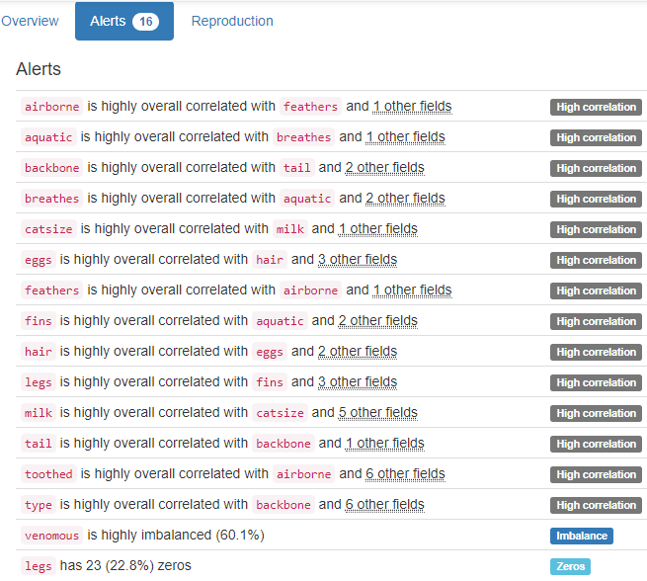

YData did not find anything that we care.

# 31 - Covertype – Life

Dataset analysed: covtype.data from <https://archive.ics.uci.edu/ml/machine-learning-databases/covtype/covtype.data.gz> (dataset_file_url column from Fiftydatasets.xlsx) It does not have header.

Elevation:

Numerical format: All 581012 values are numerical in the range (1859:3858).

Aspect (speed):

Numerical format: All 581012 values are numerical in the range (0:360).

Slope:

Numerical format: All 581012 values are numerical in the range (0:66).

Horizontal_Distance_To_Hydrology (distance):

Numerical format: All 581012 values are numerical in the range (0:1397).

Vertical_Distance_To_Hydrology (distance):

Numerical format: All 581012 values are numerical in the range (-173:601).

Horizontal_Distance_To_Roadways (distance):

Numerical format: All 581012 values are numerical in the range (0:7117).

Hillshade_9am (index):

Numerical format: All 581012 values are numerical in the range (0:254).

Hillshade_Noon (index):

Numerical format: All 581012 values are numerical in the range (0:254).

Hillshade_3pm (index):

Numerical format: All 581012 values are numerical in the range (0:254).

Horizontal_Distance_To_Fire_Points (distance):

Numerical format: All 581012 values are numerical in the range (0:7173).

Wilderness_Area_1 (binary):

Binary format: All 581012 binary values are valid.

Frequency Distribution:

Value Frequency

0 320216

1 260796

Wilderness_Area_2 (binary):

Binary format: All 581012 binary values are valid.

Frequency Distribution:

Value Frequency

0 551128

1 29884

Wilderness_Area_3 (binary):

Binary format: All 581012 binary values are valid.

Frequency Distribution:

Value Frequency

0 327648

1 253364

Wilderness_Area_4 (binary):

Binary format: All 581012 binary values are valid.

Frequency Distribution:

Value Frequency

0 544044

1 36968

Soil_Type_1 (binary):

Binary format: All 581012 binary values are valid.

Frequency Distribution:

Value Frequency

0 577981

1 3031

Soil_Type_2 (binary):

Binary format: All 581012 binary values are valid.

Frequency Distribution:

Value Frequency

0 573487

1 7525

Soil_Type_3 (binary):

Binary format: All 581012 binary values are valid.

Frequency Distribution:

Value Frequency

0 576189

1 4823

Soil_Type_4 (binary):

Binary format: All 581012 binary values are valid.

Frequency Distribution:

Value Frequency

0 568616

1 12396

Soil_Type_5 (binary):

Binary format: All 581012 binary values are valid.

Frequency Distribution:

Value Frequency

0 579415

1 1597

Soil_Type_6 (binary):

Binary format: All 581012 binary values are valid.

Frequency Distribution:

Value Frequency

0 574437

1 6575

Soil_Type_7 (binary):

Binary format: All 581012 binary values are valid.

Frequency Distribution:

Value Frequency

0 580907

1 105

Soil_Type_8 (binary):

Binary format: All 581012 binary values are valid.

Frequency Distribution:

Value Frequency

0 580833

1 179

Soil_Type_9 (binary):

Binary format: All 581012 binary values are valid.

Frequency Distribution:

Value Frequency

0 579865

1 1147

Soil_Type_10 (binary):

Binary format: All 581012 binary values are valid.

Frequency Distribution:

Value Frequency

0 548378

1 32634

Soil_Type_11 (binary):

Binary format: All 581012 binary values are valid.

Frequency Distribution:

Value Frequency

0 568602

1 12410

Soil_Type_12 (binary):

Binary format: All 581012 binary values are valid.

Frequency Distribution:

Value Frequency

0 551041

1 29971

Soil_Type_13 (binary):

Binary format: All 581012 binary values are valid.

Frequency Distribution:

Value Frequency

0 563581

1 17431

Soil_Type_14 (binary):

Binary format: All 581012 binary values are valid.

Frequency Distribution:

Value Frequency

0 580413

1 599

Soil_Type_15 (binary):

Binary format: All 581012 binary values are valid.

Frequency Distribution:

Value Frequency

0 581009

1 3

Soil_Type_16 (binary):

Binary format: All 581012 binary values are valid.

Frequency Distribution:

Value Frequency

0 578167

1 2845

Soil_Type_17 (binary):

Binary format: All 581012 binary values are valid.

Frequency Distribution:

Value Frequency

0 577590

1 3422

Soil_Type_18 (binary):

Binary format: All 581012 binary values are valid.

Frequency Distribution:

Value Frequency

0 579113

1 1899

Soil_Type_19 (binary):

Binary format: All 581012 binary values are valid.

Frequency Distribution:

Value Frequency

0 576991

1 4021

Soil_Type_20 (binary):

Binary format: All 581012 binary values are valid.

Frequency Distribution:

Value Frequency

0 571753

1 9259

Soil_Type_21 (binary):

Binary format: All 581012 binary values are valid.

Frequency Distribution:

Value Frequency

0 580174

1 838

Soil_Type_22 (binary):

Binary format: All 581012 binary values are valid.

Frequency Distribution:

Value Frequency

0 547639

1 33373

Soil_Type_23 (binary):

Binary format: All 581012 binary values are valid.

Frequency Distribution:

Value Frequency

0 523260

1 57752

Soil_Type_24 (binary):

Binary format: All 581012 binary values are valid.

Frequency Distribution:

Value Frequency

0 559734

1 21278

Soil_Type_25 (binary):

Binary format: All 581012 binary values are valid.

Frequency Distribution:

Value Frequency

0 580538

1 474

Soil_Type_26 (binary):

Binary format: All 581012 binary values are valid.

Frequency Distribution:

Value Frequency

0 578423

1 2589

Soil_Type_27 (binary):

Binary format: All 581012 binary values are valid.

Frequency Distribution:

Value Frequency

0 579926

1 1086

Soil_Type_28 (binary):

Binary format: All 581012 binary values are valid.

Frequency Distribution:

Value Frequency

0 580066

1 946

Soil_Type_29 (binary):

Binary format: All 581012 binary values are valid.

Frequency Distribution:

Value Frequency

0 465765

1 115247

Soil_Type_30 (binary):

Binary format: All 581012 binary values are valid.

Frequency Distribution:

Value Frequency

0 550842

1 30170

Soil_Type_31 (binary):

Binary format: All 581012 binary values are valid.

Frequency Distribution:

Value Frequency

0 555346

1 25666

Soil_Type_32 (binary):

Binary format: All 581012 binary values are valid.

Frequency Distribution:

Value Frequency

0 528493

1 52519

Soil_Type_33 (binary):

Binary format: All 581012 binary values are valid.

Frequency Distribution:

Value Frequency

0 535858

1 45154

Soil_Type_34 (binary):

Binary format: All 581012 binary values are valid.

Frequency Distribution:

Value Frequency

0 579401

1 1611

Soil_Type_35 (binary):

Binary format: All 581012 binary values are valid.

Frequency Distribution:

Value Frequency

0 579121

1 1891

Soil_Type_36 (binary):

Binary format: All 581012 binary values are valid.

Frequency Distribution:

Value Frequency

0 580893

1 119

Soil_Type_37 (binary):

Binary format: All 581012 binary values are valid.

Frequency Distribution:

Value Frequency

0 580714

1 298

Soil_Type_38 (binary):

Binary format: All 581012 binary values are valid.

Frequency Distribution:

Value Frequency

0 565439

1 15573

Soil_Type_39 (binary):

Binary format: All 581012 binary values are valid.

Frequency Distribution:

Value Frequency

0 567206

1 13806

Soil_Type_40 (binary):

Binary format: All 581012 binary values are valid.

Frequency Distribution:

Value Frequency

0 572262

1 8750

Cover_Type (integer):

Numerical format: All 581012 values are numerical in the range (1:7).

Last run on: 2024-02-25 17:56:27

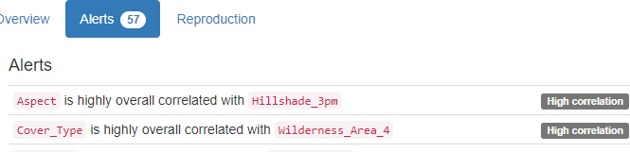

…



…

YData did not find anything that we care.

# 19 - Car Evaluation - N/A

Dataset analysed: car.data from <https://archive.ics.uci.edu/ml/machine-learning-databases/car/car.data> (dataset_file_url column from Fiftydatasets.xlsx) It does not have header.

buying (high):

All 1728 values are correctly categorical.

Categorical format with 4 unique values:

Category Frequency

high 432

low 432

med 432

vhigh 432

maint (high):

All 1728 values are correctly categorical.

Categorical format with 4 unique values:

Category Frequency

high 432

low 432

med 432

vhigh 432

doors (more):

All 1728 values are correctly categorical.

Categorical format with 4 unique values:

Category Frequency

2 432

3 432

4 432

5more 432

persons (more):

All 1728 values are correctly categorical.

Categorical format with 3 unique values:

Category Frequency

2 576

4 576

more 576

lug_boot (big):

All 1728 values are correctly categorical.

Categorical format with 3 unique values:

Category Frequency

big 576

med 576

small 576

safety (high):

All 1728 values are correctly categorical.

Categorical format with 3 unique values:

Category Frequency

high 576

low 576

med 576

Class Values (class):

All 1728 values are correctly categorical.

Categorical format with 4 unique values:

Category Frequency

unacc 1210

acc 384

good 69

vgood 65

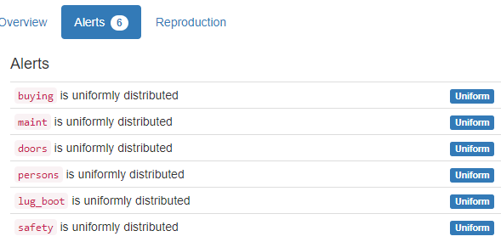

YData did not find anything that we care.

# 10 - Automobile - N/A

Dataset analysed: imports-85.data from <https://archive.ics.uci.edu/ml/machine-learning-databases/autos/imports-85.data> (dataset_file_url column from Fiftydatasets.xlsx) It does not have header.

symboling (symbol):

String format: Error(s) found:

DQI #17 (Non-String Data Type - Consistency):

205 Non-string value(s) at index(es): [(0, 3), (1, 3), (2, 1), (3, 2), (4, 2), (5, 2), (6, 1), (7, 1), (8, 1), (9, 0), ('...', '...'), (195, -1), (196, -2), (197, -1), (198, -2), (199, -1), (200, -1), (201, -1), (202, -1), (203, -1), (204, -1)] (displaying only the first and last 10 items)

String range (lexicographical): (-1 : 3)

normalized-losses (continuous):

Numerical >=0 format: Error(s) found:

DQI #1 (Missing Data - Completeness):

41 Blank/Empty/Null/Missing value(s) at index(es): [(0, '?'), (1, '?'), (2, '?'), (5, '?'), (7, '?'), (9, '?'), (14, '?'), (15, '?'), (16, '?'), (17, '?'), ('...', '...'), (127, '?'), (128, '?'), (129, '?'), (130, '?'), (131, '?'), (181, '?'), (189, '?'), (191, '?'), (192, '?'), (193, '?')] (displaying only the first and last 10 items)

Range of values: (65:256).

make:

All 205 values are correctly categorical.

Categorical format with 22 unique values:

Category Frequency

toyota 32

nissan 18

mazda 17

honda 13

mitsubishi 13

subaru 12

volkswagen 12

peugot 11

volvo 11

dodge 9

... ...

audi 7

plymouth 7

saab 6

porsche 5

isuzu 4

alfa-romero 3

chevrolet 3

jaguar 3

renault 2

mercury 1

fuel-type (type):

All 205 values are correctly categorical.

Categorical format with 2 unique values:

Category Frequency

gas 185

diesel 20

aspiration:

All 205 values are correctly categorical.

Categorical format with 2 unique values:

Category Frequency

std 168

turbo 37

num-of-doors (four):

Categorical format: Error(s) found:

DQI #1 (Missing Data - Completeness):

2 Blank/Empty/Null/Missing value(s) at index(es): [(27, '?'), (63, '?')]

Categorical format with 3 unique values:

Category Frequency

four 114

two 89

? 2

body-style (style):

All 205 values are correctly categorical.

Categorical format with 5 unique values:

Category Frequency

sedan 96

hatchback 70

wagon 25

hardtop 8

convertible 6

drive-wheels (drive):

All 205 values are correctly categorical.

Categorical format with 3 unique values:

Category Frequency

fwd 120

rwd 76

4wd 9

engine-location (location):

All 205 values are correctly categorical.

Categorical format with 2 unique values:

Category Frequency

front 202

rear 3

wheel-base (continuous):

Numerical >=0 format: All 205 values are numerical and greater or equal to 0 in the range (86.6:120.9).

length:

Numerical >=0 format: All 205 values are numerical and greater or equal to 0 in the range (141.1:208.1).

width:

Numerical >=0 format: All 205 values are numerical and greater or equal to 0 in the range (60.3:72.3).

height:

Numerical >=0 format: All 205 values are numerical and greater or equal to 0 in the range (47.8:59.8).

curb-weight (weight):

Numerical >=0 format: All 205 values are numerical and greater or equal to 0 in the range (1488:4066).

engine-type (type):

All 205 values are correctly categorical.

Categorical format with 7 unique values:

Category Frequency

ohc 148

ohcf 15

ohcv 13

dohc 12

l 12

rotor 4

dohcv 1

num-of-cylinders (four):

All 205 values are correctly categorical.

Categorical format with 7 unique values:

Category Frequency

four 159

six 24

five 11

eight 5

two 4

three 1

twelve 1

engine-size (size):

Numerical >=0 format: All 205 values are numerical and greater or equal to 0 in the range (61:326).

fuel-system (system):

All 205 values are correctly categorical.

Categorical format with 8 unique values:

Category Frequency

mpfi 94

2bbl 66

idi 20

1bbl 11

spdi 9

4bbl 3

mfi 1

spfi 1

bore:

Numerical >=0 format: Error(s) found:

DQI #1 (Missing Data - Completeness):

4 Blank/Empty/Null/Missing value(s) at index(es): [(55, '?'), (56, '?'), (57, '?'), (58, '?')]

Range of values: (2.54:3.94).

stroke:

Numerical >=0 format: Error(s) found:

DQI #1 (Missing Data - Completeness):

4 Blank/Empty/Null/Missing value(s) at index(es): [(55, '?'), (56, '?'), (57, '?'), (58, '?')]

Range of values: (2.07:4.17).

compression-ratio (ratio):

Numerical format: All 205 values are numerical in the range (7.0:23.0).

horsepower:

Numerical >=0 format: Error(s) found:

DQI #1 (Missing Data - Completeness):

2 Blank/Empty/Null/Missing value(s) at index(es): [(130, '?'), (131, '?')]

Range of values: (48:288).

peak-rpm (rpm):

Numerical >=0 format: Error(s) found:

DQI #1 (Missing Data - Completeness):

2 Blank/Empty/Null/Missing value(s) at index(es): 130, '?'), (131, '?')]

Range of values: (4150:6600).

city-mpg (mpg):

Numerical >=0 format: All 205 values are numerical and greater or equal to 0 in the range (13:49).

highway-mpg (mpg):

Numerical >=0 format: All 205 values are numerical and greater or equal to 0 in the range (16:54).

price:

Numerical format: Error(s) found:

DQI #1 (Missing Data - Completeness):

4 Blank/Empty/Null/Missing value(s) at index(es): [(9, '?'), (44, '?'), (45, '?'), (129, '?')]

Range of values: (5118:45400).

Last run on: 2024-02-25 22:05:41

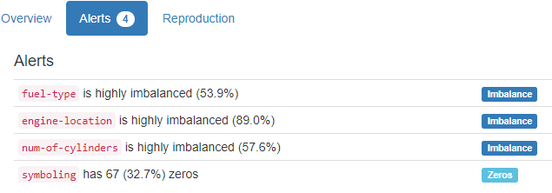

YData did not find the 7 ‘?’s

# 9 - Auto MPG - N/A

Dataset analysed: auto-mpg.data from <https://archive.ics.uci.edu/ml/machine-learning-databases/auto-mpg/auto-mpg.data> (dataset_file_url column from Fiftydatasets.xlsx) It does not have header.

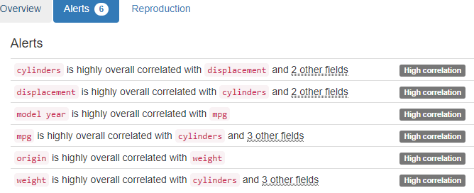

YData just found High Correlation. It did not find ‘?’, Year and Name Data Quality Issues.

mpg:

Numerical >=0 format: All 398 values are numerical and greater or equal to 0 in the range (9.0:46.6).

cylinders (cylinder):

Numerical >=0 format: All 398 values are numerical and greater or equal to 0 in the range (3:8).

displacement:

Numerical >=0 format: All 398 values are numerical and greater or equal to 0 in the range (68.0:455.0).

horsepower:

Numerical >=0 format: Error(s) found:

DQI #1 (Missing Data - Completeness):

6 Blank/Empty/Null/Missing value(s) at index(es): [(32, '?'), (126, '?'), (330, '?'), (336, '?'), (354, '?'), (374, '?')]

Range of values: (46.0:230.0).

weight:

Numerical >=0 format: All 398 values are numerical and greater or equal to 0 in the range (1613.0:5140.0).

acceleration:

Numerical format: All 398 values are numerical in the range (8.0:24.8).

model year (year):

Year format: Error(s) found:

DQI #15 (Domain Violation - Accuracy):

398 Value(s) outside range [1800, 2100] at index(es): [(0, 70), (1, 70), (2, 70), (3, 70), (4, 70), (5, 70), (6, 70), (7, 70), (8, 70), (9, 70), ('...', '...'), (388, 82), (389, 82), (390, 82), (391, 82), (392, 82), (393, 82), (394, 82), (395, 82), (396, 82), (397, 82)] (displaying only the first and last 10 items)

Actual range of values: (70 : 82)

origin:

All 398 values are correctly categorical.

Categorical format with 3 unique values:

Category Frequency

1 249

3 79

2 70

car name (name):

Name format: Error(s) found:

DQI #5 (Extraneous Data - Consistency, Uniqueness):

116 Extraneous data value(s) at index(es): [(1, 'buick skylark 320'), (5, 'ford galaxie 500'), (11, "plymouth 'cuda 340"), (18, 'datsun pl510'), (19, 'volkswagen 1131 deluxe sedan'), (20, 'peugeot 504'), (21, 'audi 100 ls'), (22, 'saab 99e'), (23, 'bmw 2002'), (25, 'ford f250'), ('...', '...'), (354, 'renault 18i'), (357, 'datsun 200sx'), (358, 'mazda 626'), (359, 'peugeot 505s turbo diesel'), (362, 'datsun 810 maxima'), (369, 'chevrolet cavalier 2-door'), (370, 'pontiac j2000 se hatchback'), (385, 'datsun 310 gx'), (391, 'dodge charger 2.2'), (397, 'chevy s-10')] (displaying only the first and last 10 items)

Frequency Distribution:

car name Frequency

ford pinto 6

amc matador 5

ford maverick 5

toyota corolla 5

amc gremlin 4

amc hornet 4

chevrolet chevette 4

chevrolet impala 4

peugeot 504 4

toyota corona 4

... ...

volvo 144ea 1

volvo 145e (sw) 1

volvo 244dl 1

volvo 245 1

volvo 264gl 1

volvo diesel 1

vw dasher (diesel) 1

vw pickup 1

vw rabbit c (diesel) 1

vw rabbit custom 1

Range of Values: (amc ambassador brougham to vw rabbit custom)

# 40 - Flags - N/A

Dataset analysed: flag.data from <https://archive.ics.uci.edu/ml/machine-learning-databases/flags/flag.data> (dataset_file_url column from Fiftydatasets.xlsx) It does not have header.

name:

Name format: All 194 name values are valid.

Frequency Distribution:

name Frequency

Afghanistan 1

Albania 1

Algeria 1

American-Samoa 1

Andorra 1

Angola 1

Anguilla 1

Antigua-Barbuda 1

Argentina 1

Argentine 1

... ...

Uruguay 1

Vanuatu 1

Vatican-City 1

Venezuela 1

Vietnam 1

Western-Samoa 1

Yugoslavia 1

Zaire 1

Zambia 1

Zimbabwe 1

Range of Values: (Afghanistan to Zimbabwe)

landmass (1=):

All 194 values are correctly categorical.

Categorical format with 6 unique values:

Category Frequency

4 52

5 39

3 35

1 31

6 20

2 17

zone (1=):

All 194 values are correctly categorical.

Categorical format with 4 unique values:

Category Frequency

1 91

4 58

2 29

3 16

area:

Numerical >=0 format: All 194 values are numerical and greater or equal to 0 in the range (0:22402).

population:

Numerical >=0 format: All 194 values are numerical and greater or equal to 0 in the range (0:1008).

language:

All 194 values are correctly categorical.

Categorical format with 10 unique values:

Category Frequency

10 46

1 43

6 30

2 21

8 19

3 17

4 6

5 4

7 4

9 4

religion:

All 194 values are correctly categorical.

Categorical format with 8 unique values:

Category Frequency

1 60

0 40

2 36

5 27

6 15

3 8

4 4

7 4

bars (number):

Numerical format: All 194 values are numerical in the range (0:5).

stripes (number):

Numerical format: All 194 values are numerical in the range (0:14).

colours (number):

Numerical format: All 194 values are numerical in the range (1:8).

red (0 if):

All 194 values are correctly categorical.

Categorical format with 2 unique values:

Category Frequency

1 153

0 41

green (0 if):

All 194 values are correctly categorical.

Categorical format with 2 unique values:

Category Frequency

0 103

1 91

blue (0 if):

All 194 values are correctly categorical.

Categorical format with 2 unique values:

Category Frequency

1 99

0 95

gold (0 if):

All 194 values are correctly categorical.

Categorical format with 2 unique values:

Category Frequency

0 103

1 91

white (0 if):

All 194 values are correctly categorical.

Categorical format with 2 unique values:

Category Frequency

1 146

0 48

black (0 if):

All 194 values are correctly categorical.

Categorical format with 2 unique values:

Category Frequency

0 142

1 52

orange (0 if):

All 194 values are correctly categorical.

Categorical format with 2 unique values:

Category Frequency

0 168

1 26

mainhue (colour):

All 194 values are correctly categorical.

Categorical format with 8 unique values:

Category Frequency

red 71

blue 40

green 31

white 22

gold 19

black 5

orange 4

brown 2

circles (circle):

Numerical >=0 format: All 194 values are numerical and greater or equal to 0 in the range (0:4).

crosses (number):

Numerical format: All 194 values are numerical in the range (0:2).

saltires (number):

Numerical format: All 194 values are numerical in the range (0:1).

quarters (number):

Numerical format: All 194 values are numerical in the range (0:4).

sunstars (number):

Numerical format: All 194 values are numerical in the range (0:50).

crescent (1 if):

All 194 values are correctly categorical.

Categorical format with 2 unique values:

Category Frequency

0 183

1 11

triangle (1 if):

All 194 values are correctly categorical.

Categorical format with 2 unique values:

Category Frequency

0 167

1 27

icon (1 if):

All 194 values are correctly categorical.

Categorical format with 2 unique values:

Category Frequency

0 145

1 49

animate (animation):

All 194 values are correctly categorical.

Categorical format with 2 unique values:

Category Frequency

0 155

1 39

text (1 if):

All 194 values are correctly categorical.

Categorical format with 2 unique values:

Category Frequency

0 178

1 16

topleft (colour):

All 194 values are correctly categorical.

Categorical format with 7 unique values:

Category Frequency

red 56

blue 43

white 41

green 32

black 12

gold 6

orange 4

botright (colour):

All 194 values are correctly categorical.

Categorical format with 8 unique values:

Category Frequency

red 69

blue 47

green 40

white 17

black 9

gold 9

brown 2

orange 1

Last run on: 2024-02-26 16:59:40

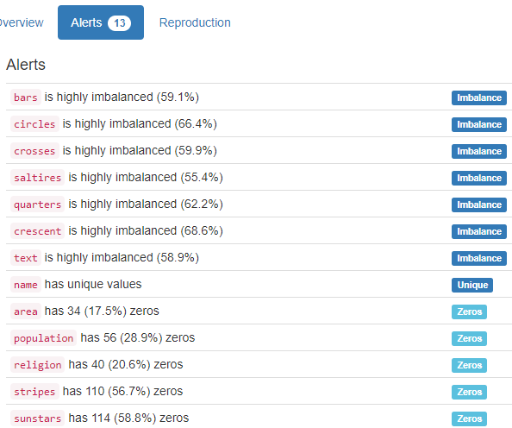

YData did not find anything that we care.

# 336 - Chronic_Kidney_Disease - N/A

Dataset analysed: @DATA part extracted from chronic_kidney_disease_full.arff that was obtained at Chronic_Kidney_Disease.rar from <https://archive.ics.uci.edu/ml/machine-learning-databases/00336/Chronic_Kidney_Disease.rar> (dataset_file_url column from Fiftydatasets.xlsx) It does not have header.

YData Profiling just brought High Correlation and Imbalance alerts, no ‘?’ information. We found dozens of cases with ‘?’.

Age:

Age format: Error(s) found:

DQI #1 (Missing Data - Completeness):

9 Blank/Empty/Null/Missing value(s) at index(es): [(30, '?'), (73, '?'), (112, '?'), (116, '?'), (117, '?'), (169, '?'), (191, '?'), (203, '?'), (268, '?')]

Actual range of values: (2 : 90)

Blood Pressure (blood):

Numerical format: Error(s) found:

DQI #1 (Missing Data - Completeness):

12 Blank/Empty/Null/Missing value(s) at index(es): [(7, '?'), (75, '?'), (132, '?'), (138, '?'), (161, '?'), (164, '?'), (185, '?'), (187, '?'), (188, '?'), (215, '?'), (293, '?'), (316, '?')]

Range of values: (50:180).

Specific Gravity (nominal):

Categorical format: Error(s) found:

DQI #1 (Missing Data - Completeness):

47 Blank/Empty/Null/Missing value(s) at index(es): [(13, '?'), (17, '?'), (21, '?'), (28, '?'), (30, '?'), (37, '?'), (50, '?'), (57, '?'), (59, '?'), (78, '?'), ('...', '...'), (228, '?'), (231, '?'), (236, '?'), (238, '?'), (245, '?'), (268, '?'), (280, '?'), (295, '?'), (322, '?'), (346, '?')] (displaying only the first and last 10 items)

Categorical format with 6 unique values:

Category Frequency

1.020 106

1.010 84

1.025 81

1.015 75

? 47

1.005 7

Albumin (nominal):

Categorical format: Error(s) found:

DQI #1 (Missing Data - Completeness):

46 Blank/Empty/Null/Missing value(s) at index(es): [(13, '?'), (17, '?'), (21, '?'), (30, '?'), (37, '?'), (50, '?'), (57, '?'), (59, '?'), (78, '?'), (81, '?'), ('...', '...'), (228, '?'), (231, '?'), (236, '?'), (238, '?'), (245, '?'), (268, '?'), (280, '?'), (295, '?'), (322, '?'), (346, '?')] (displaying only the first and last 10 items)

Categorical format with 7 unique values:

Category Frequency

0 199

? 46

1 44

2 43

3 43

4 24

5 1

Sugar (nominal):

Categorical format: Error(s) found:

DQI #1 (Missing Data - Completeness):

49 Blank/Empty/Null/Missing value(s) at index(es): [(13, '?'), (17, '?'), (21, '?'), (30, '?'), (37, '?'), (50, '?'), (57, '?'), (59, '?'), (78, '?'), (81, '?'), ('...', '...'), (228, '?'), (231, '?'), (236, '?'), (238, '?'), (245, '?'), (268, '?'), (280, '?'), (295, '?'), (322, '?'), (346, '?')] (displaying only the first and last 10 items)

Categorical format with 7 unique values:

Category Frequency

0 290

? 49

2 18

3 14

1 13

4 13

5 3

Red Blood Cells (nominal):

Categorical format: Error(s) found:

DQI #1 (Missing Data - Completeness):

152 Blank/Empty/Null/Missing value(s) at index(es): [(0, '?'), (1, '?'), (5, '?'), (6, '?'), (10, '?'), (12, '?'), (13, '?'), (15, '?'), (16, '?'), (17, '?'), ('...', '...'), (245, '?'), (268, '?'), (280, '?'), (290, '?'), (295, '?'), (309, '?'), (322, '?'), (349, '?'), (350, '?'), (381, '?')] (displaying only the first and last 10 items)

Categorical format with 3 unique values:

Category Frequency

normal 201

? 152

abnormal 47

Pus Cell (nominal):

Categorical format: Error(s) found:

DQI #1 (Missing Data - Completeness):

65 Blank/Empty/Null/Missing value(s) at index(es): [(5, '?'), (13, '?'), (17, '?'), (21, '?'), (28, '?'), (30, '?'), (34, '?'), (37, '?'), (39, '?'), (43, '?'), ('...', '...'), (245, '?'), (268, '?'), (280, '?'), (290, '?'), (295, '?'), (309, '?'), (322, '?'), (349, '?'), (350, '?'), (381, '?')] (displaying only the first and last 10 items)

Categorical format with 3 unique values:

Category Frequency

normal 259

abnormal 76

? 65

Pus Cell clumps (nominal):

Categorical format: Error(s) found:

DQI #1 (Missing Data - Completeness):

4 Blank/Empty/Null/Missing value(s) at index(es): [(290, '?'), (300, '?'), (316, '?'), (328, '?')]

Categorical format with 3 unique values:

Category Frequency

notpresent 354

present 42

? 4

Bacteria (nominal):

Categorical format: Error(s) found:

DQI #1 (Missing Data - Completeness):

4 Blank/Empty/Null/Missing value(s) at index(es): [(290, '?'), (300, '?'), (316, '?'), (328, '?')]

Categorical format with 3 unique values:

Category Frequency

notpresent 374

present 22

? 4

Blood Glucose Random (blood):

Numerical format: Error(s) found:

DQI #1 (Missing Data - Completeness):

44 Blank/Empty/Null/Missing value(s) at index(es): [(1, '?'), (21, '?'), (23, '?'), (24, '?'), (29, '?'), (38, '?'), (41, '?'), (47, '?'), (52, '?'), (54, '?'), ('...', '...'), (209, '?'), (215, '?'), (232, '?'), (234, '?'), (276, '?'), (283, '?'), (312, '?'), (315, '?'), (332, '?'), (378, '?')] (displaying only the first and last 10 items)

Range of values: (22:490).

Blood Urea (blood):

Numerical format: Error(s) found:

DQI #1 (Missing Data - Completeness):

19 Blank/Empty/Null/Missing value(s) at index(es): [(23, '?'), (54, '?'), (55, '?'), (64, '?'), (67, '?'), (113, '?'), (134, '?'), (161, '?'), (165, '?'), (209, '?'), (215, '?'), (220, '?'), (232, '?'), (276, '?'), (283, '?'), (312, '?'), (315, '?'), (334, '?'), (378, '?')]

Range of values: (1.5:391.0).

Serum Creatinine (creatinine):

Numerical format: Error(s) found:

DQI #1 (Missing Data - Completeness):

17 Blank/Empty/Null/Missing value(s) at index(es): [(23, '?'), (55, '?'), (64, '?'), (67, '?'), (113, '?'), (161, '?'), (165, '?'), (209, '?'), (215, '?'), (216, '?'), (220, '?'), (232, '?'), (276, '?'), (283, '?'), (312, '?'), (315, '?'), (334, '?')]

Range of values: (0.4:76.0).

Sodium:

Numerical format: Error(s) found:

DQI #1 (Missing Data - Completeness):

87 Blank/Empty/Null/Missing value(s) at index(es): [(0, '?'), (1, '?'), (2, '?'), (4, '?'), (7, '?'), (8, '?'), (10, '?'), (19, '?'), (23, '?'), (28, '?'), ('...', '...'), (232, '?'), (234, '?'), (235, '?'), (237, '?'), (240, '?'), (283, '?'), (303, '?'), (315, '?'), (336, '?'), (363, '?')] (displaying only the first and last 10 items)

Range of values: (4.5:163.0).

Potassium:

Numerical format: Error(s) found:

DQI #1 (Missing Data - Completeness):

88 Blank/Empty/Null/Missing value(s) at index(es): [(0, '?'), (1, '?'), (2, '?'), (4, '?'), (7, '?'), (8, '?'), (10, '?'), (19, '?'), (21, '?'), (23, '?'), ('...', '...'), (232, '?'), (234, '?'), (235, '?'), (237, '?'), (240, '?'), (283, '?'), (303, '?'), (315, '?'), (336, '?'), (363, '?')] (displaying only the first and last 10 items)

Range of values: (2.5:47.0).

Hemoglobin:

Numerical format: Error(s) found:

DQI #1 (Missing Data - Completeness):

52 Blank/Empty/Null/Missing value(s) at index(es): [(23, '?'), (28, '?'), (30, '?'), (34, '?'), (41, '?'), (57, '?'), (60, '?'), (61, '?'), (66, '?'), (67, '?'), ('...', '...'), (230, '?'), (232, '?'), (233, '?'), (247, '?'), (273, '?'), (319, '?'), (324, '?'), (328, '?'), (330, '?'), (365, '?')] (displaying only the first and last 10 items)

Range of values: (3.1:17.8).

Packed Cell Volume (volume):

Numerical >=0 format: Error(s) found:

DQI #1 (Missing Data - Completeness):

71 Blank/Empty/Null/Missing value(s) at index(es): [(13, '?'), (16, '?'), (17, '?'), (23, '?'), (28, '?'), (30, '?'), (34, '?'), (38, '?'), (41, '?'), (45, '?'), ('...', '...'), (224, '?'), (228, '?'), (230, '?'), (232, '?'), (233, '?'), (247, '?'), (273, '?'), (319, '?'), (324, '?'), (365, '?')] (displaying only the first and last 10 items)

Range of values: (9:54)

White Blood Cell Count (count):

Numerical >=0 format: Error(s) found:

DQI #1 (Missing Data - Completeness):

106 Blank/Empty/Null/Missing value(s) at index(es): [(6, '?'), (10, '?'), (13, '?'), (16, '?'), (17, '?'), (23, '?'), (28, '?'), (29, '?'), (30, '?'), (33, '?'), ('...', '...'), (238, '?'), (239, '?'), (247, '?'), (273, '?'), (274, '?'), (287, '?'), (302, '?'), (319, '?'), (324, '?'), (330, '?')] (displaying only the first and last 10 items)

Range of values: (2200:26400)

Red Blood Cell Count (count):

Numerical >=0 format: Error(s) found:

DQI #1 (Missing Data - Completeness):

131 Blank/Empty/Null/Missing value(s) at index(es): [(1, '?'), (2, '?'), (6, '?'), (10, '?'), (13, '?'), (16, '?'), (17, '?'), (23, '?'), (28, '?'), (29, '?'), ('...', '...'), (238, '?'), (239, '?'), (247, '?'), (273, '?'), (274, '?'), (287, '?'), (302, '?'), (319, '?'), (324, '?'), (330, '?')] (displaying only the first and last 10 items)

Range of values: (2.1:8.0).

Hypertension (nominal):

Categorical format: Error(s) found:

DQI #1 (Missing Data - Completeness):

2 Blank/Empty/Null/Missing value(s) at index(es): [(288, '?'), (297, '?')]

Categorical format with 3 unique values:

Category Frequency

no 251

yes 147

? 2

Diabetes Mellitus (nominal):

Categorical format: Error(s) found:

DQI #1 (Missing Data - Completeness):

2 Blank/Empty/Null/Missing value(s) at index(es): [(288, '?'), (297, '?')]

Categorical format with 5 unique values:

Category Frequency

no 258

yes 134

no 3

yes 3

? 2

Coronary Artery Disease (disease):

Categorical format: Error(s) found:

DQI #1 (Missing Data - Completeness):

2 Blank/Empty/Null/Missing value(s) at index(es): [(288, '?'), (297, '?')]

Categorical format with 4 unique values:

Category Frequency

no 362

yes 34

no 2

? 2

Appetite:

Categorical format: Error(s) found:

DQI #1 (Missing Data - Completeness):

1 Blank/Empty/Null/Missing value(s) at index(es): [(294, '?')]

Categorical format with 3 unique values:

Category Frequency

good 317

poor 82

? 1

Pedal Edema (nominal):

Categorical format: Error(s) found:

DQI #1 (Missing Data - Completeness):

1 Blank/Empty/Null/Missing value(s) at index(es): [(294, '?')]

Categorical format with 3 unique values:

Category Frequency

no 323

yes 76

? 1

Anemia:

Categorical format: Error(s) found:

DQI #1 (Missing Data - Completeness):

1 Blank/Empty/Null/Missing value(s) at index(es): [(294, '?')]

Categorical format with 3 unique values:

Category Frequency

no 339

yes 60

? 1

Class:

All 400 values are correctly categorical.

Categorical format with 3 unique values:

Category Frequency

ckd 248

notckd 150

ckd 2

Last run on: 2024-02-26 20:59:59

# 50 - Image Segmentation - N/A

Dataset analysed: segmentation.data from <https://archive.ics.uci.edu/ml/machine-learning-databases/image/segmentation.data> (dataset_file_url column from Fiftydatasets.xlsx) It has not only a header but also some comments before the header. Therefore it was necessary to copy the file to local directory to extract extraneous lines.

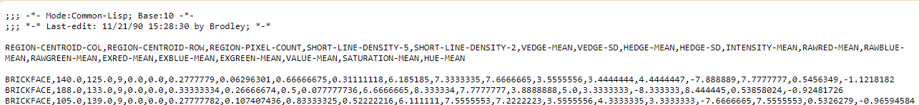

class:

All 210 values are correctly categorical.

Categorical format with 7 unique values:

Category Frequency

BRICKFACE 30

CEMENT 30

FOLIAGE 30

GRASS 30

PATH 30

SKY 30

WINDOW 30

region-centroid-col (column):

Numerical format: All 210 values are numerical in the range (1.0:252.0).

region-centroid-row (row):

Numerical format: All 210 values are numerical in the range (11.0:250.0).

region-pixel-count (count):

Numerical >=0 format: All 210 values are numerical and greater or equal to 0 in the range (9:9).

short-line-density-5 (density):

Numerical >=0 format: All 210 values are numerical and greater or equal to 0 in the range (0.0:0.11111111).

short-line-density-2 (density):

Numerical >=0 format: All 210 values are numerical and greater or equal to 0 in the range (0.0:0.22222222).

vedge-mean (mean):

Numerical format: All 210 values are numerical in the range (0.0:25.5).

vegde-sd (standard deviation):

Numerical >=0 format: All 210 values are numerical and greater or equal to 0 in the range (0.0:572.9964).

hedge-mean (mean):

Numerical format: All 210 values are numerical in the range (0.0:44.722225).

hedge-sd (standard deviation):

Numerical >=0 format: All 210 values are numerical and greater or equal to 0 in the range (0.0:1386.3292).

intensity-mean (intensity):

Numerical format: All 210 values are numerical in the range (0.0:143.44444).

rawred-mean (mean):

Numerical format: All 210 values are numerical in the range (0.0:136.88889).

rawblue-mean (mean):

Numerical format: All 210 values are numerical in the range (0.0:150.88889).

rawgreen-mean (mean):

Numerical format: All 210 values are numerical in the range (0.0:142.55556).

exred-mean (mean):

Numerical format: All 210 values are numerical in the range (-48.22222:5.7777777).

exblue-mean (mean):

Numerical format: All 210 values are numerical in the range (-9.666667:78.77778).

exgreen-mean (mean):

Numerical format: All 210 values are numerical in the range (-30.555555:21.88889).

value-mean (mean):

Numerical format: All 210 values are numerical in the range (0.0:150.88889).

saturatoin-mean (mean):

Numerical format: All 210 values are numerical in the range (0.0:1.0).

hue-mean (mean):

Numerical format: All 210 values are numerical in the range (-2.5309503:2.8649306).

Last run on: 2024-02-26 22:03:00

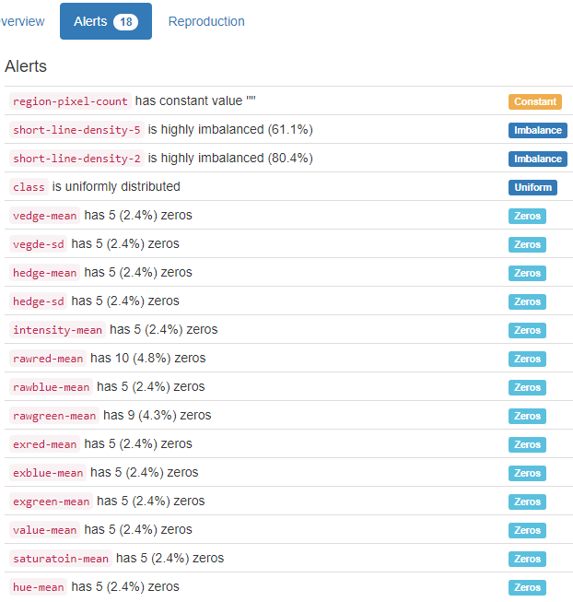

YData shows column region-pixel-count with constant value "". We have not checked that. For us it is a numerical with values in the range (9:9).

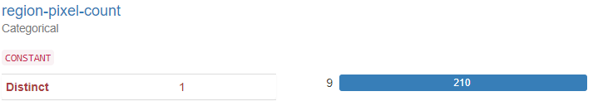

# 162 - Forest Fires – Physical

Dataset analysed: forestfiles.csv from <https://archive.ics.uci.edu/ml/machine-learning-databases/forest-fires/forestfires.csv> (dataset_file_url column from Fiftydatasets.xlsx) has header

X - x-axis spatial coordinate within the Montesinho park map (x):

Numerical format: All 517 values are numerical in the range (1:9).

Y - y-axis spatial coordinate within the Montesinho park map (y):

Numerical format: All 517 values are numerical in the range (2:9).

month - month of the year (month):

Month format: All 517 month values are valid.

Frequency Distribution:

Month Frequency

August 184

September 172

March 54

July 32

February 20

June 17

October 15

April 9

December 9

January 2

May 2

November 1

day - day of the week (day of the week):

Weekday format: All 517 weekday values are valid.

Frequency Distribution:

Weekday Frequency

Sunday 95

Friday 85

Saturday 84

Monday 74

Tuesday 64

Thursday 61

Wednesday 54

FFMC - FFMC index from the FWI system (index):

Numerical format: All 517 values are numerical in the range (18.7:96.2).

DMC - DMC index from the FWI system (index):

Numerical format: All 517 values are numerical in the range (1.1:291.3).

DC - DC index from the FWI system (index):

Numerical format: All 517 values are numerical in the range (7.9:860.6).

ISI - ISI index from the FWI system (index):

Numerical format: All 517 values are numerical in the range (0.0:56.1).

temp - temperature in Celsius degrees (temperature):

Numerical format: All 517 values are numerical in the range (2.2:33.3).

RH - relative humidity in % (humidity):

Numerical >=0 format: All 517 values are numerical and greater or equal to 0 in the range (15:100).

wind - wind speed in km (speed):

Numerical format: All 517 values are numerical in the range (0.4:9.4).

rain - outside rain in mm (rain):

Numerical >=0 format: All 517 values are numerical and greater or equal to 0 in the range (0.0:6.4).

area - the burned area of the forest (area):

Numerical >=0 format: All 517 values are numerical and greater or equal to 0 in the range (0.0:1090.84).

YData did not find anything that we care.

# 235 - Individual household electric power consumption – Physical

Dataset analysed: 1 - household_power_consumption.txt from <https://archive.ics.uci.edu/ml/machine-learning-databases/00235/household_power_consumption.zip> (dataset_file_url column from Fiftydatasets.xlsx) has header and over 2 million lines ! The code has run in 5 minutes in an Intel i7 CPU notebook!

Start of Analysis on: 2024-09-01 12:34:10

date:

Date format: All 2075259 date values are valid in the DDMMYYYY format in the range 16/12/2006 to 26/11/2010.

time:

Time format: All 2075259 time values are valid in the range 00:00:00 to 23:59:00

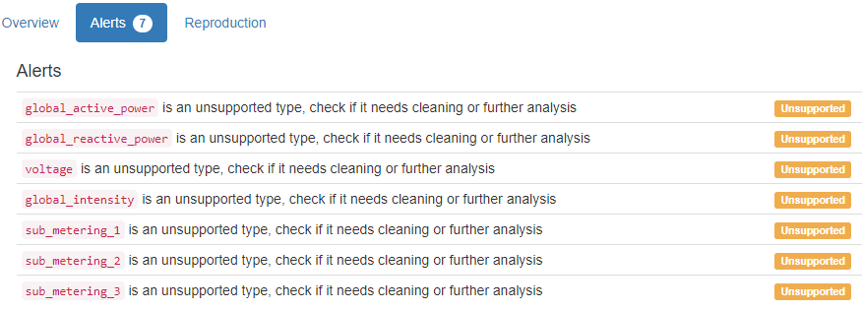

global_active_power (power):

Numerical format: Error(s) found:

DQI #1 (Missing Data - Completeness):

25979 Blank/Empty/Null/Missing value(s) at index(es): [(6839, '?'), (6840, '?'), (19724, '?'), (19725, '?'), (41832, '?'), (61909, '?'), (98254, '?'), (98255, '?'), (142588, '?'), (190497, '?'), ('...', '...'), (1990180, '?'), (1990181, '?'), (1990182, '?'), (1990183, '?'), (1990184, '?'), (1990185, '?'), (1990186, '?'), (1990187, '?'), (1990188, '?'), (2027411, '?')] (displaying only the first and last 10 items)

Range of values: (0.076:11.122).

global_reactive_power (power):

Numerical format: Error(s) found:

DQI #1 (Missing Data - Completeness):

25979 Blank/Empty/Null/Missing value(s) at index(es): [(6839, '?'), (6840, '?'), (19724, '?'), (19725, '?'), (41832, '?'), (61909, '?'), (98254, '?'), (98255, '?'), (142588, '?'), (190497, '?'), ('...', '...'), (1990180, '?'), (1990181, '?'), (1990182, '?'), (1990183, '?'), (1990184, '?'), (1990185, '?'), (1990186, '?'), (1990187, '?'), (1990188, '?'), (2027411, '?')] (displaying only the first and last 10 items)

Range of values: (0.0:1.39).

voltage:

Numerical format: Error(s) found:

DQI #1 (Missing Data - Completeness):

25979 Blank/Empty/Null/Missing value(s) at index(es): [(6839, '?'), (6840, '?'), (19724, '?'), (19725, '?'), (41832, '?'), (61909, '?'), (98254, '?'), (98255, '?'), (142588, '?'), (190497, '?'), ('...', '...'), (1990180, '?'), (1990181, '?'), (1990182, '?'), (1990183, '?'), (1990184, '?'), (1990185, '?'), (1990186, '?'), (1990187, '?'), (1990188, '?'), (2027411, '?')] (displaying only the first and last 10 items)

Range of values: (223.2:254.15).

global_intensity (intensity):

Numerical format: Error(s) found:

DQI #1 (Missing Data - Completeness):

25979 Blank/Empty/Null/Missing value(s) at index(es): [(6839, '?'), (6840, '?'), (19724, '?'), (19725, '?'), (41832, '?'), (61909, '?'), (98254, '?'), (98255, '?'), (142588, '?'), (190497, '?'), ('...', '...'), (1990180, '?'), (1990181, '?'), (1990182, '?'), (1990183, '?'), (1990184, '?'), (1990185, '?'), (1990186, '?'), (1990187, '?'), (1990188, '?'), (2027411, '?')] (displaying only the first and last 10 items)

Range of values: (0.2:48.4).

sub_metering_1 (metering):

Numerical format: Error(s) found:

DQI #1 (Missing Data - Completeness):

25979 Blank/Empty/Null/Missing value(s) at index(es): [(6839, '?'), (6840, '?'), (19724, '?'), (19725, '?'), (41832, '?'), (61909, '?'), (98254, '?'), (98255, '?'), (142588, '?'), (190497, '?'), ('...', '...'), (1990180, '?'), (1990181, '?'), (1990182, '?'), (1990183, '?'), (1990184, '?'), (1990185, '?'), (1990186, '?'), (1990187, '?'), (1990188, '?'), (2027411, '?')] (displaying only the first and last 10 items)

Range of values: (0.0:88.0).

sub_metering_2 (metering):

Numerical format: Error(s) found:

DQI #1 (Missing Data - Completeness):

25979 Blank/Empty/Null/Missing value(s) at index(es): [(6839, '?'), (6840, '?'), (19724, '?'), (19725, '?'), (41832, '?'), (61909, '?'), (98254, '?'), (98255, '?'), (142588, '?'), (190497, '?'), ('...', '...'), (1990180, '?'), (1990181, '?'), (1990182, '?'), (1990183, '?'), (1990184, '?'), (1990185, '?'), (1990186, '?'), (1990187, '?'), (1990188, '?'), (2027411, '?')] (displaying only the first and last 10 items)

Range of values: (0.0:80.0).

sub_metering_3 (metering):

Numerical format: Error(s) found:

DQI #1 (Missing Data - Completeness):

25979 Blank/Empty/Null/Missing value(s) at index(es):

25979 Non-NULL values: [(6839, 'Empty'), (6840, 'Empty'), (19724, 'Empty'), (19725, 'Empty'), (41832, 'Empty'), (61909, 'Empty'), (98254, 'Empty'), (98255, 'Empty'), (142588, 'Empty'), (190497, 'Empty'), ('...', '...'), (1990180, 'Empty'), (1990181, 'Empty'), (1990182, 'Empty'), (1990183, 'Empty'), (1990184, 'Empty'), (1990185, 'Empty'), (1990186, 'Empty'), (1990187, 'Empty'), (1990188, 'Empty'), (2027411, 'Empty')]

Range of values: (0.0:31.0).

Last run on: 2024-09-01 12:39:02 – 5 MINUTES!

# 165 - Concrete Compressive Strength – Physical

Dataset analysed: Concrete_Data.xls from <https://archive.ics.uci.edu/ml/machine-learning-databases/concrete/compressive/Concrete_Data.xls> (dataset_file_url column from Fiftydatasets.xlsx) has header

Cement:

Numerical >=0 format: All 1030 values are numerical and greater or equal to 0 in the range (102.0:540.0).

Blast Furnace Slag (slag):

Numerical format: All 1030 values are numerical in the range (0.0:359.4).

Fly Ash (ash):

Numerical >=0 format: All 1030 values are numerical and greater or equal to 0 in the range (0.0:200.1).

Water:

Numerical format: All 1030 values are numerical in the range (121.75:247.0).

Superplasticizer (quantitative):

Numerical format: All 1030 values are numerical in the range (0.0:32.2).

Coarse Aggregate (quantitative):

Numerical format: All 1030 values are numerical in the range (801.0:1145.0).

Fine Aggregate (quantitative):

Numerical format: All 1030 values are numerical in the range (594.0:992.6).

Age -- quantitative -- Day (day):

Day format: All 1030 values are numerical and valid in the range [1, 366].

Actual range of values: (1 : 365)

Concrete compressive strength -- quantitative -- MPa -- Output Variable (quantitative):

Numerical format: All 1030 values are numerical in the range (2.331807832:82.5992248).

Last run on: 2024-02-29 14:35:20

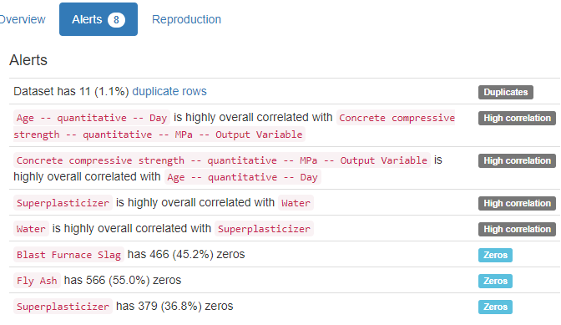

YData did not find anything that we care.

138 - Robot Execution Failures – [archive.ics.uci.edu/ml/machine-learning-databases/robotfailure-mld/lp1.data](https://archive.ics.uci.edu/ml/machine-learning-databases/robotfailure-mld/lp1.data) Physical had data set in different lines for the same instance of data. There is no way to read such dataset. See two instances below:

normal

-1 -1 63 -3 -1 0

0 0 62 -3 -1 0

-1 -1 61 -3 0 0

-1 -1 63 -2 -1 0

-1 -1 63 -3 -1 0

-1 -1 63 -3 -1 0

-1 -1 63 -3 0 0

-1 -1 63 -3 -1 0

-1 -1 63 -3 -1 0

-1 -1 61 -3 0 0

-1 -1 61 -3 0 0

-1 -1 64 -3 -1 0

-1 -1 64 -3 -1 0

-1 -1 60 -3 0 0

-1 0 64 -2 -1 0

normal

-1 -1 63 -2 -1 0

-1 -1 63 -3 -1 0

-1 -1 61 -3 0 0

0 -4 63 1 0 0

0 -1 59 -2 0 -1

-3 3 57 -8 -3 -1

-1 3 70 -10 -2 -1

0 -3 61 0 0 0

0 -2 53 -1 -2 0

0 -3 66 1 4 0

-3 3 58 -10 -5 0

-1 -1 66 -4 -2 0

-1 -2 67 -3 -1 0

0 1 66 -6 -3 -1

-1 -1 59 -3 -4 0

52 – Ionosphere - Physical <https://archive.ics.uci.edu/ml/machine-learning-databases/ionosphere/ionosphere.data>

This dataset does not exhibit names/labels of columns/attributes.

# 381 - Beijing PM2.5 Data - Physical

Dataset analysed: PRSA_data_2010.1.1-2014.12.31.csv from <https://archive.ics.uci.edu/ml/machine-learning-databases/00381/PRSA_data_2010.1.1-2014.12.31.csv> (dataset_file_url column from Fiftydatasets.xlsx) has header

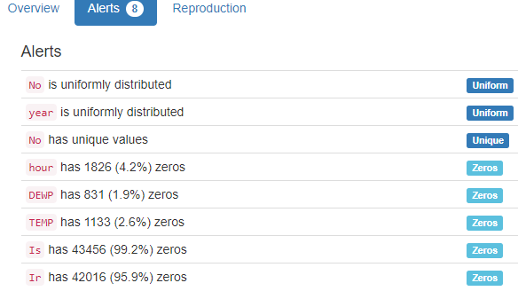

YData found that the column ‘No’ has unique values. We just found that it is a numerical format with nothing wrong. Besides that we found that the column pm2.5 should have only numerical values but we found over 2000 values with the content ‘NA’. They also found that but did not consider an alert.

No (number):

Numerical format: All 43824 values are numerical in the range (1:43824).

year:

Year format: All 43824 values are numerical and valid in the range [1800, 2100].

Actual range of values: (2010 : 2014)

month:

Month format: All 43824 month values are valid.

Frequency Distribution:

Month Frequency

January 3720

March 3720

May 3720

July 3720

August 3720

October 3720

December 3720

April 3600

June 3600

September 3600

November 3600

February 3384

day:

Day format: All 43824 values are numerical and valid in the range [1, 366].

Actual range of values: (1 : 31)

hour:

Numerical (between 0 and 24) format: All 43824 values are numerical and valid in the range [0, 24].

Actual range of values: (0 : 23)

pm2.5 (concentration):

Numerical >=0 format: Error(s) found:

DQI #17 (Wrong Data Type - Consistency):

2067 Non-numeric value(s) at index(es): [(0, 'NA'), (1, 'NA'), (2, 'NA'), (3, 'NA'), (4, 'NA'), (5, 'NA'), (6, 'NA'), (7, 'NA'), (8, 'NA'), (9, 'NA'), ('...', '...'), (43283, 'NA'), (43544, 'NA'), (43545, 'NA'), (43546, 'NA'), (43547, 'NA'), (43548, 'NA'), (43549, 'NA'), (43550, 'NA'), (43551, 'NA'), (43552, 'NA')] (displaying only the first and last 10 items)

Range of values: (0.0:994.0).

DEWP (dew point):

Numerical format: All 43824 values are numerical in the range (-40:28).

TEMP (temperature):

Numerical format: All 43824 values are numerical in the range (-19.0:42.0).

PRES (pressure):

Numerical format: All 43824 values are numerical in the range (991.0:1046.0).

cbwd (direction):

All 43824 values are correctly categorical.

Categorical format with 4 unique values:

Category Frequency

SE 15290

NW 14150

cv 9387

NE 4997

Iws (speed):

Numerical format: All 43824 values are numerical in the range (0.45:585.6).

Is (hours):

Numerical >=0 format: All 43824 values are numerical and greater or equal to 0 in the range (0:27).

Ir (hours):

Numerical >=0 format: All 43824 values are numerical and greater or equal to 0 in the range (0:36).

Last run on: 2024-02-29 15:32:41

# 320 - Student Performance - Social

Dataset analysed: student-por.csv from <https://archive.ics.uci.edu/ml/machine-learning-databases/00320/.student.zip_old> (dataset_file_url column from Fiftydatasets.xlsx), but, as the original file ends with zip_old, the file had to be renamed to only .zip to extract the final dataset has header

school - student's school (binary):

Binary format: All 649 binary values are valid.

Frequency Distribution:

Value Frequency

GP 423

MS 226

sex - student's sex (binary):

Binary format: All 649 binary values are valid.

Frequency Distribution:

Value Frequency

F 383

M 266

age - student's age (age):

Age format: All 649 values are numerical and valid in the range [0, 130].

Actual range of values: (15 : 22)

address - student's home address type (binary):

Binary format: All 649 binary values are valid.

Frequency Distribution:

Value Frequency

U 452

R 197

famsize - family size (binary):

Binary format: All 649 binary values are valid.

Frequency Distribution:

Value Frequency

GT3 457

LE3 192

Pstatus - parent's cohabitation status (binary):

Binary format: All 649 binary values are valid.

Frequency Distribution:

Value Frequency

T 569

A 80

Medu - mother's education (numeric):

Numerical format: All 649 values are numerical in the range (0:4).

Fedu - father's education (numeric):

Numerical format: All 649 values are numerical in the range (0:4).

Mjob - mother's job (job):

All 649 values are correctly categorical.

Categorical format with 5 unique values:

Category Frequency

other 258

services 136

at_home 135

teacher 72

health 48

Fjob - father's job (job):

All 649 values are correctly categorical.

Categorical format with 5 unique values:

Category Frequency

other 367

services 181

at_home 42

teacher 36

health 23

reason - reason to choose this school (reason):

All 649 values are correctly categorical.

Categorical format with 4 unique values:

Category Frequency

course 285

home 149

reputation 143

other 72

guardian - student's guardian (guardian):

All 649 values are correctly categorical.

Categorical format with 3 unique values:

Category Frequency

mother 455

father 153

other 41

traveltime - home to school travel time (numeric):

Numerical format: All 649 values are numerical in the range (1:4).

studytime - weekly study time (numeric):

Numerical format: All 649 values are numerical in the range (1:4).

failures - number of past class failures (number):

Numerical format: All 649 values are numerical in the range (0:3).

schoolsup - extra educational support (binary):

Binary format: All 649 binary values are valid.

Frequency Distribution:

Value Frequency

no 581

yes 68

famsup - family educational support (binary):

Binary format: All 649 binary values are valid.

Frequency Distribution:

Value Frequency

yes 398

no 251

paid - extra paid classes within the course subject (binary):

Binary format: All 649 binary values are valid.

Frequency Distribution:

Value Frequency

no 610

yes 39

activities - extra-curricular activities (binary):

Binary format: All 649 binary values are valid.

Frequency Distribution:

Value Frequency

no 334

yes 315

nursery - attended nursery school (binary):

Binary format: All 649 binary values are valid.

Frequency Distribution:

Value Frequency

yes 521

no 128

higher - wants to take higher education (binary):

Binary format: All 649 binary values are valid.

Frequency Distribution:

Value Frequency

yes 580

no 69

internet - Internet access at home (binary):

Binary format: All 649 binary values are valid.

Frequency Distribution:

Value Frequency

yes 498

no 151

romantic - with a romantic relationship (binary):

Binary format: All 649 binary values are valid.

Frequency Distribution:

Value Frequency

no 410

yes 239

famrel - quality of family relationships (numeric):

Numerical format: All 649 values are numerical in the range (1:5).

freetime - free time after school (numeric):

Numerical format: All 649 values are numerical in the range (1:5).

goout - going out with friends (numeric):

Numerical format: All 649 values are numerical in the range (1:5).

Dalc - workday alcohol consumption (alcohol):

Numerical format: All 649 values are numerical in the range (1:5).

Walc - weekend alcohol consumption (alcohol):

Numerical format: All 649 values are numerical in the range (1:5).

health - current health status (numeric):

Numerical format: All 649 values are numerical in the range (1:5).

absences - number of school absences (number):

Numerical format: All 649 values are numerical in the range (0:32).

G1 - first period grade (grade):

Numerical >=0 format: All 649 values are numerical and greater or equal to 0 in the range (0:19).

G2 - second period grade (grade):

Numerical >=0 format: All 649 values are numerical and greater or equal to 0 in the range (0:19).

G3 - final grade (grade):

Numerical >=0 format: All 649 values are numerical and greater or equal to 0 in the range (0:19).

Last run on: 2024-02-29 21:26:03

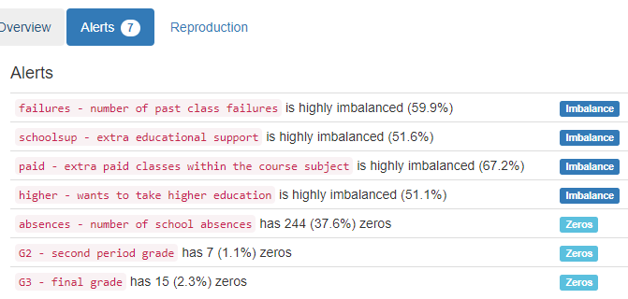

YData did not find anything that we care.

# 275 - Bike Sharing Dataset - Social

Dataset analysed: hour.csv from <https://archive.ics.uci.edu/ml/machine-learning-databases/00275/Bike-Sharing-Dataset.zip> (dataset_file_url column from Fiftydatasets.xlsx) has header

instant:

Numerical >=0 format: All 17379 values are numerical and greater or equal to 0 in the range (1:17379).

dteday (date):

Date format: All 17379 date values are valid in the YYYYMMDD format in the range 2011-01-01 to 2012-12-31.

season:

All 17379 values are correctly categorical.

Categorical format with 4 unique values:

Category Frequency

3 4496

2 4409

1 4242

4 4232

The following column had to be altered in the AllColumnsfromFortyDatasets sheet because it does not contain appropriate year values, just the values 0 and 1. So, it was marked as nominal.

yr (nominal):

All 17379 values are correctly categorical.

Categorical format with 2 unique values:

Category Frequency

1 8734

0 8645

mnth (month):

Month format: All 17379 month values are valid.

Frequency Distribution:

Month Frequency

May 1488

July 1488

December 1483

August 1475

March 1473

October 1451

June 1440

April 1437

September 1437

November 1437

January 1429

February 1341

hr (hour):

Numerical (between 0 and 24) format: All 17379 values are numerical and valid in the range [0, 24].

Actual range of values: (0 : 23)

holiday ( or not):

Binary format: All 17379 binary values are valid.

Frequency Distribution:

Value Frequency

0 16879

1 500

weekday:

Weekday format: All 17379 weekday values are valid.

Frequency Distribution:

Weekday Frequency

Friday 2512

Thursday 2487

Sunday 2479

Tuesday 2475

Wednesday 2471

Monday 2453

workingday (neither):

Binary format: All 17379 binary values are valid.

Frequency Distribution:

Value Frequency

1 11865

0 5514

weathersit (weathersit):

All 17379 values are correctly categorical.

Categorical format with 4 unique values:

Category Frequency

1 11413

2 4544

3 1419

4 3

temp (normalized):

Normalized format: All 17379 values are numerical and valid in the range [0, 1].

Actual range of values: (0.02 : 1.0)

atemp (normalized):

Normalized format: All 17379 values are numerical and valid in the range [0, 1].

Actual range of values: (0.0 : 1.0)

hum (normalized):

Normalized format: All 17379 values are numerical and valid in the range [0, 1].

Actual range of values: (0.0 : 1.0)

windspeed (normalized):

Normalized format: All 17379 values are numerical and valid in the range [0, 1].

Actual range of values: (0.0 : 0.8507)

casual (count):

Numerical >=0 format: All 17379 values are numerical and greater or equal to 0 in the range (0:367).

registered (count):

Numerical >=0 format: All 17379 values are numerical and greater or equal to 0 in the range (0:886).

cnt (count):

Numerical >=0 format: All 17379 values are numerical and greater or equal to 0 in the range (1:977)

Last run on: 2024-03-01 12:49:47.

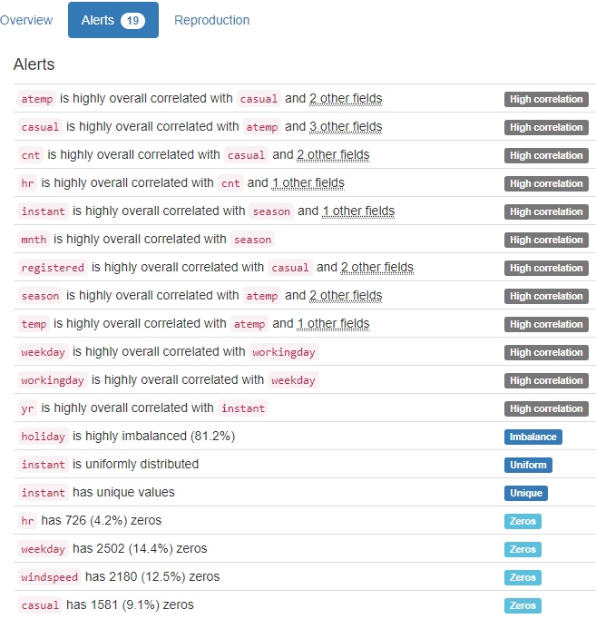

YData shows the column 'instant' as Unique. We have not checked that.

# 13 - Balloons - Social

Dataset analysed: adult+stretch.data from <https://archive.ics.uci.edu/ml/machine-learning-databases/balloons/adult+stretch.data> (dataset_file_url column from Fiftydatasets.xlsx) has

Color:

All 19 values are correctly categorical.

Categorical format with 2 unique values:

Category Frequency

PURPLE 10

YELLOW 9

size (large):

All 19 values are correctly categorical.

Categorical format with 2 unique values:

Category Frequency

LARGE 10

SMALL 9

act (stretch):

All 19 values are correctly categorical.

Categorical format with 2 unique values:

Category Frequency

STRETCH 11

DIP 8

The following column had to be altered in the AllColumnsfromFortyDatasets sheet because it does not contain appropriate age values, just the values ADULT and CHILD. So, it was marked as nominal.

age (nominal):

All 19 values are correctly categorical.

Categorical format with 2 unique values:

Category Frequency

ADULT 11

CHILD 8

inflated class (class):

All 19 values are correctly categorical.

Categorical format with 2 unique values:

Category Frequency

F 12

T 7

Last run on: 2024-03-01 14:29:19

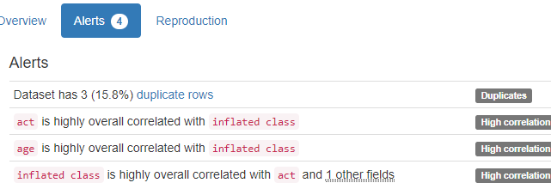

YData did not find anything that we care.